

Ref No.
IG/

Application for Improvement Award
Security/Stairlighting

Please read the Guidance Notes included at the start of this form before filling it in.

Please return the completed form and estimates to:

Private Sector Services Unit
3 City Square
DUNDEE DD1 3BA

For further information, please telephone:

01382 436880

or email: private.sector@dundeecity.gov.uk
website: http://www.dundeecity.gov.uk/housing/privatesector/

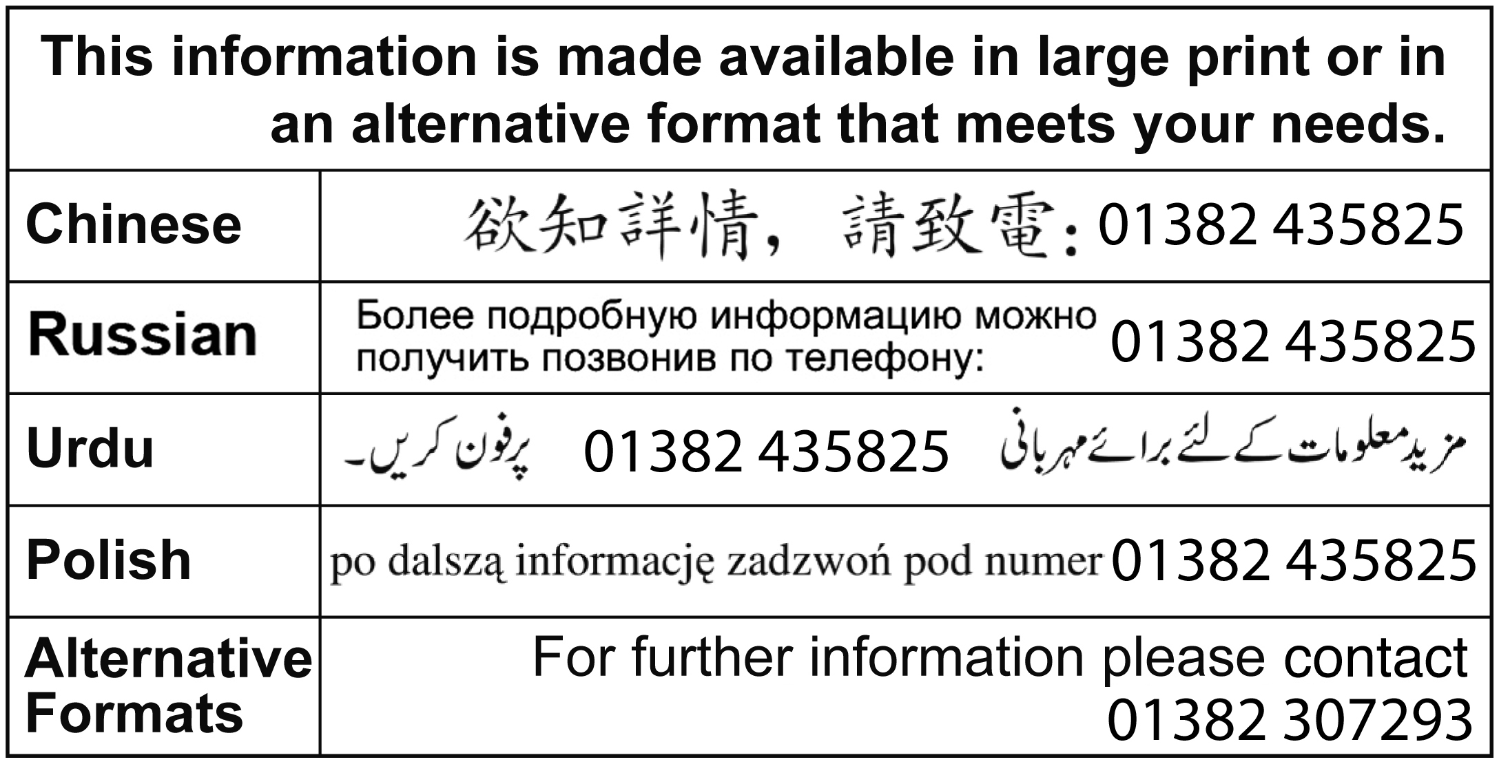

Guidance Notes

Subject to the availability of funds, assistance is currently available towards security/ stairlighting improvements to tenemental properties.

You are required to obtain 2 competitive estimates for the proposed works and return them with your application form. We will only accept original estimates - photocopies are not acceptable.

The award for common door entry systems is a fixed sum of up to £250 per flat or the cost of installation, whichever is the less. This is available to all owners towards the installation of a secure door entry system. To enable an effective installation, full agreement is required between the various owners.

The attached Security/Stairlighting Award Specification should be given to your contractor in order for them to incorporate this into the estimates.

The award for stair lighting is a fixed sum of up to £100 per flat or the cost of installation, whichever is the less. This is available to all owners towards the installation/upgrading of common stair lighting. Options can include a common supply or alternatively independent lighting supplied from individual flats. In the latter case not all owners are required to install an individual light but there must be at least one light fitting per level suitably located and operating on a dawn to dusk or equivalent sensor. Where independent lighting is supplied from individual flats, only those installing the lighting will be eligible to apply for the award.
Assistance can only be considered if the house is at least 10 years old.

Please ensure that adequate postage is paid when returning your application, otherwise this will delay the process.

Once an application has been submitted, a Technical Officer will contact you to carry out an inspection of your property (internal and external) and issue a report showing details of the costs approved for award purposes (based on your estimates).

You may also be asked to carry out additional works as a condition of your award; your application can then be formally approved only on receipt of your written agreement to these conditions. You should be aware that not all additional work required as a condition of award will attract financial assistance.

No works should commence until the Formal Notice of Approval of your award has been issued by the Council. Where works have been completed before the Technical Officer has inspected the property and issued his report, no award will be given.

Once you have received Formal Notice of Approval, payment of your award can only be made upon completion of the works to the satisfaction of the Technical Officer.

All award proceeds will be paid by cheque/BACS to the grant applicant; in the case of joint applicants, the cheque will be issued in both names unless otherwise directed by you. Payment may be mandated to an approved agent, solicitor or bank account if required. Mandates in favour of contractors are not acceptable.

For details of the full qualifying criteria please refer to the relevant section of the Scheme of Assistance for Private Sector Housing on the City Council's website.

Part A - General

A1. Address of the house where work is to be done.
Please include the flat number/position, if applicable

Postcode

A2. Your details (the applicant)

Mr Mrs Miss Ms

Name
Address (if different from A1)
 |  | Postcode
Telephone (day) | Telephone (evening)
Telephone (mobile) | Email

A3. Who owns the house where the work is to be done?
If there are joint owners, please continue on a separate sheet if necessary

Owner's name
Owner's address
Postcode | Telephone

A4. If you want someone else to deal with the application for you, please give their details.

Name
Address
 |  | Postcode
Telephone (day) | Telephone (evening)
Telephone (mobile) | Email

Part B - About the House

B1. What sort of property is it? Please tick one box

House: detached |  | semi-detached |  |  | terraced
Flat: tenement |  | high-rise |  |  | 4-in-a-block
Business premises
Other - please describe

B2. Please give a brief description of the planned works.

B3. How much will these works cost? (based on lowest estimate(s) submitted)

Cost of work | £
VAT on work | £
Professional Fees | £
VAT on fees | £
Total | £

B4. As far as you know, have any other grants been applied for to do work on this house, within the past 10 years? Please tick one box

No Yes Please give details below

Type of Grant
Amount | £
Date Approved

B5. Is the property at least 10 years old at the date of application?

Yes No

B6. When did you purchase the property? (DD/MM/YY)
Part C - You and the House

C1. What is your connection with the house?

Owner Go to Part D

Liferenter Go to Part D

Owner, but do not currently live in the house

C2. Does a family member live in the house?

Yes (Go to Part D)

No

C3. Are you a Registered Landlord?

Yes

My Registration Number is: | /180/

(Go to Part D)

No (A Landlord Registration application must therefore be submitted)

Part D - Declarations

Applicant's Declaration

Please read this declaration carefully and then sign and date this form.

In order to process your application Dundee City Council requires certain information from you, as detailed on the application form. As an individual you have certain rights and protection under the Data Protection Act 1988. The information you provide on this form is held by Dundee City Council. It must be processed fairly and lawfully and you are entitled to know how we intend to use the information which you provide. In terms of the Act you have the right to contact us in writing to ask for a copy of the personal information which we hold on you.

Dundee City Council is a registered data controller. Any enquiries regarding the processing of your personal data by Dundee City Council should be directed to the Legal Manager and Data Protection Officer at (01382) 434577.

A copy of the Council's Data Protection Policy can be obtained by writing to the Legal Manager and Data Protection Officer, c/o Depute Chief Executive (Support Services), 21 City Square, Dundee, DD1 3BY.

This form gives us permission to share information which you have provided in your application form with other Council Departments or to contact external agencies if we feel that we need to verify the accuracy of the information provided by you on your application form.

In the absence of your specific consent, as indicated below, or where records are held by the Council we may contact you and ask you to provide supporting evidence of any of the details contained in your application before we can process this.

__________________________________________________________________________

This is my application form for financial assistance towards the cost of works described in this form.

I/We certify that the information that is provided is to the best of my knowledge true and complete.
I understand that if I make false declaration knowingly this could amount to a criminal offence for which I may be prosecuted.

I understand that the Private Sector Services Unit of Dundee City Council will make relevant enquiries with other Council Departments and external agencies such as my bank or building society, in order to request information to verify the details provided on my application. I consent to other Council Departments sharing information held by them with the Private Sector Services Unit and I hereby authorise Dundee City Council to make any further enquiries with external agencies which are necessary in order to verify the information provided by me in connection with my application.

Signed ............................................................................ Date ................................

Print name .....................................................................................................................

Owner's Declaration

All owners of the property must sign below.

I/We declare that I/We am/are the owner(s) of the property at

I/We consent to application being made for financial assistance in respect of the said property.

I/We consent to being bound by the following conditions, if financial assistance is awarded, for a period of 10 years from the date when the work detailed in the application are completed.

I/We understand that any breach of the conditions may lead to a demand for repayment of the financial assistance together with interest.

Conditions

- The house must be used as a private dwelling house (although part may be used for business purposes).
- If the owner or a member of the owner’s family occupies the house, it must be their only or main residence.
- The house must be kept in good repair.

Signed ........................................................................... Date ................................

Print name . ...................................................................................................................

Signed ............................................................................. Date ...............................

Print name .....................................................................................................................

Signed ............................................................................ Date ................................

Print name ....................................................................................................................

Signed ........................................................................... Date .................................

Print name......................................................................................................................

SECURITY AWARD

Door Entry System Specification

A complete integrated GDX5 Lite Low Rise audio door entry system compliant with the technical and performance criteria set out in the GDX Technologies manufacturer’s instructions (or equal and approved by the Private Sector Services Unit).

The contractors must provide a fully detailed specification of the system to be installed.

The control unit to be Flush Fitted and rated to IP66 (water resistant). and constructed in vandal resistant material.

An electromagnetic ' maglocks ' locking system compatible with the Door Entry system installation, with a minimum holding force of 1200lbf to be locked when energised to allow "fail-to-safe" on power failure.

Electric lock release to be electric signal provided by mains control from push buttons at door or telephone handset.

Push Button release to be green "Mushroom" type and fitted in close proximity to exit.

The Electrical Contractor must ensure that the mains supply to the property involved in the works does not affect the supplies to other tenemental properties prior to disconnecting/replacing the supply.

Where it is identified that the supply is common to adjoining properties this supply must be reconnected to ensure that the supply is maintained.

The responsibility is with the owners to ensure the contractor is made aware of this requirement and any costs involved in reconnection at a later date following the installation will be met by the owners.

Front Entrance Door

The front entrance door to be a solid timber door and frame, with fan and side light, (where site conditions allow).

The door is provided with a heavy duty door closer, i.e. Dorma., and " D " handle.

Typical Stairlighting Specification

Individual Installation

- Supply, wire and fit a suitable light fitting with a dawn to dusk sensor in an agreed position outside the door of flat.
- Supply, wire and fit an isolator switch inside the property, the preference being situated at high level.
- Ensuring that the new installation is tested and a certificate provided by the electrical contractor.

Common Stair Lighting

For the upgrading or installation of a new common supply servicing a common stairlighting system. The installation will be dependent upon site conditions and specification in terms of bulk head fittings, wiring, trunking etc. to be agreed between the owners and the contractors.

Ensuring in all cases the new installation is tested and a certificate provided by the electrical contractor.

Lighting in Common Areas of Domestic Buildings

Common areas should have artificial lighting capable of providing a uniform
lighting level, at floor level, of not less than 100 lux on stair flights and landings and 50 lux elsewhere within circulation areas. Lighting should not present sources of glare and should avoid creation of areas of strong shadow that may cause confusion or miss-step. A means of automatic control should be provided to ensure that lighting is operable during the hours of darkness.

There are currently a number of fittings for close lighting, a typical unit is the Coughtrie SP Fitting (details attached) which can offer a standard Bayonet Cap connection, Low Energy PL Lamp connection and more recently, they offer a LED version.(or Equal and Approved)

The Electrical Contractor must ensure that the mains supply to the property involved in the works does not affect the supplies to other tenemental properties prior to disconnecting/replacing the supply.

Where it is identified that the supply is common to adjoining properties this supply must be reconnected to ensure lighting system is maintained.

The responsibility is with the owners to ensure the contractor is made aware of this requirement and any costs involved in reconnection at a later date following the installation will be met by the owners.

All works to be carried out to current IEE wiring regulations and
Technical Standards

