DP Coordinating Group Minute
13th March 2025
Central Library Meeting Room 2 / Teams

In Attendance
In Person | Online
Lali Tudela (DVVA) | Anna Day (LACD)
Laura Henderson (Public Health) | Barbara Whiting (DCC, Sustainability Team)
Nicky Maccrimmon (DCC, Communities) | Connie Calvo (SDS)
Paul Davies (DCC, Community Planning) | Paul Robertson (SFRS)
Peter Allan (DCC, Community Planning) | Rachael Thomas (CWB, City Development)
 | Rory Young (DCC, City Development)
Apologies
Andrea Calder (DCC, Chief Executive’s Services) | Kathryn Sharp (HSCP)
Colin Echavarria (Police Scotland) | Nora Ferda-McKay (Scottish Enterprise)
Jill Brash (DCC, Research & Information) | Rachael Burns (Police Scotland)
Judy Dobbie (LACD) | Rhian Ferguson (DCC, Community Justice)

1. | Introductions & Apologies
 | Peter led a round of introductions. Apologies received are as noted above.
2. | Matters Arising
 | Rory sent information on the shape of the new Employability Service – see slides attached with this minute.
3. | Strategic Leadership Groups
a) | Inclusive Economic Growth
 | Paul provided a summary of the 19th February SLG meeting, held at Live House. The theme was ‘Key Priorities’. Presentations included:  - We Back Ambition by Matthew Lockley from Scottish Enterprise, discussing changes to SE’s strategic priorities, their new branding, and the core driving purpose to support businesses to innovate and scale up  - Community Wealth Building Strategy & Action Plan Update by Rachael Thomas – see item 6  - Dundee’s Growth Story: Draft Vision and Action Plan by Rory Young, focussing on updating economic data and addressing feedback to better reflect the link between delivering economic growth sustainably and tackling the climate change emergency  The IEG also covered Quarterly Performance Monitoring and noted a positive decline in unemployment levels and an increase in Business Gateway start-ups. The Economic Development Quarterly Briefing provided updates on various sectors and areas within the city, including ambitious plans by D&A College to drive economic growth and regeneration.  The next IEG is scheduled for the 14th May, with the Dundee Economic Summit following on the 18th June.  Discussion included:  - The Just Transition project led by Dundee University aims to ensure deprived communities are not left out. Nicky to keep people updated | NM
b) | Child Poverty & Inequalities
- Laura and Peter to discuss relevant subject matter for the SLG, which is still developing, and agree on a path for the group
- New Director of Public Health may be appointed by July
- A data dashboard has been created and will be shared at each meeting
- Sheila Allan is leading the Engine Room work with various organisations involved
- A range of partners has provided input to the SLG to date
- Locality based work is being examined
- Fairness Leadership Panel recommendations are to be presented at the next SLG meeting
c) | Climate Leadership Group
 | It was noted at the DP Management Group that this group is good at asking for resources, including from the Scottish Government and chasing these up to keep things moving. Paul to circulate the DPMG Update for information (attached) | PAD
4. | DPMG Update and Actions
 | - Paul and Peter discussed various actions coming out of the March DPMG. Attached for action / information  - Prevention work was discussed, focusing on the Fire Service’s domestic work via their Community Action Team. Campbell Sands to be contacted | PR / PAD
5. | Strategic Theme Connections
 | Cultural Development
 | - The consultations were helpful in engaging people in the budgeting process, despite the savings being considered  - Multi-year funding will be received by eight organisations in the cultural sector, up from four last year  - Future Artland project will be engaging with Dundee schools to encourage work in the sector. Anna is coordinating locally and will share a presentation at our next meeting  - Nicky to link Anna with Jimmy Dodds to facilitate links with the Youth Work Network  - Nicky is starting work on a new Tenant Participation Strategy and would welcome input. First draft due in May / June | AD  NM  All
 | Alcohol and Drugs
 | Child & Adult Protection
 | Community Safety & Justice
 | Updates on the three items above will be sought and shared with the group
6. | Community Wealth Building
 | - Strategy development is almost complete, with feedback from Paul Thomson expected this week  - Rachael will outline the strategy, which aligns well with legislation and is ambitious, at the next meeting  - One area of work is in relation to Kirkton Community Centre which closed in February. We are supporting community members in developing a new community centre that will generate income to support itself. Examples from other local authorities are being looked at  - Engagement is also taking place with social enterprises and charities. Some groups are good at pulling in resources from the private sector too  - Oor Village – an event organized by Roy Kane and others including the Apex Enterprise Trust. Anna attended and felt there was good networking and discussion on the joint use of resources. Tools needed to facilitate better sharing and it would be useful for a small group of us to make contact with the organisers.  - NHS Tayside's Anchor Work was discussed. There are links with employability work, including academies, and procurement related developments  - Noted that colocation often helps to make better links between partners | RT  AD / PA
7. | Locality Leadership Group
- More streamlined LCPPs, reducing from eight to six in July, should make it more possible for partners to engage. Drumgeith Community Campus and Morgan Academy catchment areas match fairly well with the joint LCPPs that will be formed
- LCPPs are the ‘place to get closer to communities’, and on ultra-local work can benefit both local people and organisations (e.g. the Local Fairness Initiative)
8. | DPCG Development Event Planning
 | As many are new to the group, a development day is being planned. Paul D to lead on generating initial ideas and working with some of the group, aiming for a half day workshop to look at how we work together | PAD
9. | AOCB
 | Place Based Work in Dundee
Paul outlined some of the work he and Peter have been carrying out with place-based projects in Dundee. Projects identified and met with are:
- The Local Fairness Initiative. Seeking to increase financial wellbeing and social outcomes in Linlathen and Stobswell West
- Global Bridge – Linlathen. To help prepare families on Universal Credit, especially those in the ‘no work’ category, for upcoming changes in requirements by creating digital records of achievement
- Planet Youth. Helping to reduce youth substance use through prevention and delaying substance use, targeting S3 and S4 pupils. Seeks to improve emotional wellbeing, reduce anti-social behaviour and create safe lives
- ReKindle. Planning to implement a ‘supplementary school’ for disengaged young people aged 11-14 offering alternative schooling from 4-7pm on weekdays plus Saturday mornings
- What Matters To You. Empowering local people by shifting power, budgets and control to local communities through the Make It Happen fund

A number of elements in common have been identified across some / all of these projects:
- Aim – community empowerment
- Funding Sources – Scottish Government for some, Private / Trust funding for others
- Outcomes – community engagement
- Themes – holistic approaches and/or collaboration by some
 | Results of the Community Planning Survey
Peter shared the results of the national Community Planning Survey (see diagram below) which shows that there are a number of areas that can be improved upon. The Improvement Service aims to carry out work with each Community Planning Partnership every two years to help drive improvements.

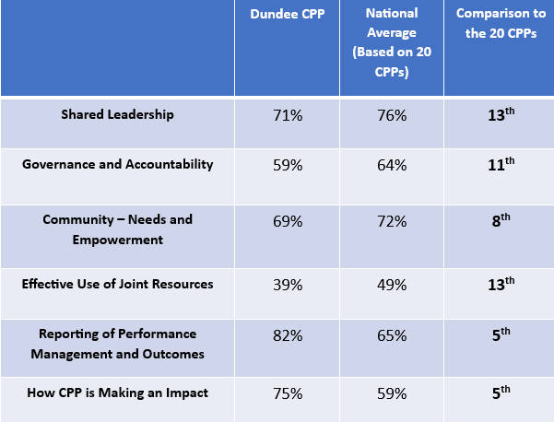
Date of Next Meetings:
- 19th June
- 18th September
- 11th December
Venue: Central Library, Meeting Room 2, hybrid with Teams.
Enc:
- Slides from 13th November Discover Work Annual Conference
- Climate Leadership Group DPMG Update
- DPMG Action List
- (potentially updates from the three Strategic Themes not covered on the day)

