REPORT TO: POLICY AND RESOURCES COMMITTEE – 9 DECEMBER 2013

REPORT ON: ALLOCATION OF COMMUNITY REGENERATION FUNDING 2014/15

REPORT BY: CHIEF EXECUTIVE

REPORT NO: 521-2013

1. PURPOSE OF REPORT

This report recommends community regeneration fund allocations for the year 2014/15.

2. RECOMMENDATIONS

2.1 It is recommended that:

a) £125,000 be allocated to the Community Regeneration Forums for Coldside, Maryfield, North East and Strathmartine

b) increased allocations of £136,473 and £190,462 be awarded to the East End and Lochee Community Regeneration Forums respectively

c) that £10,000 be allocated to the Local Community Planning Partnerships for The Ferry and West End

3. FINANCIAL IMPLICATIONS

3.1 The cost of the recommendations in this report will be met through the ongoing budget of £750,000 for Community Regeneration Forums and an additional allocation of £96,935 from the Council’s Capital Budget in 2014/15.

4. BACKGROUND

4.1 The Scottish Index of Multiple Deprivation and National Direction.

4.1.1 Deprivation across Scotland is measured and reported through the Scottish Index of Multiple Deprivation. It is updated every few years and the most recent report was published in 2012. It measures a number of aspects of inequality including Income, Employment, Health, Education, Housing and Crime to produce an overall score for small areas called datazones. Datazones for the whole of Scotland are then ranked by score in 5% bands. The recognised measure of multiple deprivation is the most disadvantaged 15% of datazones in Scotland.

4.1.2 There are 179 datazones in Dundee and 55 of these are scored and ranked as within the ‘worst’ 15% in Scotland. However, it is possible to identify varying degrees of deprivation within the 15%. Datazones within the 0-5% category are subject to the most severe levels of deprivation in Scotland and the impact is described by the Improvement Service in Scotland as “exhibiting consistent, interacting and mutually reinforcing negative outcomes across all aspects of life”.

4.1.3 The report Making Better Places, Making Places Better then goes on to explain the result of the multiple deprivation in the worst areas.

“The discussion to date has been dry and analytical so what does it mean in terms of peoples lives? What it means is people living in areas where children’s achievement in education is less than half the Scottish norm, and 25% of that achieved by children in the least deprived areas. It means people living in areas where 20%+ of the adult population are prescribed drugs for anxiety and depression; where in any year, 3 in every 10 adults will be emergency admitted to hospital and where life expectancy and healthy life expectancy are more than ten years less than the Scottish average. It means people living in areas where the rate of crime is 4 times the average for Scotland and 8 times the average for the least deprived areas in Scotland. All these negatives in peoples lives in these areas are statistically inter-related but, more importantly, practically interact in the daily lives of these communities creating ‘cycles’ of deprivation”.

4.1.4 In its guidance on Single Outcome Agreements, the Scottish Government also signalled that partnerships must:

- use an evidence based approach underpinned by disaggregated data, to drive improvement on meeting the differing needs of local populations

- focus upon reducing outcome gaps within populations and between areas – and promote early intervention and preventative approaches in reducing outcome inequalities

4.2 Analysis of Multiple Deprivation in Dundee

4.2.1 Table 1 and Figure 1 below present the number and distribution of datazones in the worst 15% in Scotland by ward.

Ward | Total No of Data Zones | No of Datazones in worst 15% | % of Datazones in worst 15%
Coldside | 24 | 8 | 14.5
East End | 21 | 10 | 18.2
Lochee | 26 | 14 | 25.4
Maryfield | 19 | 5 | 9.1
North East | 21 | 9 | 16.4
Strathmartine | 24 | 9 | 16.4
The Ferry | 23 | 0 | 0
West End | 21 | 0 | 0
DZ in 15% MD | 179 | 55 | 100

Figure 1: Percentage of Data Zones ranked within the 15% Most Deprived SIMD 2012

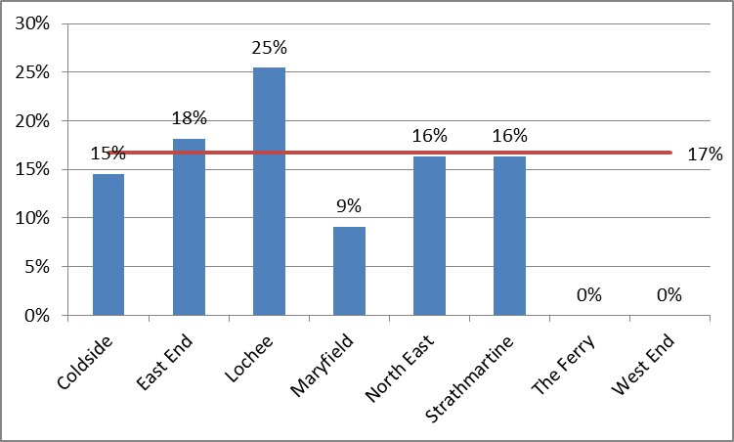
4.3 Community Regeneration Funding Allocations

4.3.1 Since 2008/09, a total budget of £750,000 has been allocated to Community Regeneration Forums. The current allocation to each of the six Community Regeneration Forums is £125,000 per annum. While this was previously for a two or three year period, the allocation for 2012/13 was for one year only. The £125,000 distributed by each Forum represents 16.7% of the total budget.

4.3.2 During the Policy and Resources Committee’s debate on the Revenue Budget and Council Tax 2013/14 on 14 February 2013, officers were asked to consider whether a uniform level of funding to all community regeneration forums adequately reflects varying levels of deprivation.

4.3.3 The report aims to create an allocation of funding which more closely reflects the different levels of deprivation in wards. However, in the Single Outcome Agreement 2013-17, the Council and its partners made a commitment to respond to the needs of community regeneration areas through the additional targeting of services and resources to close the inequality gap in the city. It is therefore recommended that no Community Regeneration Forum should have funding withdrawn. Instead additional resources will be necessary to ensure that wards with greater levels of deprivation achieve appropriate allocations.

4.3.4 Table 2 below sets out the recommended levels of funding for 2014/15 with greater resources allocated to the Lochee and East End wards as a result of the levels of deprivation exceeding the average allocation to Forums.

Table 2 – Share of Deprivation and Allocation by Ward

Ward | Current % share of Allocation | % of Datazones in worst 15% | Current Allocation | Proposed Allocation | Change
Coldside | 16.7 | 14.5 | 125,000 | 125,000 | -
East End | 16.7 | 18.2 | 125,000 | 136,473 | +11,473
Lochee | 16.7 | 25.4 | 125,000 | 190,462 | +65,462
Maryfield | 16.7 | 9.1 | 125,000 | 125,000 | -
North East | 16.7 | 16.4 | 125,000 | 125,000 | -
Strathmartine | 16.7 | 16.4 | 125,000 | 125,000 | -

4.3.5 While it remains strategically correct to allocate all of the existing community regeneration funding to those areas experiencing the scale, degree and multiple causes of deprivation in the SIMD worst 15%, it is recognised that the impact of fuel poverty, unemployment and benefit reforms, for example, are also currently being felt by individuals and families in The Ferry and West End wards. In recognition of this, it is recommended the Local Community Planning Partnerships for The Ferry and the West End wards receive allocations of £10,000 for 2013/14.

4.3.6 Each year, the majority of community regeneration grants are used to fund physical and environmental improvements to neighbourhoods. Therefore the additional £96,935 required to fund the recommendations set out in paras 4.3.3 and 4.3.4 will be met from Council’s capital budgets for 2014/15.

5. POLICY IMPLICATIONS

This report has been screened for any policy implications in respect of Sustainability, Strategic Environmental Assessment, Anti-Poverty, Equality and Impact Assessment and Risk Management.

An Equality Impact Assessment is attached.

6. CONSULTATIONS

The Director of Corporate Services and the Head of Democratic and Legal Services have been consulted in the preparation of this report.

7. BACKGROUND PAPERS

None.

David K Dorward
Chief Executive …………………………………… 29/07/2026

DUNDEE CITY COUNCIL

Equality and Diversity Rapid Impact Assessment
Part 1
Date 9 December 2013 | Title Community Regeneration Fund
Is this a new document? | Is this an exisitng document under review? √
Please list any existing documents which have been used to inform this Equality and Diversity Impact Assessment. | Single Outcome Agreement and Delivery Plan for Dundee 2009-12
What is the description of the policy, procedure or strategy? | A dedicated fund to tackle poverty and deprivation in community regeneration areas in Dundee
What is the intended outcome of this policy, procedure or strategy? | To fund, physical, environmental, youth work and community group activity which will 'close the gap' between community regeneration areas and the rest of the city
Which individuals are responsible for undertaking Equality and Diversity Impact Assessment? | Peter Allan, Community Planning Manager

Part 2
Which groups of the population will be positively or negatively affected by this policy, procedure or strategy?
 | Positively | Negatively | No  Impact | Not Known
Ethnic Minority Communities including Gypsies and Travellers |  |  |  | √
Gender including transgender people |  |  |  | √
Religion or Belief |  |  |  | √
People with a disability | √
Age | √
Lesbian, Gay and Bisexual |  |  |  | √
Socio-economic | √
Other (please state)

Part 3
Equality and Diversity Rapid Impact Assessment
- Have any positive impacts been identified?  We must ensure at this stage that we are not achieving equality for one strand of equality at the expense of another. | If yes please give further details  The fund is targeted at improving services, opportunities and the physical environment for people in the areas defined by the SIMD, 15% for deprivation. The greatest impact is therefore in relation to socio-economic factors but this often overlaps with others
- Have any negative impacts been identified?  Based on direct knowledge, published research, community involvement, customer feedback etc  If unsure seek advice. | If yes please give further details  None. No funding is being removed or transferred from other groups
- What action is proposed to overcome any negative impacts?  If you identify a negative impact that cannot be eliminated by amending or replacing the policy it would then be necessary to seek legal advice. | Please give details  None identified as required.
- Consultation or involvement which has informed this assessment. | Please give details  Ongoing liaison with community regeneration forums and financial inclusion partners
- Is there a need to collect further evidence? | If yes please give further details including how you gather further evidence.  None
- How will the policy be monitored ? | Please give details  The range of groups impacted positively will be assessed on a monthly basis by the Dundee Partnership Team and any equality issues will be reported to the Building Stronger Communities Theme Group
Part 4
Department
Corporate Planning/Community Planning Team

Type of Document
Human Resource Policy
General Policy
Strategy/Service
Change Papers/Local Procedure
Guidelines and Protocols
Other Grant Allocation Report | √

Contact Information
Manager Responsible | Author Responsible
Name Peter Allan | Name Peter Allan
Designation Community Planning Manager | Designation Community Planning Manager
Base 21 City Square, Dundee | Base 21 City Square
Telephone Ext 4465 | Telephone Ext 4465
Email peter.allan@dundeecity.gov.uk | Email peter.allan@dundeecity.gov.uk

Signature of author of the policy, procedure or strategy: Peter Allan

Head of Department and Service area: David K Dorward

Date of next review: 30 November 2014

