REPORT TO: SCRUTINY AND AUDIT COMMITTEE - 24 JUNE 2026
REPORT ON: ANNUAL COMPLAINTS REPORT 2025/2026
REPORT BY: CHIEF EXECUTIVE
REPORT NO: 119-2026

1. PURPOSE

The Annual Report on Complaints for 2025/26, contained in Appendix 1, presents an update on performance regarding corporate complaints in 2025/26, with comparisons to previous years, and shows how the Council continues to learn from complaints.

2. RECOMMENDATIONS

It is recommended that Committee notes:

- the key performance indicators (KPIs) on complaints closed between 1 April 2025 and 31 March 2026, with trends from previous periods – full report is attached as Appendix 1;

- a summary of complaints about the Council received by and determined by the Scottish Public Services Ombudsman during 2025/26;

- examples of the range and volume of transactions the Council has with customers and citizens as a context for the number of complaints received – contained in Appendix 2;

- examples of how complaints have been used to improve services;

- examples of compliments received about Council services, and

- results of the satisfaction survey sent to people who made complaints in 2025/26.

3. FINANCIAL IMPLICATIONS

There are no direct financial implications arising from the agreement of this report.

4. BACKGROUND

4.1 The model Complaints Handling Procedure for Local Authorities requires that regular reports are produced for elected members. This is the annual report covering complaints closed between 1 April 2025 and 31 March 2026.
4.2 In terms of performance management, the report includes data on key complaint handling indicators and results from the quarterly satisfaction surveys sent to those who had complaints closed during 2025/2026.

4.3 The Model Complaints Handling Procedure places a duty on public bodies to demonstrate how they used complaints to improve their services. The attached report gives examples of customer feedback gathered through corporate complaints and how this has been used to improve processes.

4.4 Appendix 2 includes infographics giving examples of the range and number of transactions the Council has with customers and citizens, providing context for the number of complaints received. In 2025/26 the Council recorded tens of millions of individual interactions with our citizens, including:

- 5.63m of household waste and bin collections completed
- 16,500 households supported with Council Tax Reduction
- 57,450 of house repairs carried out
- 178,860 calls answered by Customer Services
- 18,360 children attending and being educated in Dundee schools each day.

5. OVERVIEW OF PERFORMANCE
5.1 The report presented in Appendix 1 contains detailed information in relation to Key Performance Indicators (KPIs) and trends to give a comprehensive picture on how complaints were handled in 2025/26. This is summarised as follows:
- The Council closed 1041 complaints in 2025/26 compared to 833 in 2024/25, being a 25% increase. There were 850 Stage 1 complaints and 191 Stage 2 complaints.

- 53.74% of Stage 1 complaints (457 out of 850) were completed within the 5-day target – a decrease from 66.8% in 2024/25.

- The average number of days taken to close Stage 1 complaints was 9.1, compared to 5.9 in 2024/25.

- 41.88% of Stage 2 complaints (80 out of 191) were completed within the 20-day target, compared to 49.3% in 2024/25.

- The average number of days to handle Stage 2 complaints was 33.5, compared to 24.9 in 2024/25.

- The top reason for complaints in 2025/26 was “Failure to provide a service” - 30.6%. The second most common reason for complaints was “Treatment by or attitude of a member of staff” - 18.2%.
5.2 The KPIs for both stages of complaints are designed to drive improvement in the promptness of responses, rather than being absolute standards that every case is expected to meet. Stage 2 cases especially can be about cross service, complex and/or sensitive issues.

5.3 The Council saw a 25% increase on the number of complaints compared to the previous year. This trend is also being recorded by other councils and reported across the Local Authority Complaints Handlers Network (LACHN). LACHN meetings are attended by a representative from the SPSO office, who has reported a similar pattern of increase in the number of complaints they receive, and their complexity, over the recent financial year. A key factor that may be contributing to the rise in number and complexity of complaints, which was not noted in previous years, is the increasing public awareness and use of AI tools, where members of the public use AI platforms to help them draft their complaints. AI-generated complaints frequently quote various acts and legislation, where Investigating Officers may need to seek advice from senior officers and/or consult legal colleagues before issuing a response.

5.4 To address the increasing number of complaints that the Council receives and improve performance, a number of actions were undertaken during 2025/26, and some are being taken forward into 2026/27.
- Handling Complaints training sessions are held regularly throughout the year with a return to in-person sessions from June 2026. Online sessions will also be available to ensure flexibility.
- Bespoke Handling Complaints training was delivered to Neighbourhood Services and is offered to other services.
- Continuation of issuing monthly updates to the Council Leadership Team on complaints performance.
- The guidance for employees on complaint handling document has been reviewed and updated.
- A new E-Learning module “Introduction to Corporate Complaints” was developed for all frontline employees, aiming to increase awareness of the Council’s complaints procedure. A paper version of the module is also available for employees with no access to ICT facilities.
- Work is underway to develop training on Child Friendly Complaints with launch being planned during 2026/27.
- A new Corporate Complaints Dashboard is being developed to make it easier for services to track their performance on complaints in real time and develop service improvements to improve performance.

5.5 In addition to the above, performance and improvements will be monitored and discussed at the Council Leadership Team, the Complaints Review Group and within individual services. The “Learning from Complaints” section demonstrates the Council’s continued commitment to improving the service that is provided to the citizens of Dundee, as well as the processes to prevent the same issues from recurring. A number of complaints led to senior managers within services speaking to their team members to ensure that improving customer experience is at the heart of service delivery.

6. STATISTICS FROM THE SCOTTISH PUBLIC SERVICES OMBUDSMAN

6.1 39 complaints were received by the Ombudsman about Dundee City Council in 2025/26, compared to 35 in 2024/25. This represented 1.8% of complaints received by the Ombudsman about all local authorities in the year 2025/26. Out of the 39 complaints, “Housing” was the most frequent subject complained about (18 cases), followed by “Social Work” (8 cases).

6.2 The Ombudsman determined 38 cases in 2025/26 and no cases which reached the SPSO’s Investigation stage. More detail is provided in Section 5 of Appendix 1.

7. POLICY IMPLICATIONS

7.1 This report has been subject to the Pre-IIA Screening Tool and does not make any recommendations for change to strategy, policy, procedures, services or funding and so has not been subject to an Integrated Impact Assessment. An appropriate senior manager has reviewed and agreed with this assessment.

7.2 The complaints recording database includes a feature that asks Investigating Officers to note whether any complaints relate to an equalities issue or a protected characteristic - age, disability, gender reassignment, marriage/civil partnership, pregnancy/maternity, race, religion/belief, sex or sexual orientation. Over the course of 2025/26, there were 25 complaints related to equalities or a protected characteristic. Two complaints related to ‘race’, one complaint was related to ‘age’ one was in relation to ‘sex’ and 21 complaints were in relation to ‘disability’. Complaint case files for these complaints were drawn to the attention of Council’s Equality and Fairness Officer and any recommendations arising from these complaints, or any issues identified, are taken up with the services concerned. Feedback and learning from these complaints will be discussed by the Council’s Corporate Equality and Diversity Group.

8. CONSULTATIONS

The Council Management Team was consulted in the preparation of this report.

9. BACKGROUND PAPERS

None.

GREGORY COLGAN  CHIEF EXECUTIVE | DATE: 1 JUNE 2026

ANDREA CALDER
HEAD OF CHIEF EXECUTIVE’S SERVICE

APPENDIX 1
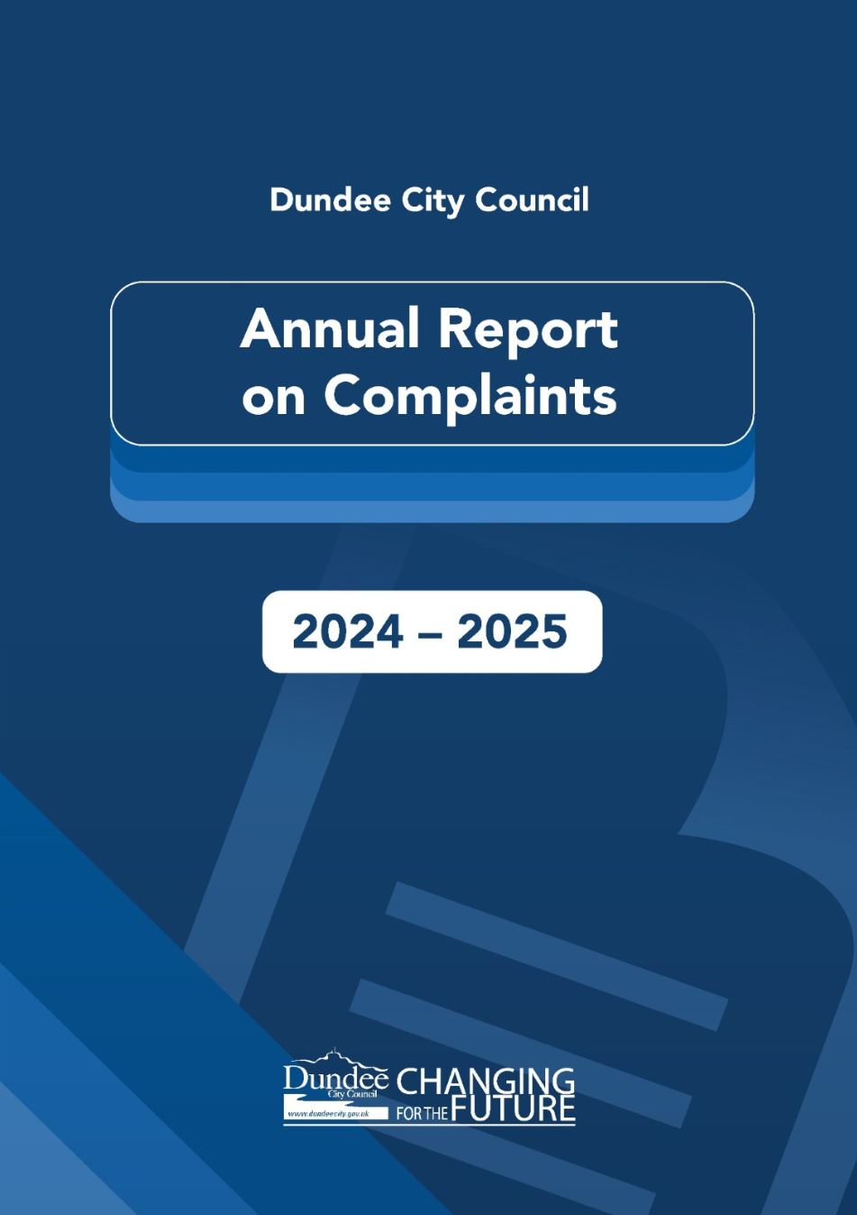
2025-2026

1. INTRODUCTION
Dundee City Council is committed to providing high-quality customer services and values complaints to improve its services. The Council's Complaints Handling Procedure (CHP) is designed to resolve customer dissatisfaction as close to the point of service delivery as possible.
Complaints are treated as a valuable source of customer feedback and we strive to deal with them well, carrying out thorough, fair, and impartial investigations and making evidence-based decisions.
If something has gone wrong, complaints let us put things right, they help us to learn lessons, and to improve our processes to prevent the same problems from happening again.
The Chief Executive provides leadership and direction to ensure an effective CHP and that the Council learns from the complaints received.

2. DUNDEE CITY COUNCIL COMPLAINTS PROCEDURE
The Scottish Local Authorities Model Complaints Handling Procedure which defines a complaint as follows is used by the Council:
“an expression of dissatisfaction about the Council’s action or lack of action or about the standard of service provided by or on its behalf”
Our Complaints Handling Procedure has two stages:
- At Stage 1 of the complaints process, the target is to respond within 5 working days, unless there are exceptional circumstances. The target time for Stage 1 complaints can be extended to up to 10 working days if necessary. Stage 1 complaints are also referred to as “Frontline” complaints.
- Stage 2 complaints process is used if the complaint is particularly serious or complex and can’t be dealt with within 10 days, or if the person remains dissatisfied after they’ve had a Stage 1 response. Stage 2 of our complaints process is also called the “Investigation” stage.
If the complainant remains dissatisfied following Stage 2 of our complaints process, they can raise the complaint further by contacting the Scottish Public Services Ombudsman.

3. KEY PERFORMANCE INDICATORS
The Scottish Public Services Ombudsman places a duty on Local Authorities to record and report on key data related to the complaints handling process. Our performance data on handling complaints during 2025/26 is presented below, with regards to all complaints closed during the period of 1 April 2025 to 31 March 2026.

3.1 Number of complaints closed
The chart below shows the total number of complaints closed per year in the last seven years. In 2025/26 there were a total of 1041 complaints closed. This is an increase in number of complaints of 24.8% compared to 2024/25, and the highest number of complaints recorded since 2019/20.
This is consistent with the national trend observed by other Local Authorities and reported by the Scottish Public Services Ombudsman.

Detailed breakdown of complaints closed by services in the last seven years is illustrated in the table below. In 2025/26 every service, except for Children and Families: Criminal Justice recorded an increase in number of complaints closed.
In January 2025, Neighbourhood Services: Communities, Safety and Protection service was merged with the Housing and Construction, under new name of Neighbourhood Services: Housing, Construction and Communities. Data in the chart below for “Housing, Construction and Communities” from 2025/26 onwards will also include complaints relating to Communities.
Service | 2019/20 | 2020/21 | 2021/22 | 2022/23 | 2023/24 | 2024/25 | 202526
Corporate Services | 71 | 80 | 83 | 92 | 108 | 68 | 83
Children & Families
Education | 98 | 41 | 70 | 83 | 93 | 110 | 125
Children's Services | 43 | 30 | 37 | 60 | 52 | 36 | 60
Criminal Justice | 8 | 3 | 4 | 7 | 5 | 11 | 3
Neighbourhood Services
Housing, Construction and Communities | 177 | 130 | 162 | 199 | 316 | 292 | 334
Environment Services | 136 | 129 | 263 | 228 | 232 | 183 | 239
Communities, Safety & Protection (ceased) | 22 | 19 | 31 | 41 | 59 | 27 | n/a
City Development | 56 | 48 | 58 | 76 | 117 | 78 | 120
Chief Executive's | 4 | 2 | 2 | 0 | 1 | 0 | 1
Dundee Health & Social Care Partnership | 51 | 23 | 50 | 44 | 41 | 28 | 76
Totals | 666 | 505 | 760 | 830 | 1024 | 833 | 1041
Nature of complaints
“Nature of complaints” are categories that are set by the Scottish Public Services Ombudsman. They help councils to identify trends in complaints made by members of the public. This information is used to identify training needs or areas of improvement across the Council.
The top two reasons for complaints closed in 2025/26 was “Failure to provide a service” and “Treatment by or attitude of a member of staff”.
Nature of Complaint | 2019/20 | 2020/21 | 2021/22 | 2022/23 | 2023/24 | 2024/25 | 2025/26
Delay in responding to enquiries and requests | 16.3% | 18.2% | 22.8% | 16.2% | 20.9% | 23.5% | 15.4% (160)
Failure to meet our service standards | 17.8% | 15.5% | 16.4% | 17.0% | 16.9% | 16.8% | 13.8% (144)
Treatment by or attitude of a member of staff | 24.8% | 20.3% | 18.9% | 20.2% | 20.5% | 21.2% | 18.2% (189)
Failure to provide a service | 25.6% | 24.6% | 27.2% | 34.1% | 26.8% | 25.4% | 30.6% (319)
Dissatisfaction with our policy | 11.2% | 14.1% | 11.4% | 8.6% | 10.5% | 8.4% | 15.9% (166)
Failure to follow the proper administrative process | 4.3% | 7.3% | 3.3% | 3.9% | 4.4% | 4.6% | 5.8% (60)
Refusal to give advice or answer questions | 0% | 0% | 0% | 0% | 0% | 0% | 0.3%  (3)

3.2 Overview of Stage 1 and Stage 2 Complaints
Stage 1 (Frontline) Complaints
In 2025/26 a total of 850 complaints were closed at Stage 1. The diagram below shows that Neighbourhood Services – Housing, Construction and Communities had the highest number of Stage 1 complaints (288), followed by Neighbourhood Services – Environment (222), while Chief Executive’s Services recorded 0 complaints.
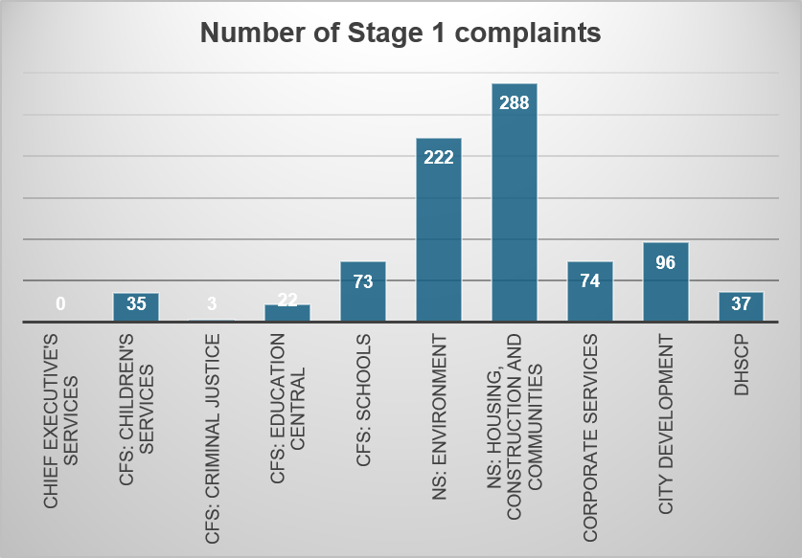

Stage 2 (Investigation) Complaints
In 2025/26 191 complaints were closed at Stage 2. 81 of those were opened at Stage 2, and 110 were escalated from previously being considered at Stage 1. The diagram below shows that Neighbourhood Services – Housing, Construction and Communities had the highest number of Stage 2 complaints (46), followed by Dundee Health and Social Care Partnership with 39 Stage 2 complaints.

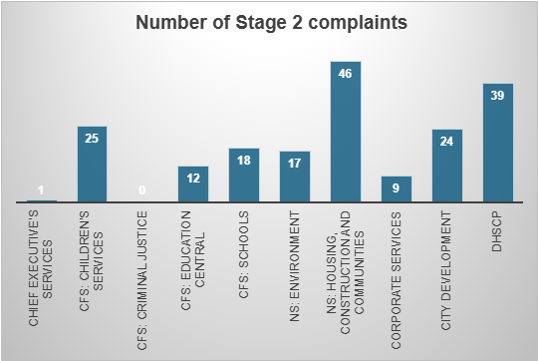
3.3 Stage 1 complaints closed within the target of 5 working days

3.4 Average number of days taken to close Stage 1 complaints.

3.5 Stage 2 complaints closed within the target of 20 working days

3.6 Average number of days to close Stage 2 complaints

3.7 Outcomes of complaints closed.
Stage 1 Complaints
The majority of Stage 1 complaints were either upheld (27.4%) or partially upheld (19.3%). 40.2% of complaints were not upheld, and 13.1% of complaints were “resolved”, where a resolution was agreed with the complainant, without a decision being made whether to uphold the complaint or not.

Stage 1 outcomes for Dundee City Council in year 2025/26 compared to benchmark of the Scottish average and our Family Group average for year 2024/25 is provided in the table below. Benchmarking complaints data for 2025/26 is not yet available.
Outcome | Dundee 2024/25 | Dundee 2025/26 | Family Group 2024/25 | Scottish Average 2024/25
Upheld | 28.2% | 27.4% | 36% | 40%
Not Upheld | 43.5% | 40.2% | 30% | 30.1%
Partially Upheld | 17% | 19.3% | 20.9% | 15.3%
Resolved | 11.2% | 13.1% | 13.2% | 13.9%

Stage 2 Complaints
The majority of Stage 2 complaints were either upheld (22.5%) or partially upheld (25.7%). 46.1% of complaints were not upheld and the “resolved” outcome was used in only 5.8% of cases.

Stage 2 outcomes for Dundee City Council in year 2025/26 compared to benchmark of the Scottish average and our Family Group average for year 2024/25 is provided in the table below.
Outcome | Dundee 2024/25 | Dundee 2025/26 | Family Group 2024/25 | Scottish Average 2024/25
Upheld | 18.4% | 22.5% | 15.6% | 23.2%
Not Upheld | 55.1% | 46.1% | 45.1% | 47.9%
Partially Upheld | 22.4% | 22.6% | 25% | 22.1%
Resolved | 4.1% | 5.8% | 12.9% | 6.5%

4. COMPLEX COMPLAINTS
While the target in the complaints handling procedure for dealing with complaints at Stage 2 is 20 days, this can be extended without any limit, as it is acknowledged by the Ombudsman that many complaints at this stage will be more complex and take longer to investigate. Data for the last 6 years on the number of cases closed in each time period is shown in the table below:

Year | 20 days or less | 21-39 days | 40-99 days | 100 days +
2025/2026 | 49 | 64 | 49 | 5
2024/2025 | 74 | 30 | 14 | 1
2023/2024 | 75 | 36 | 19 | 2
2022/2023 | 85 | 40 | 10 | 1
2021/2022 | 91 | 29 | 11 | 1
2020/2021 | 60 | 11 | 13 | 3

- STATISTICS FROM THE SCOTTISH PUBLIC SERVICES OMBUDSMAN FOR 2024/25
39 complaints were received by the Ombudsman about Dundee City Council in 2025/26, compared to 35 in 2024/25, representing a 11.4% increase. This rate of increase in number of cases received by the SPSO is similar compared to previous year.
The list of subjects of complaints received is summarised in the table below:
Subject of complaint: | No of cases:
Education | 2
Environmental Health & Cleansing | 1
Finance | 1
Housing | 18
Land and Property | 1
Legal and Admin | 2
Roads & Transport | 4
Social Work | 8
Subject Unknown (or outside of Jurisdiction) | 1
Welfare Fund - Community Care Grants | 1
Total | 39

The Ombudsman determined a total of 38 Dundee City Council’s cases in 2025/26. None of the cases were taken forward by the SPSO for a full investigation. Only complaints which reach the Investigation stage can be determined as upheld, partially upheld, resolved or not upheld.
SPSO determination stage reached: | No of cases:
Assessment and Guidance | 16
Triage and Early Decision | 3
Preliminary Investigation | 19
Investigation | 0
Total | 38

6. SATISFACTION WITH COMPLAINTS HANDLING – QUARTERLY SURVEYS
The model Complaints Handling Procedure requires the Council to report on a measure of customer satisfaction with its complaints process. To do this, quarterly surveys are issued to people who have made complaints. The survey agreed by the Scottish Local Authorities Complaint Handlers Network is issued to complaints by email. Since the survey sample consists entirely of people who have made a complaint, many of which are not upheld, it may not be surprising that satisfaction levels are not particularly high.
The response rates to our survey are low, with return rate ranging between 19% and 30%. Caution must be exercised due to the small sample who return the survey and the fact that those who remain unhappy may be more motivated to do so.
Question 1: Please indicate the extent to which you agree or disagree with the statements below:

Question 2: I was told if the response was going to take longer than the set timescales
(5 working days at Stage 1 and 20 working days at Stage 2)

Question 3: What service was your complaint about?

Question 4: Overall, how satisfied or dissatisfied are you with the outcome of your complaint?

7. LEARNING FROM COMPLAINTS
When a complaint is upheld or partially upheld Investigating Officers are asked to identify the root cause of the complaint and planned service improvements, designed to prevent similar issues from recurring.
Planned Service Improvements can involve speaking to individual employees, arranging training for teams on correct use of procedures and customer care standards, or using the complaint as a 'case study' in team discussions.
However, complaints are used to identify wider process/service improvements and below are some examples of how that was done during 2025/26.

Customer complained that... | We listened; we acted...
A parent’s school placing request for their child who suffers from mental health difficulties was delayed, causing distress. | Placing request process at Greenfield Academy has now been reviewed and improved. The school was in its first two weeks of existence and was managing a major transition and induction process. The pupil is now enrolled.
A tenant complained that a plasterboard repair job was put on hold half-way through and left unfinished for 3 weeks. | A subsequent repair inspection was carried out and further repair ordered.
Glass recycling container was full, with glass waste overflowing onto pavement due to collections being too infrequent. | The waste department will monitor the area for additional collections needed and arrange for signage with contact details to alert the department when additional collection is needed.
A tenant requested that a housing repairs visit takes place on a specific date. Due to lack of available staff, a visit was carried out on a different date when she was not at the property. | Housing repairs team will ensure that tenants will receive a phone call if staff unable to attend at the requested date.
A customer made an enquiry regarding an HMO property, and it was not responded to. | The team responsible will improve note keeping ensuring all enquiries are answered in a timely manner.
School did not adhere to the complaints timescales for responding to a Stage 1 complaint. | School staff undertook additional training on Handling Complaints.
Numerous bins collections were missed around the same area. | Waste team to review workload and make necessary changes to ensure collections are timely and regular.
A resident complained that position of a bus stop is causing issues accessing it. | Arrangements are being made for the bus stop to be moved.
A tenant received a demand for payment letter for two months' rent as his direct debit failed to be collected by Dundee City Council. | Rent recovery team will carry out a full review of the rent direct debit process.
Communal waste bins have not been emptied 11 out of 32 weeks. | Some of the collections were made impossible due to cars parked on the side, blocking access to the bins. The team have arranged for the lowering of the kerb and the addition of a painted pathway, which would allow for bins to be moved safely to the collection vehicle.
The Environmental Health team visited the wrong property during an investigation into noise nuisance, while there was no response to a calling card left at the source property and this was not followed up upon by the team. | The Environmental Health team has now agreed that if it is not clear to the officers as to which property is responsible at the time of their visit, they should continue to visit any property that has not responded to a calling card. Only after all persons / properties that are potentially the source of the noise have been contacted, and the source has been clearly identified would other properties no longer be pursued.

A complainant appealed a LEZ penalty charge notice, and their appeal was rejected. The system allowed further appeals to be logged and acknowledged for the same PCN, giving the incorrect impression that further appeals were possible, leading to confusion over the LEZ appeal process. | The council will investigate and address the LEZ appeal system loophole.
A customer fell into arrears with his community alarm invoice payments, but he had not realised this, as debt was not timely chased, allowing for the instalments to accumulate. | New recovery process will be put in place whereby debt will be highlighted and chased more frequently.
A parent applied for a nursery funded place for their child but were declined a place due to not being in the nursery’s catchment area. The parent felt the guidance around nursery place allocations and catchment areas was insufficient, misleading and contradictory. | The Council will review the current Admission Guidance to ensure it provides clear, transparent and easily understood information on how local areas are used when allocating nursery places. The Council will provide additional guidance and training to staff to ensure that only accurate, relevant and appropriate information is shared with parents during discussions about nursery placements and related processes.

8. COMPLIMENTS
In addition to complaints, the Council also receives many compliments from members of the public, who are satisfied with the service provided. Below are examples of compliments received between October 2025 and March 2026 from customers, either directly to the service concerned, or via the “Tell Us About Good Service” online form on the Council's website.
“I just wanted to recognise great service from the crew on the garden waste collection. I had forgotten to put the bin out (again) and the guys obviously spotted me running to the garden and wated until I had checked how full the bin was before heading off. I did not ask them to do this and wanted to thank them for holding off. Thankfully the bin was not full.”

“Last week, a pest control officer came to our home but forgot to leave a card to say he had visited. Because of this, I contacted you to ask the status of visits. This email is to confirm he had in fact visited, but the trace of bait was out of sight. That was my error. I am thankful to the officers who come out and think praise is due. I would recommend this Council service if asked. Thank you for your help.”

“Would like to thank the street cleaners for their help this morning, neighbour had bad fall and could not get up, one of the street cleaners came over to help as I was unable to get the man up; he called his colleague for assistance and they both managed to get him up, thank you.”

“Thank you for eventually removing these abandoned caravans. They, and the advertising trailers, are an eyesore for residents and visitors coming into Dundee. I would hope that this does not occur again and has to be reported by a member of the public to get action.”

“Missed brown bin collection now rectified - Contacting to express my gratitude for the quick response. Many thanks!”

“Thanks for sending roofers to check water on the shared landing. They were very professional. They were also very understanding when I was upset. Fine gentleman.”

“Missed bin now collected. Many thanks for organising this and also for the way your member of staff handled the initial query. Gold stars al around! Good job!”

“I just want to thank the Council for their understanding and sensible approach to the issue of parking around the high school of Dundee at collection time. As a family of 2 working parents, it is one less stressor to know we can park without concern of penalty for the brief period needed to collect our children. The news of Bell Street reopening with similar plan of limited free parking is also very welcome. Many thanks”

“Good afternoon, I would just like to say what an absolutely awesome job the painter did on my hallway landing and bedroom wall. It was very badly affected by mould due to my flat roof needing replaced, his hard work, advice and friendly nature were very much appreciated. Many thanks.”

Email sent to Customer Services: “I would also like to thank your colleague, who was very conscientious and called me back when the call got cut off and followed up first thing the following Monday. I very much appreciate his exemplary service."

Email to Customer Services adviser: “I just wanted to formally record my thanks to you and the team for the speed, courtesy and kindness in your help with sorting out an additional bin for my mum. It was there when I visited this weekend and I am incredibly grateful for your help. You were brilliant, thank you.”

An email to Customer Services received from a complainant who received assistance from an adviser: "Thankfully I had a really nice lady today and I would like to say she’s an asset to the council; she really helped me today and kept me calm during my frustration.”

An email regarding a NEC replacement card: “Thank you so much for the email and the Customer Service telephone number. All dealt with, evidence uploaded and new card ordered within a few minutes. First class service a male adviser and yourself. He said he’d put me through to a survey about the experience but unfortunately, the line was cut off, so no feedback given. However, I am more than happy for my feedback to be passed on to him.”

A thank you email to Customer Services: “Just to let you know that mums bin was emptied yesterday, thank you so much for all your help, it’s much appreciated and very kind of you.”

NEC replacement card: “Just to let you know, the customer phoned in simply to say thank you, as she has just received her replacement card.”

A customer got in touch to send a “thank you” to a male gardener who went over and above that morning cutting her grass. She appreciates everything the gardeners do and wanted to pass this on.

Email from a social worker based at the Ninewells Hospital discharge team: “Just wanted to drop a note and say how much we appreciated today and the time you gave us, the home you have created for residents is exceptional.”

An email to all the staff at Menzieshill House: “Just want to say a HUGE 'thank you' to all your wonderful people for all the love, care and compassion given to my mum over the past three years and especially during the last week before she passed. There are care homes and care homes and then there is Menzieshill House! My mum was happy and enjoyed all of your lovely activities. A big thank you too to the wonderful catering staff who made meals and baked snacks for my sister and I while we sat by mum's bed during her final days. How very kind of them and much appreciated by us! Keep doing what you're doing. You are one of a kind!”

“I can’t thank you enough, for all your help and support over the past FEW years! You have helped us cope with looking after my Mum at home, as well as supporting us with her care in the nursing home. We could not have possibly had a better person than you to help us. You have quite simply been fantastic, and we couldn't have managed as long as we did, without you. Please tell your bosses they need to give you a wage rise at least!!! You have earned every penny of it, and then some. We will be forever grateful for what you have done. Once again, thank you very much!”

“I just wanted to send a quick email to thank you for allocating the X’s case for assessment and review. We had a very positive meeting yesterday and I have also emailed your colleague to thank him for his understanding and compassion. He listened to our views and concerns and demonstrated genuine empathy which was so very reassuring for us after such a stressful time. I know how stretched and demanding your jobs are at times but think it's really important to recognise when things are handled sensitively and positively as in our situation.
X has settled so well in Harestane which is down to the approach of the staff team, they have been such a great support. Although we see a marked decline in their cognitive ability, we know that they are safe and being very well cared for.”

Email to DHSCP care manager: “Thank you for your kind words and thank you for your help and support, you made a difficult time a lot easier.”

Email sent to the Connect team: “I had a bout of ill health last month that slowed things down for me. However, the difference your efforts made in mine and my parents' households has been immense and this isn't an exaggeration. There was always a sense of anxiety and frustration about how to make ends meet and we just didn't realise how much of a toll this took on our mental health until that worry was no longer there. Everyone is less stressed and things just feel lighter in these last couple of months. So, we wanted you to know how much your help has made a difference to us and just how much we appreciate it. Many thanks and hope you have a wonderful holiday season.”

Email to Council Advice Services Manager: “We me with your female worker now on three occasions and I can't tell you what an asset this young lady is to your team. From our first meeting she was professional, compassionate and displays a non-judgemental approach when dealing with us. She has gone way over and above to help resolve issues around benefits etc. Hence my main reason for emailing you. If this is this culture within your team you should be very proud.”

From a “Thank You” cards to Council Advice Services:
“Whatever the outcome today, I cannot thank you enough for what you have done for me, it is very much appreciated”
“I am sending this card to let you know that your adviser has been a great help and support with all my struggles. She is easy to talk to, cheerful and has a fab sense of humour. I have never been nervous approaching her and that makes a huge difference to me.”
*Thank you for everything you have done for me.”
“With my very grateful thanks for all your help.”

I recently opened an enquiry, the matter has been resolved within a few hours, and the correspondent was great at explaining what happened and what steps they've taken to resolve it. I appreciate it moving quickly and being properly listened to.

The Bin collectors in Lawside road were carrying out their work with a spring in their step. They looked as if they were enjoying their work- it really lifted my spirits to see them.

I phoned about renewing my Dad’s blue badge last Wednesday. The lady I spoke to was really helpful - I’m afraid I didn’t take her name. I followed her instructions and applied for the renewal on Sunday, and the application was processed by lunchtime today. I’d like to say thanks for such a great service. My Dad would be lost without his blue badge, and we’d find it much harder to get him out - which is important for his mental and physical health.

Well done to the team who look after the woodland at Camperdown Park. It is an absolute delight to walk around the well-maintained paths and woodland. Today the snowdrops were looking so beautiful.

G. kept me informed and her colleague P. was also helpful when I phoned back. Today BT have contractors mending the drain cover and road. Hopefully this fixes the issue. Thanks again.

We recently asked for a bathroom repair, which turned out to be more complicated than expected. However, you sent G. the carpenter, K. the floor covering expert and M. the plumber. Their professionalism, tidiness and enthusiasm for their work have certainly been reflected in a now excellent bathroom. Please pass on our compliments to all three for a great job well done.

Thank you for repairing the water leak on Macalpine Road very quickly.

Thank you very much for your very quick response in repairing the craters on Harrison Avenue and there were many. It is refreshing to know that Dundee Council respond quickly to road conditions. You did the same quick response in repairing the water leak on Macalpine Road opposite the Crematorium. Well done.

I know DCC get a lot of flack but I had two young painters, decorators in, they did great job, lovely boys, helpful, nice. Credit to DCC, so just to let you know.

Hi I'm a resident of Fintry. I just wanted to email and say that I have noticed a great difference in Fintry area with our new litter picker who goes around picking up off the streets. It makes such a difference to the area, especially after bin collections. He's doing a great job! Always smiling and friendly as well. I hope he continues to work in the community, I know he is highly liked and appreciated.

For the past 16 years my family and I have been DCC tenants. I would like to take this opportunity to express my sincere and heartfelt appreciation for the outstanding support we have received from our caretaker, during our time here. A. has always kept the building clean, well maintained, and running smoothly while dealing with numerous day-to-day issues, as you might imagine. There was never a dull moment in the multis, yet he consistently showed a positive and caring attitude towards everyone. He regularly asked how our children were doing and always made tenants feel welcome and supported.

During our heating emergency just before Christmas, A. was incredibly supportive. He provided us with fans and regularly checked in on us to make sure our family stayed warm when outside temperatures were below zero. His kindness, quick action, and genuine concern made a very difficult situation much easier for us at a particularly stressful time of year. His thoughtfulness was also evident shortly before we moved out, when—due to a misunderstanding—Dundee City Council sent a joiner to change our locks while we were still tenants. A. took the keys from the joiner and personally gave them to me, sparing us a trip to collect them from the council offices. He was aware that I had broken my leg and had reduced mobility, and his help meant more to us than he probably realised. When we then discovered that our key fobs were no longer working, A. again stepped in and helped us obtain new ones within 24 hours.

A. has always been helpful, polite, and approachable—nothing was ever too much trouble for him. He is a genuinely caring person, and you should be very proud to have someone like him on your team. He made a massive difference in our lives while we were tenants. His dedication, compassion, and tireless hard work created a positive and supportive environment for our family, and we will always be deeply grateful for everything he has done for us. I hope you are able to pass this message on to A, with a very big thank you from our family. It truly meant more to us than words can express.

I just wanted to get in touch to say what a fantastic job our local street sweeper is doing. He is very friendly, really personable, always has a cheery word for folk, is out there in all weathers and is hard working. I have lived in Fintry for a long time and have never seen the area looking so good! He must be a huge asset to your team and is a wonderful advert for the Council. Thank you so much.

Just wondered if you could pass on my thanks to the DCC guys who were there at a family interment yesterday morning at Balgay Cemetery. They were so respectful and helpful at the burial, and it was commented on by others attending. I'd be grateful if you could pass on our appreciation possibly via a supervisor. Many thanks.

A message received for an employee from the Waste Management Service: Thank you A five-star service.

A message to Customer Services employee: Hi, Thank you so much for your efficient support! I was delighted to receive the bus card yesterday! Even though the scheme and my new bus card will only be valid for one week, I am thrilled to have it and could not wait to share the good news with you and E! This could not have happened so quickly with the kindness and support from both of you, and I am truly grateful! Your help has made such a meaningful difference.

APPENDIX 2

EXAMPLES OF THE VOLUME OF TRANSACTIONS THE COUNCIL DEALT WITH IN 2025/26
