Dundee Housing Allocations
Policy Review

Frequently Asked Questions

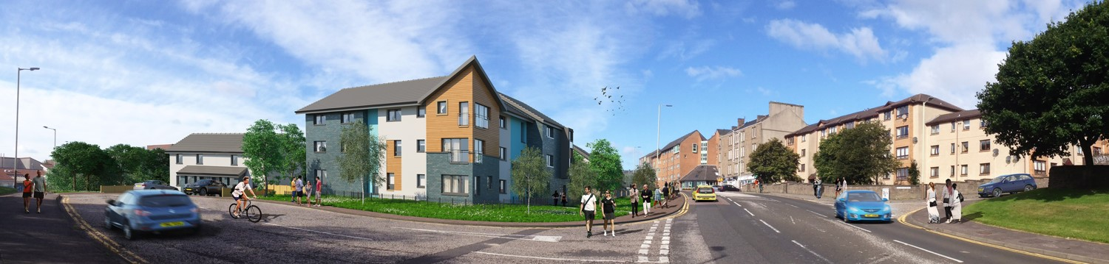

Please find below some Frequently Asked Questions which will hopefully answer some of the main points for reviewing the Housing Allocations Policy.

Q. Why review the allocations policy now?
- It was last reviewed in 2016
- There has been guidance and legislative changes between 2016 – 2019

Q. What are the Aims of the Policy?
- To accurately assess housing need
- To let houses to people with the greatest need, whose household fits each empty property best

Q. Housing needs can include the following:
- Homelessness
- Living in Poor Housing Conditions
- Overcrowding
- Living in house/area which causing them stress
- Medical reason
- Under occupation in a social rented house
- Redevelopment
- Wants own tenancy
- Insecure accommodation

Q. Who can Apply?
- Anyone aged 16 or over can apply for mainstream housing
- Anyone aged 50+ can apply for amenity housing (requires the Medical Advisory Service assessment for those under 50)
- Anyone aged 60+ can apply for sheltered housing (requires the Medical Advisory Service assessment for those under 60)

Q. How is an application assessed?
- There are different groups and points system to assess an application
- Acknowledgment letter sent out to applicant advising on waiting list within 10 days of receiving form
- Applicant can make changes to their application at any time

Q. How are points currently awarded?
- Homeless Group 70 points
  - Can only have medical points added to application
- Below Tolerable Standard 70 points
- Overcrowding- Can only be awarded to Council, Housing Association and Private Tenants
  - Require 1 additional bedroom 40 points
  - Require 2 or more additional bedrooms 70 points
- Under Occupation- Can only be awarded to Council and Housing Association Tenants
  - Under Occupied by 1 bedroom 40 points
  - Under Occupied by 2 bedrooms or more 70 points
- Medical Award
  - High Priority 70 points
  - Medium Priority 40 points
  - Low Priority 20 points
- Social Need - Evidence required 40 points
- Insecure Accommodation 20 points
- Wants own Tenancy 10 points
- Redevelopment 70 points

Q. What are the main changes?
- New award of higher Social Needs points for Domestic; Racial Abuse and
severe cases of harassment
  - Definition of severe harassment: Incidents involving violence, fire raising, vandalism and threating behaviour
- Introduce a 2-offer rule for all applicants including homeless
Suspensions – Housing (Scotland) 2014 Act
- Introduction of suspensions for rehousing applications on the waiting list
- Introduce new suspensions for breaches of tenancy, abandonments and evictions including housing support referrals and case management
- Suggested periods of suspensions, including housing support referrals and case management
- Coordinate support and monitor any suspended cases with a view to un-suspend at the earliest opportunity

These proposed changes ensure the Policy:-
- Is compliant with current legislation and good practice; i.e. Suspensions and Adapted Housing
- Targets those in urgent needs of housing in a fair and more consistent way avoiding the need for them to apply as homeless or leaving them in an at-risk situation; i.e. Social Needs Points
- Provides a policy which is easier to understand ensuring fair and transparent access.
- Putting in place and embed a policy to support residents who are affected by domestic abuse. (“Make a stand pledge”)
- Scottish Housing Regulator compliant

Q. What is the period of Consultation?
- Starts in November 2022 and concludes in December 2022

Q. Who are we consulting with?
- Councillors/Elected Members
- Housing Best Value Group and Dundee Federation Tenants Association
- Registered Social Landlords - Tenants Organisations including their Boards
- Staff and other Dundee City Council Services
- Tenants, Resident Tenant Organisations, Local Community Partnerships and other applicants (Survey Monkey)
- NHS, The Medical Advisory Service, Equal opportunities, SHELTER, Dundee Law Centre, MARAC

Q. When will it be implemented?
- Following a comprehensive consultation
- Approved by Common Housing Register Partners
- Approved by Committee and Common Housing Register Boards
- Implementation will follow the approval process

Additional Information:
Please visit www.dundeecity.gov.uk, searching for ‘Housing Allocations Policy Review 2022’, for links to all supporting documentation, proposed changes to the policy, and instruction on how you can take part in the survey.

Should you require supply of a hard copy, different format of any documents, or provide a return response, please contact Mark Cooper at mark.cooper@dundeecity.gov.uk.

Alternatively, you can contact your Registered Social Landlord, Dundee Federation of Tenant Association or Dundee city Councils Housing Service directly.

