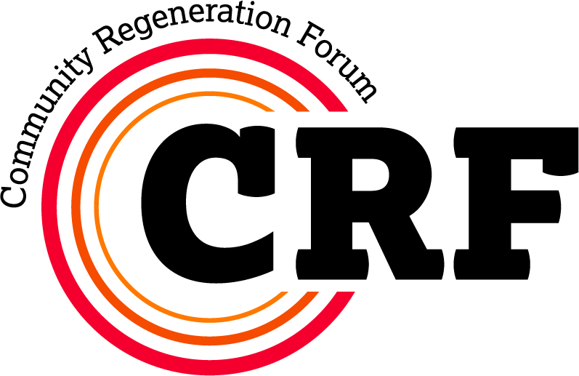

For official use only:
Ref:

Logged □
Scanned □
Input □

Dundee Partnership
Community Regeneration Fund

Grant Application (Ferry / West End)
2019/2020

Applicant Information

Name of Group
Activity Title
Grant Requested (£)
The Local Community Planning Partnerships (LCPPs) in the Ferry and West End will examine their existing Local Community Plans to identify outstanding actions with a direct relationship to community regeneration and consider allocation of some or all of their available funding to commissioning works that would allow achievement of these agreed priorities. Each area has a total allocation of £20,000 for 2019-20 with which to commission activities, and so activities that attract external funding may be prioritised.

TICK THE WARD WHERE YOUR PROJECT WILL OPERATE
The Ferry □
West End □

Checklist for the DP Commissioning Form

Before submitting your application form to the Dundee Partnership Team, please use the below checklist to ensure that your form is as fully completed as possible. Please also note that submitting an incomplete form can cause delays in processing or rejection of your application.

Data Privacy Notice
We will be collecting data for the purpose of allowing us to process applications to the Dundee Partnership Community Regeneration Fund. Please see the full privacy notice for further information at:
www.dundeecity.gov.uk/sites/default/files/publications/dp_privacy_statement_for_applicants.pdf

Agreement:
I have read and understood the privacy notice, and give permission for my data to be used for the purpose stated (note that without this permission we will be unable to process the application)
Please tick here if you agree

Have you:

Read the guidance sections of the form
Fully completed the information on the front of the form
Provided a response to all sections of the application form
(including indicating a section as ‘N/A’ where relevant)
Checked that your budget adds up properly?
Checked that your start date is after the date at which funds could be available
(see page 7) and that your end date is within the financial year?
Included appropriate, measurable outputs & outcomes?
Provided your groups accounts, where applicable?
Sourced and attached relevant quotes?
Checked that the bank details or financial code are correct / complete?
Signed the form and given accurate contact details?

Who is the grant for?
(Name of Group / Department)
Did you receive a Dundee Partnership grant during 2018-19?  (If yes, list all grants below) |  |  |  | YES / NO
Title of project funded |  | Amount granted | When | Was it fully spent?

Please give a description of what you want this grant for - (Use additional sheet if required)

Which City Plan / Local Community Plan Outcome(s) will it address?

How many people will benefit from this project? |  | MALE |  | FEMALE
 | WHOLE COMMUNITY (tick if applicable)

Please say why the project is needed (Use additional sheet / expand this text box if required)

How will the project / activity tackle deprivation or benefit those experiencing deprivation?

For Physical & Environmental Improvements the following questions must be answered:

Have all relevant permissions been agreed? (please state what these are)

How will the planned project be maintained? (please state who will be responsible for this)

What is the expected 'life' of the improvement? (e.g. before it will require replacement)

Could a plaque indicating the Community Regeneration Fund as a source be added on location for this award? (If there would be additional costs for this, please indicate this in the budget section)

How do you intend to monitor the project Outputs and Outcomes?

What other sources of funding can you bring to this activity? (Detail below, including applications that are pending)

Source of Funding (detail if this funding is for more than 1 year, if applicable) | £

What are the costs of your activity and how much money is required? Please give specific details (expand list / use an additional sheet if required) and provide all quotes (good practice for applications for over £5,000 is to provide three quotes to ensure value for money is received).

Cost Heading | Full Costs  (£) | DP Aid  (£)
Totals

What other documents are you attaching to evidence the budget costs for this application? (e.g. quotes, estimates, projected income and expenditure)

What is the planned start date of the event/activity?
Please note turn around on applications is 6 - 10 weeks and funding cannot be retrospective (see section 2 of the guidance notes)
What is the planned end date of the event/activity?

Outputs & Outcomes

It is expected that evidence will be available to support performance information when completing returns on the performance against targets. Consideration of this should be given when outputs and outcomes are set out.

Grants will usually impact on one Strategic Outcome, but the table below can be replicated if required. Please refer to section 3 of the Guidance Notes for examples of outputs and outcomes / indicators.

City Plan / Local Community Plan Outcome:

Purpose of activity / project within this Outcome:

Target 2019-20
Outputs
Outcomes / Indicators:

Name (please print)
Position in Organisation
Address
Date
Telephone Number
Email Address
Note: all paperwork relating to this application will be sent electronically to this email address. If you would prefer paper copies, please check here: □
Payment Details
(bank account and sort code or internal transfer code)

Important Note: By signing this form below you are agreeing to our use of your personal data as specified on Page 2. Without this permission we will not be able to process your application.

Signature of Applicant →
(responsible for completing financial and activity reports)

Completed applications should be sent to the Dundee Partnership Team,
Floor 3, 8 City Square, Dundee, DD1 3BG
or emailed to alix.finlayson@dundeecity.gov.uk
If delivering in person they should be handed to Reception, 20 City Square, Dundee, DD1 3BS.

Please also return a copy of the completed form to the relevant Communities Officer
The Ferry: Natalie Mackland, Grove Centenary Wing, Broughty Ferry
West End: Vanessa Kelly, Mitchell Street Centre, Mitchell Street, Dundee

GUIDANCE NOTES

Section 1 - Criteria & Requirements

If you require assistance in completing this form, please contact the relevant Communities Officer.

CRITERIA
- Applications will be identified by the Local Community Planning Partnership (LCPP) for either The Ferry or West End Ward and the above details will then be completed by the agency / department identified to carry out the activity
- Applicants must highlight the relevant Outcome(s) relating to their application from the City Plan or Local Community Plan (see section 3 below) and explain how their application will assist in closing the gap for the most disadvantaged people and children
- It is expected that applicants will explain how the application may assist in delivering on actions in the relevant Local Community Plan (available at www.dundeecity.gov.uk under Community Planning or from local Communities Officers)
- LCPPs will be expected to demonstrate that they are supporting the Dundee Partnership's commitment to tackling deprivation by 'closing the gap' between the best and worst off in Dundee. For further information please refer to ‘For Fairness in Dundee’ (copies available from local Community Workers)

REQUIREMENTS
- All applicants must compare their reserves and their annual expenditure. If reserves are more than a quarter of annual expenditure then annual accounts must be submitted to the Dundee Partnership Team with their application. These must clearly show what funds are available to the applicant i.e. the level of reserves held, and the overall annual expenditure of the applicant
- Estimates / Quotations for expenditure are necessary in all cases and detailed quotes are required where expenditure is greater than £5,000 to demonstrate value for money. Good practice would be to secure three competitive quotes for larger items of spend
- All applications for Physical or Environmental Improvements must state how maintenance will be carried out
- All agreed funding must be spent by 31st March 2020. Unspent funds will be reclaimed

Section 2 - Process

- It should be noted by applicants that the below process will take between 6 to 10 weeks. Payments cannot be made retrospectively and so applicants must ensure that they apply in sufficient time to receive any funding before expenditure on their planned activity starts
- Applicants identified by the LCPP are to complete the commissioning form, inclusive of financial and any other evidence required and provide to the Dundee Partnership Team and relevant Communities Officer (see below). Forms must be fully completed, signed and include all relevant bank details or code transfer information
- Completed commissioning forms, with all necessary supporting evidence, are to be submitted as early as possible to enable the LCPP Chair and local Communities Officer to consider the content and agree that it is to proceed
- Communities Officers may contact applicants with for clarifications or any required amendments to their submission prior to any recommendation for funding
- The application will then be submitted to the Building Stronger Communities group for ratification.
- Applicants will be informed of the final decision on their application after the relevant meeting of the Building Stronger Communities Group

2019 Submission Deadline | Building Stronger Communities
21st January | 21st February*
25th February | 21st March*
25th March | 18th April
29th April | 23rd May
27th May | 20th June
24th June | 18th July
29th July | 22nd August
26th August | 19th September
30th September | 24th October
28th October | 21st November
18th November | 12th December

* Note that funds for 2019-20 activities will not be released until after the 2nd April

- Successful applicants will be required to sign an acceptance agreeing to the terms and conditions. Completed acceptances are required by the Dundee Partnership Team before money is released for successful applicants
- Providing monitoring returns on performance and financial expenditure are part of the terms and conditions relating to an award. These forms will be provided by the Dundee Partnership Team to successful applicants. Failure to provide these reports will result in any further applications being rejected until such time as satisfactory reports have been received. In addition where a grant awarded to a non-DCC provider is over £5,000, annual accounts must be submitted with the above reports
- If your award is for year round activity (April to March), an interim report on performance and financial expenditure must be submitted by the 30th November. Failure to submit this will also result in any further applications being rejected until such time as satisfactory reports have been received

Section 3 - Outputs & Outcomes

Applicants should select the appropriate Dundee City Plan Outcome or Local Community Plan Outcome to which their application relates most closely and within which their outputs and outcomes can be recorded. (Both plans are available at www.dundeecity.gov.uk).

ACTIVITY OUTPUTS & OUTCOMES

Outputs
These are details of activities (i.e. what you will do) and will have numeric targets such as:
- Hold a community event for 400 people. Target = 400 people
- Hold 10 daytime activity sessions over a 10 week period. Target = 10 sessions (you would also be likely to include an output and target for the numbers attending each session)
- 8 hours of street work by two workers per week over 50 weeks. Target = 400hrs
- Satisfactory installation of 20 security doors and buzzer systems. Target = 20
Please only include outputs that are key to the activity/project. If you are unclear about what you should include, contact your local Communities Officer in the first instance.

Outcomes / Indicators

These are measures to show the impact of the activity/project (i.e. what difference you will make). There does not have to be a set target, but a numeric response should be possible at the end of the activity

Whilst setting out the outcomes / indicators, applicants need to be sure that these will be measurable from their recorded data (or other data that they are able to access) for their own benefit, that of the LCPP and of the Dundee Partnership. If you are unclear about what you should include, contact your local Communities Officer in the first instance.
- Number of participants reporting an increased knowledge of the benefits of exercise (could be recorded on feedback forms)
- Young people will better understand the dangers of substance misuse (again a feedback form could be used)
- There is a reduced level of reported anti-social behaviour and criminal activity (information from the police could be used)
- Local residents report being happier with their local area (this could be based on information from annual DCC questionnaires or other, more specific, feedback gained at e.g. community events)

COMMUNITIES OFFICERS

Each of the Wards listed below has a Communities Officer with a specific responsibility for supporting the activity of the Local Community Planning Partnership, including providing support to potential applicants. The contact details for these officers are given below.

The Ferry: Natalie Mackland 436796 natalie.mackland@dundeecity.gov.uk
West End: Vanessa Kelly 435873 vanessa.kelly@dundeecity.gov.uk

