

Ref No.

Application for
Repair/Improvement Grant Assistance For Owner Occupier

Please read the Guidance Notes included at the start of this form before filling it in.
Please return the completed form and estimates to:

Private Sector Services Unit
Dundee House
50 North Lindsay Street
DUNDEE DD1 1NB

For further information, please telephone:

01382 436880

or email: private.sector@dundeecity.gov.uk
Website: http://www.dundeecity.gov.uk/housing/privatesector/

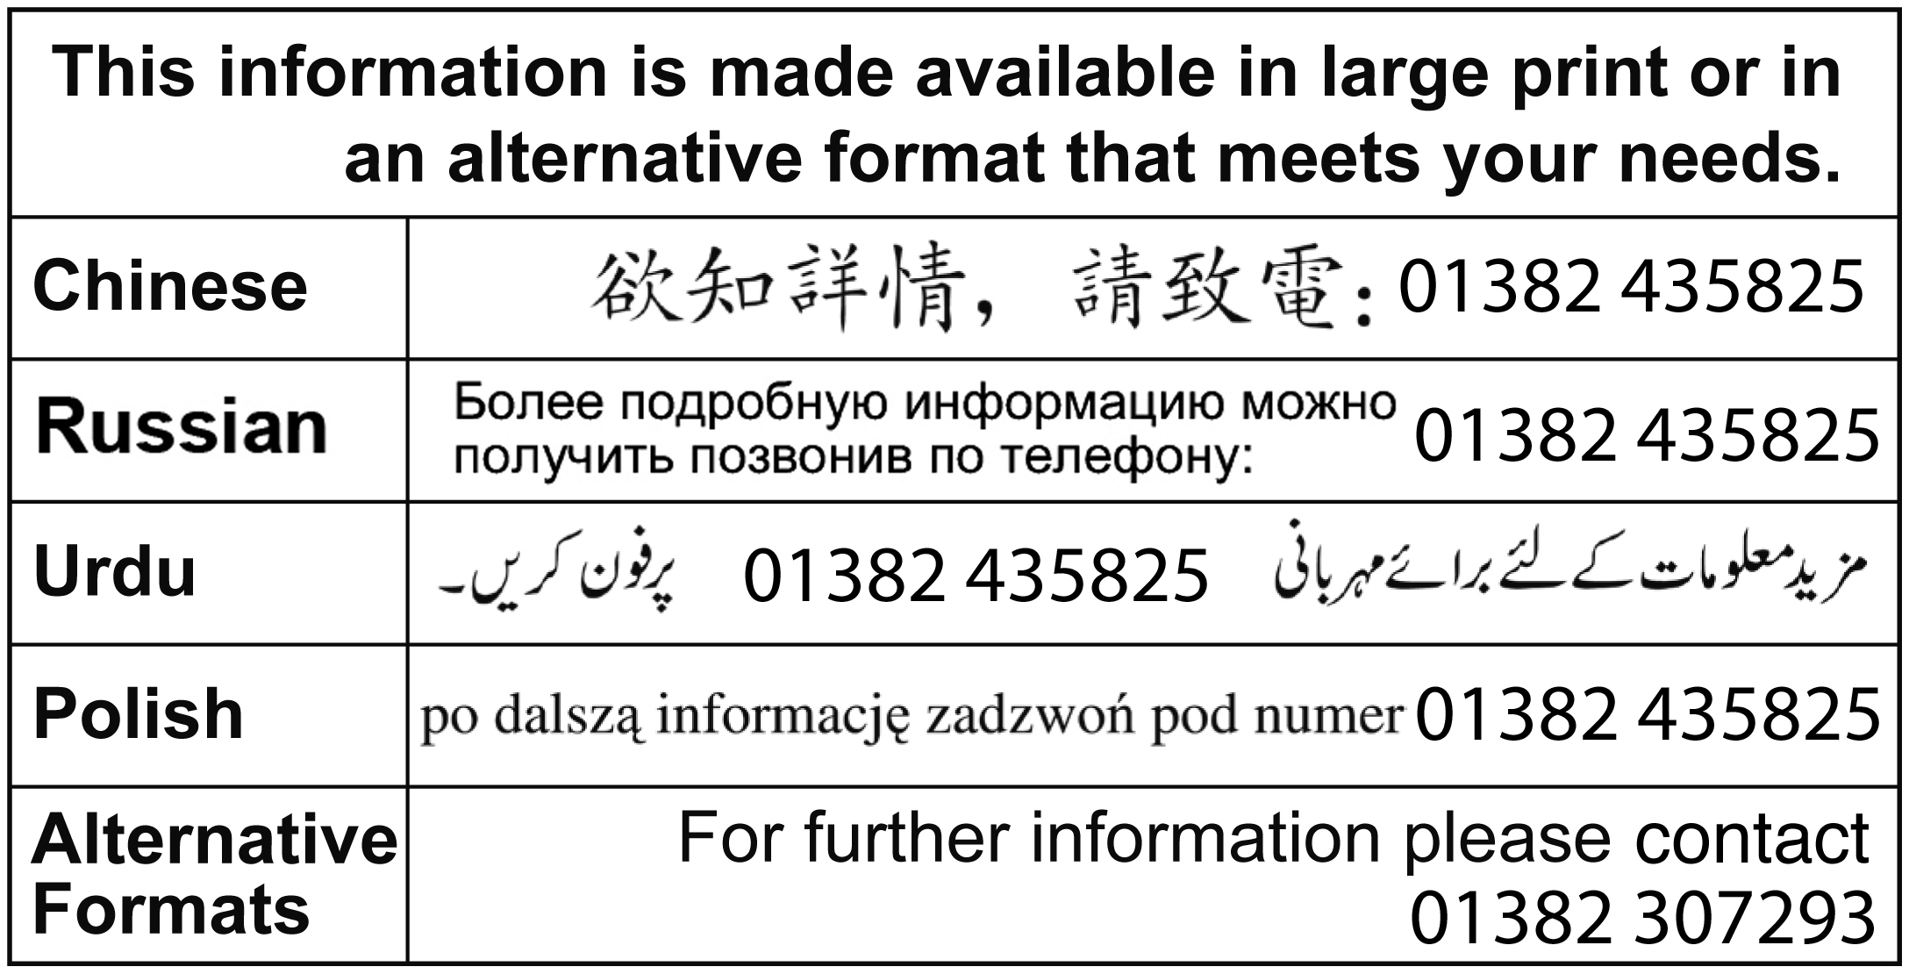

Guidance Notes

Subject to the availability of funds and the applicant's financial circumstances, discretionary grant assistance is currently available towards the following categories of work at the percentage grants indicated:

          - Below Tolerable Standard (BTS) Housing 40%
          - Lead water supply pipes 40%
          - Serious disrepair 40%
          - Common Repairs
            - Owner occupier 40%
            - Non professional landlord 40%
            - Professional landlord 25%
            - Commercial Premises 25%
            - Common door entry systems (fixed sum) up to £250 per flat
            - Common stair lighting (fixed sum) up to £100 per flat

The Council reserves the right to exercise its discretion to consider works out with the above categories for grant assistance where there are considered to be exceptional circumstances.
The approved cost of works to which the relevant grant percentage will be applied will be based on the balance of the cost of the proposed work after any owner's contribution from personal savings has been taken into account.
The maximum approved cost of works for grant purposes is £20,000. The approved cost will normally be based on the lowest estimate submitted.
Grant assistance will not be considered for works below the value of £500 per applicant. This does not apply to door entry systems or stair lighting which are the subject of a fixed award.
The first £6,000 (for those under pensionable age) and £10,000 (for those over pensionable age) of an owner's personal savings will be ignored, however any personal savings above this figure will be deducted from the approved cost of the works prior to the calculation of grant. Owner's personal savings include those of their spouse or civil partner.
Grant assistance can only be considered if the house is at least 10 years old and has been owned and occupied by them for a minimum of 2 years prior to the date of application. The 2 year occupancy period will not apply to common repairs in tenement buildings or replacement of lead water supply pipes.

You are required to obtain 2 competitive estimates (excluding the Council's Capital Works Programme) for the proposed works and return them with your application form. For overhauling/replacing roof coverings, 3 estimates are required, 2 of which must be from VAT registered companies. For works to eradicate timber defects, reports and estimates from 2 specialist contractors are required (see attached list of Approved Specialist Contractors). For rewiring the electrical installation, an Electrical Installation Condition Report is also required NOTE: We will only accept original estimates - photocopies are not acceptable.

Please ensure that adequate postage is paid when returning your application, otherwise this will delay the process.

Once an application has been submitted, a Technical Officer will contact you to carry out an inspection of your property (internal and external) and issue a report showing details of the costs approved for award purposes (based on your estimates).

You may also be asked to carry out additional works as a condition of your grant award; your application can then be formally approved only on receipt of your written agreement to these conditions. You should be aware that not all additional work required as a condition of grant will attract grant assistance.

No works should commence until the Formal Notice of Approval of your grant has been issued by the Council. Where works have been completed before the Technical Officer has inspected the property and issued his report, grant assistance will be refused.

Once you have received Formal Notice of Approval, payment of your grant can only be made upon completion of the works to the satisfaction of the Technical Officer. A statutory fee for recording the Notice of Payment will be deducted from the final grant payment.

All grant proceeds will be paid by cheque/BACS to the grant applicant; in the case of joint applicants, the cheque will be issued in both names unless otherwise directed by you. Payment may be mandated to an approved agent, solicitor or bank account if required. Mandates in favour of contractors are not acceptable.

Where a grant applicant has an outstanding debt to the Council, including Council Tax debt, which is not the subject of a repayment plan, this debt may be deducted from any grant payments made. For further information, please contact the Debt Management Team, Finance Department, telephone 431201.

In the case of common repairs, it is advisable that a maintenance account is set up and all owners sign an acceptable irrevocable mandate in favour of the building maintenance account. Where an acceptable irrevocable mandate is in place, all grant payments will be paid directly into the building maintenance account and no deductions for outstanding Council debt, including Council Tax arrears, will be made. Where no acceptable irrevocable mandate is in place, grant payments will be subject to the deduction of any outstanding debt to the Council, including Council Tax Debt as indicated above. For further advice/information on setting up a maintenance account, please contact the Advice & Liaison Team on Tel: 435405.

For details of the full qualifying criteria please refer to the relevant section of the Scheme of Assistance for Private Sector Housing on the City Council's website.

Part A - General

A1. Address of the house where work is to be done.
Please include the flat number/position, if applicable

Postcode

A2. Your details (the applicant)

Mr Mrs Miss Ms

Name
Address (if different from A1)
 |  | Postcode
Telephone (day) | Telephone (evening)
Telephone (mobile) | Email

A3. Who owns the house where the work is to be done?
If there are joint owners, please continue on a separate sheet if necessary

Owner's name
Owner's address
Postcode | Telephone

A4. If you want someone else to deal with the application for you, please give their details.

Name
Address
 |  | Postcode
Telephone (day) | Telephone (evening)
Telephone (mobile) | Email

Part B - About the House

B1. What sort of property is it? Please tick one box

House: detached |  | semi-detached |  |  | terraced
Flat: tenement |  | high-rise |  |  | 4-in-a-block
Business premises
Other - please describe

B2. Please give a brief description of the planned works.

B3. How much will these works cost? (Based on lowest estimate(s) submitted)

Cost of work | £
VAT on work | £
Professional Fees | £
VAT on fees | £
Total | £

B4. As far as you know, have any other grants been applied for to do work on this house, within the past 10 years? Please tick one box

No Yes Please give details below

Type of Grant
Amount | £
Date Approved

B5. Is the property at least 10 years old at the date of application?

Yes No

B6. When did you purchase the property? (DD/MM/YY)
Part C - You and the House

C1. What is your connection with the house?

Owner-Occupier Occupied By Family Member Vacant

Owner, but do not currently live in the house

Liferenter (Copy of Liferent Agreement must be submitted)

Part D - Savings and Investments

Do you/your partner/joint owner(s) have savings/investments?

Yes Please give details below No (Go To Part E)

Description of Savings and Investments | You | Your Partner
Description of Savings and Investments | Date of Birth: | Date of Birth:
 | £ | £
 | £ | £
 | £ | £
 | £ | £
 | £ | £

Description of Savings and Investments | Joint Owner | Joint Owner
Description of Savings and Investments | Date of Birth: | Date of Birth:
 | £ | £
 | £ | £
 | £ | £
 | £ | £
 | £ | £
Part E - Declarations

Applicant's Declaration

Please read this declaration carefully and then sign and date this form.

In order to process your application Dundee City Council requires certain information from you, as detailed on the application form. As an individual you have certain rights and protection under the Data Protection Act 1988. The information you provide on this form is held by Dundee City Council. It must be processed fairly and lawfully and you are entitled to know how we intend to use the information which you provide. In terms of the Act you have the right to contact us in writing to ask for a copy of the personal information which we hold on you.

Dundee City Council is a registered data controller. Any enquiries regarding the processing of your personal data by Dundee City Council should be directed to the Legal Manager and Data Protection Officer at (01382) 434577.

A copy of the Council's Data Protection Policy can be obtained by writing to the Legal Manager and Data Protection Officer, c/o Depute Chief Executive (Support Services), 21 City Square, Dundee, DD1 3BY.

This form gives us permission to share information which you have provided in your application form with other Council Departments or to contact external agencies if we feel that we need to verify the accuracy of the information provided by you on your application form.

In the absence of your specific consent, as indicated below, or where records are held by the Council we may contact you and ask you to provide supporting evidence of any of the details contained in your application before we can process this.

_____________________________________________________________________________

This is my application form for financial assistance towards the cost of works described in this form.

I/We certify that the information that is provided is to the best of my knowledge true and complete.
I understand that if I make false declaration knowingly this could amount to a criminal offence for which I may be prosecuted.

I understand that the Private Sector Services Unit of Dundee City Council will make relevant enquiries with other Council Departments and external agencies such as my bank or building society, in order to request information to verify the details provided on my application. I consent to other Council Departments sharing information held by them with the Private Sector Services Unit and I hereby authorise Dundee City Council to make any further enquiries with external agencies which are necessary in order to verify the information provided by me in connection with my application.

Signed ................................................................................ Date ................................

Print name .....................................................................................................................
Owner's Declaration

All owners of the property must sign below.

I/We declare that I/We am/are the owner(s) of the property at

I/We consent to application being made for financial assistance in respect of the said property.

I/We consent to being bound by the following conditions, if financial assistance is awarded, for a period of 10 years from the date when the work detailed in the application are completed.

I/We understand that any breach of the conditions may lead to a demand for repayment of the financial assistance together with interest.

Conditions

- The house must be used as a private dwelling house (although part may be used for business purposes).
- If the owner or a member of the owner's family occupy the house, it must be their only or main residence.
- The house must be kept in good repair.

Signed ................................................................................ Date ................................

Print name .....................................................................................................................

Signed ................................................................................ Date .................................

Print name ......................................................................................................................

Signed ................................................................................ Date ................................

Print name .....................................................................................................................

Signed ................................................................................ Date .................................

Print name ......................................................................................................................

