CONTENTS

INTRODUCTION

WHY WE CONTINUE TO TRANSFORM

CHANGING FOR THE FUTURE - C2022

C2022 THEMES AND PROJECTS

DELIVERING C2022

COMMUNICATING C2022

- INTRODUCTION

The Council with its partners across Dundee are constantly reviewing its overall strategic objectives in light of new challenges. The Council recently fully endorsed the shared vision for our city set out in the Dundee Partnership’s City Plan 2017 – 2026.

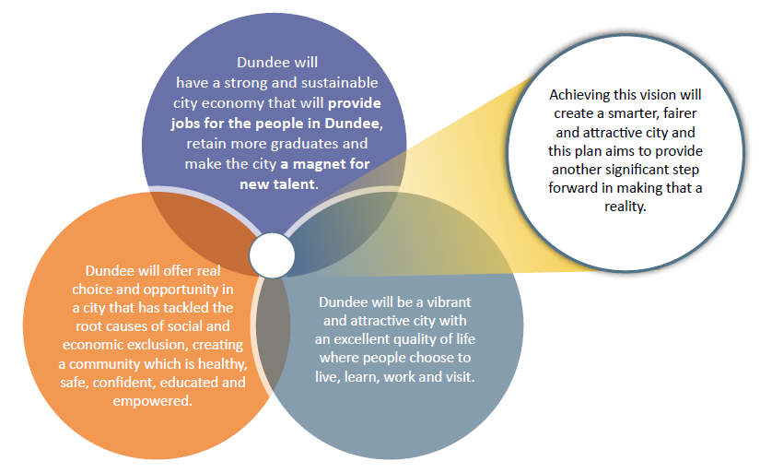

The Council subsequently agreed its Council Plan 2017-22 which sets out how we as a local authority will play our part in achieving this vision for the City. The Council Plan also outlines that we need to continue on our Changing for the Future transformation journey by reviewing and changing how the Council operates to help make this vision a reality.

The Changing for the Future (C2022) programme’s primary aim is to support the Council in its delivery of the Dundee City Plan, its strategic priorities and the associated Dundee outcomes. The Changing for the Future programme will be restructured to ensure it can better support these strategic aims, as well as the outcomes laid out in the Council Plan.

The focus of the C2022 is on assisting the delivery of the city and Council plans and the long-term transformation of services to ensure the Council can continue to deliver high quality services for the benefit of Dundee’s citizens.

While the main objective of the programme is as stated above, the programme will continue to support savings targets through identification of saving opportunities in the course of long-term transformation projects and will work closely with finance leads on all projects to find a balance between transformation for citizen benefit and identifying savings for the support of Council budgets.

The programme will feed into the Tay Cities and Dundee approach to improving outcomes. Additionally, the programme will continue to focus on transformation and be closely linked with the Council’s financial strategy.

The Council has a vital role in enabling transformational change to meet the needs of the city. There are three main drivers of change:

The rising and ageing population
The Council has to keep a balanced budget with increasing cost pressures and demands
The type of work we do and the technology we use to do it is changing

WHY WE CONTINUE TO TRANSFORM
C2022 has a clear vision to develop an organisation which:

Seeks to shape local markets, support regional working & encourage collaborative methods of delivering core services
Focusses on prevention of service need rather than reaction to service demand
Puts local democracy at its core
Puts citizens at the heart of everything we do

In order to deliver on the priorities set out in the City Plan and our Council Plan we will:

Continues to make best use of the financial resources available to us, ensuring best value for the public purse

Have a flexible, skilled and motivated workforce

Listen to, and be responsive to, our customers, shaping our services around their needs and focusing our resources where they are most needed

Work closely with our partners, including local communities, focusing on our agreed outcomes for all the citizens of Dundee.

Our aim is to be the best we can be – whether in terms of cost, efficiency or the achievement of the key outcomes set out in the Council and City Plans. Dundee is already a well performing Council, but we want our services to be great and among the top performing in Key priority areas. We are digitally skilled but on a journey to being a smart and connected digital city. We are recognised as sound but want to be known as ambitious and innovative.

How the Council shapes itself to empower communities, manage finances, and make best use of technology and other assets will be a significant challenge and opportunity. The Council has integrated children and family services and health and social care. The Council is also embracing new technologies that can improve lives and communities such as new online services, smart city initiatives and technology enabled care.

It is important that the programme focusses on our citizens and working in partnership with others such as the Health and Social Care Partnership and Leisure and Culture Dundee. The C2022 and partner programmes will focus on ensuring that the lives of our citizens, regardless of background, age or circumstance, are made better by delivering the services that matter to them, in a way that meets their needs because we have designed the services with them, not just for them.

Managing change presents new challenges, including an increasingly complex organisational landscape and changing demands from the public based on their lifestyle, technology use and needs.

We have a number of arm's length organisations, strategic partnerships, commissioned service arrangements and alternative delivery models which mean the way we deliver services is increasingly complex. This goes hand in hand with other challenges such as increasingly complex finances, demand for alternative access to services and legislative complexity.

CHANGING FOR THE FUTURE 2022 (C2022)
This next phase of the programme will continue to be structured around core themes and made up of a number of projects. Each project will be aligned to relevant Council and City Plan strategic service area priorities to ensure a joined-up approach to delivering on the programme, the City Plan for Dundee and the Council Plan.

In building this programme, we have held a number of workshops with a cross section of our employees from across Council services. In the workshops, participants were asked to think of ‘Dundee City Council in 2022’, specifically tasked to think of big transformational changes they would like to see in the Council and use the above model to develop their ideas.

The response from those involved was very positive, with all participants approaching this way of working with enthusiasm and excitement to be part of building a Council which is ‘Changing for the Future’.

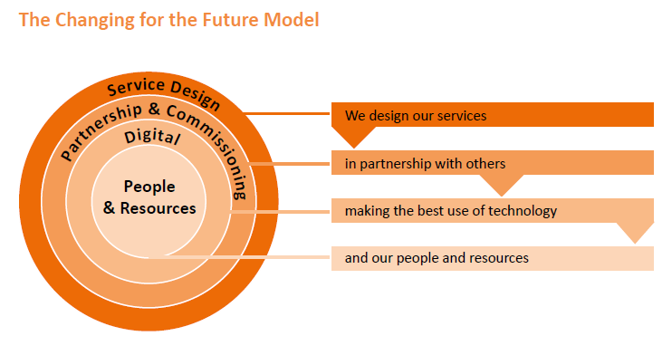

We recognise that service areas already have strategic service plans, savings plans and projects started and identified to contribute to the delivery of these plans. What C2022 aims to do is help support existing plans and projects using the Changing for the Future Model, service design methodologies, a formal transformation Programme Management Office (PMO) and the Building Organisational Leadership & Development (BOLD) programme.

Through this programme and the appropriate adherence to governance, reporting to the PMO and use of methodology we will ensure that all our efforts deliver a better Dundee and Council for our citizens, as well as support and complement our strategic priorities, existing plans and the long term financial plans of the Council.

Projects contained within C2022 will be subject to update reports and reviews by the Council’s committees to ensure that Councillors and Dundee’s citizens have the opportunity to engage with the Council’s transformation plans.

C2022 THEMES, PROJECTS & STRATEGIC LINKS
The C2022 programme will be made up of some new and existing project reviews, grouped around the City Plan and Council plan Strategic Priorities. The following projects will form the core of the programme over the next 4 years to help deliver the priorities of the City Plan.

As the Council is a key part of the city wide partnership, there will be other transformation programmes running in the city which the C2022 programme will link directly with and be informed other partners’ transformation programmes, in particular those of the Integrated Health & Social Care Partnership and Leisure & Culture Dundee.

The pages that follow set out the individual projects and their objectives under each theme. Each of these project reviews will be carried out using the Changing for the Future model with the aim of delivering robust business cases, proposing how the services can be designed or re-designed, using partnerships or commission (where appropriate), best use of technology and our people and resources (in line with our People Strategy).
Service Design is about empowered communities, prevention not reaction and being citizen focussed.

We will designing our services to ensure our citizens remain at the heart of what we do, to deliver the best outcomes for all
Partnership & Commissioning is about commissioning, partnerships and collaborative working and procurement reform.

We will review services to identify where developing a partnership or commissioning approach will deliver new options for a better service
Digital is about digital citizens, workforce and services.

We will implement the digital strategy to deliver new tools to deliver efficiencies and improved outcomes
People & Resources is about making the best use of all our existing resources, be they financial, people, building or other assets.

We will deliver greater flexibility with our people, finances, buildings, information, vehicles and land

SERVICE DESIGN
Key Transformation Projects

To make best use of our school estate, exploring how schools can be utilised more as community assets to better meet the needs of their communities. In particular their use out with school hours and the school year
365 SCHOOLS – Sponsor: Executive Director of Children & Families
Council / City Plan Priorities
C&F – 3 & 4
NS – 1, 2 & 3

Review of our waste management service to ensure that we continue to provide the best waste service to citizens and businesses as possible, while helping to deliver a sustainable Dundee
WASTE MANAGEMENT – Sponsor: Executive Director of Neighbourhood Services
NS – 4 & 6 – 9

Integrating all services offered to citizens with MyDundee, NEC & Young Scot to create a citizen card which is designed for the benefit of all our citizens and visitors to Dundee
CITIZEN CARD FOR DUNDEE – Sponsor: Head of Chief Executive’s Services
CS – 3

Development of a city wide meals provision which focusses on providing healthy, balanced meals to care homes and schools across the city
CITY WIDE MEALS PROVISION – Sponsor: Executive Director of Children & Families
C&F – 4

CULTURAL SECTOR – Sponsor: Executive Director of Leisure & Culture Dundee
Review of the cultural sector across Dundee and relevant strategic partnerships to ensure the sector continues to offer robust and sustainable cultural services
L&CD – 1 – 11

SUPPORTING LEARNING & CARE IN DUNDEE –
Working with existing initiatives to further develop and improve young people’s attainment, education and enhanced care provision in Dundee
C&F – 1 – 5
NS – 3

Sponsor: Executive Director of Children & Families

PARTNERSHIP & COMMISSIONING
Key Transformation Projects

PROCUREMENT & COMMISSIONING OPPORTUNITIES REVIEW – Sponsor: Executive Director of Corporate Services
Council / City Plan Priorities

CD – 1 – 3
NS – 5
CS – 6
CE – 6
Reviewing options for procurement and commissioning opportunities which encourage best value, fair work and delivery of shared outcomes. This includes how we work across the Tay Cities region

TAYSIDE CONTRACTS REVIEW – Sponsor: Executive Director of City Development
Reviewing what Tayside contacts currently offers to the region to see if there are any further opportunities to expand their remit to the benefit of all councils and partners
L&CD – 1 – 11

Full review of the cities energy needs, limitations and options to fully understand Dundee’s energy needs across the next 10-20 years
CITY WIDE ENERGY – Sponsor: Executive Director of City Development
NS – 4 & 6 – 9

Working with our neighbouring councils, partners and the 3rd sector on collaborative projects, initiatives and opportunities to deliver efficiencies across the city and region
CITY & REGIONAL SHARED SERVICES – Sponsor: Chief Executive
CS – 3

A focused programme of improvement and transformation addressing key elements of social work protection practice and decision-making in collaboration with the H&SCP, the Care Inspectorate and the Improvement Service
TRANSFORMING PUBLIC PROTECTION – Sponsor: Chief Executive
CS – 3

DIGITAL
Key Transformation Projects

Ensuring that people in mobile roles have the technology to carry out their roles in a flexible way, are digitally confident and are working in a culture that supports mobile and flexible working
MOBILE DIGITALLY ENABLED WORKFORCE – Sponsor: Executive Director of Corporate Services
Council / City Plan Priorities
CD – 3
CS – 2 – 4

DIGITAL 2020 – Sponsor: Executive Director of Corporate Services
Delivering the digital strategy’s original aim of becoming a digital council by 2020, continuing to adapt and evolve the strategy to be fit for purpose in a changing digital world
CD – 3
NS – 2
CS – 3 & 4

Includes: Channel Shift Programme

Create a smart city of the future which embraces new technology & innovative ways of delivering services to our citizens
SMART CITIES – Sponsor: Executive Director of City Development
NS – 4
CS – 3 & 4

Developing a ‘data by default’ policy which ensures that any and all data that we hold, that is not sensitive or personal, is developed in a way that it can be shared through the open data platform that encourages innovation in the City
OPEN DATA COUNCIL – Sponsor: Executive Director of Corporate Services
NS – 10
CS – 3 & 4

Developing new & innovative ways of using digital to deliver our existing services in enhanced ways
DIGITAL INNOVATION – Sponsor: Executive Director of Corporate Services
CS – 3 & 4
CS – 4

PEOPLE & RESOURCES
Key Transformation Projects

FLEXIBLE WORKFORCE – Sponsor: Executive Director of Corporate Services
Council / City Plan Priorities

Ensuring that the council has a flexible and dynamic workforce with the right skills to meet the needs of our citizens and city, now and into the future
CD – 1 & 3
CS – 2 & 4

Includes: Clerical/Admin Support Project

MAXIMISING USE OF OUR ASSETS – Sponsor: Executive Director of City Development

Reviewing council buildings, land and property holdings to ensure that the council makes the best use and value from our assets and that Dundee’s communities are empowered to get the most out of assets in the community
CD – 1 – 3
CS – 5 & 6

Maximising use of our extensive fleet out with of normal operating hours, supporting other projects, council departments, partners and 3rd sector
365 FLEET – Sponsor: Executive Director of City Development
CD – 4 & 5

Includes: Fleet & Transportation Project

Reviewing services the council provides and exploring opportunities to change or improve our charging and concession approach as well as looking at how we benefit from a more commercial approach to revenue generation
CHARGING, CONCESSIONS & COMMERCIALISATION – Sponsor: Chief Executive
NS – 5
CS – 5 & 6
CE – 6

OTHER CITY TRANSFORMATION PROGRAMMES

The C2022 programme will be a programme for the city of Dundee. In order to achieve this, the programme will need to link with and be heavily informed and influenced by other key partner transformation programmes in progress in the city to ensure that we are all working towards the same shared vision for the city laid out in the city plan.
Dundee Health & Social Care Partnership

The Dundee Integration Joint Board has required the Dundee Health and Social Care Partnership (DHSCP) to set out a robust governance structure to ensure the delivery of the Integration Joint Board’s Transformation Programme and this has led to the development of the Transformation Delivery Group.

The purpose of the Transformation Delivery Group is to oversee, support and ensure the delivery of and the realisation of the transformation programme. The success of the transformation programme is measured against achieving the vision and strategic priorities set out in the DHSCP Strategic and Commissioning Plan 2016 – 2021, within the financial framework and resources delegated to the Health and Social Care Partnership.

There are several areas of synergy between the vision and strategic priorities set out within the DHSCP Strategic and Commissioning Plan 2016 – 2021 and the vision and key priorities set out in City Plan for Dundee 2017-2026, particularly around the strategic themes of tackling poverty, reducing substance misuse and improving health and wellbeing.

The business of the Transformation Delivery Group is therefore to support and report on the progress being made within the following approved strategic themes for change:

- policy changes
- models of support
- person centred care
- early intervention and prevention and
- maximising resources

These interventions fit clearly with the individual and shared strategic priorities of the DHSCP as noted below:
- Health Inequalities
- Early Intervention/Prevention
- Person Centred Care and Support
- Carers
- Localities & Engaging with Communities
- Building Capacity
- Models of Support, Pathways of Care
- Managing Our Resources Effectively
Fundamental to achieving these strategic priorities will be the continued investment in delivering person centred care, building capacity with individuals, families and communities, as well as tackling health inequalities and supporting carers within the context of a locality or as part of a community of interest.
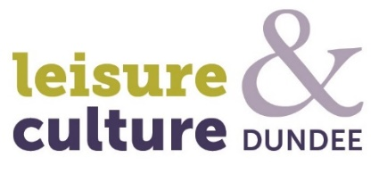
Leisure & Culture Dundee

The Transformation Programme for Leisure and Culture Dundee will continue to be implemented, and contains the following priority areas for strategic review and investment:

- Full review of assets
- Exploring partnership opportunities with Council
- Future investment review
- Reviewing City Box Office
- Citizen Card for Dundee (as detailed on page 10)
- Cultural Sector (as detailed on page 10)

As these programmes are established and grow the C2022 programme will become an essential support and partner to them and all programmes will aim to support each other in their delivery.

DELIVERING C2022
Over the course of the past year, we have been learning from previous phases of our transformation journey and will make some changes to the way it is run to ensure that the programme is best placed to support transformation and change across the Council and the city.

To ensure that the C2022 programme can adequately support the city’s strategic priorities, the programme will ensure that it has in place robust enough governance, methodologies, performance management tools and resources to deliver consistently on change.

The Council requires a different kind of transformation programme if the city’s challenges are to be address and Dundee is to achieve its ambitions over the course of the next 10 years.

  - GOVERNANCE

Programme Management Office (PMO)

The Corporate Improvement Team (CIT) sits in the Chief Executive’s service and is responsible the Councils transformation programme and continuous improvement initiatives.

To adequately support the C2022 programme, there needs to be robust governance which is available to support and guide the programme and the projects contained within each theme. The Corporate Improvement Team and how it supports C2022 will be re-designed to ensure that this team will be able to operate as a Programme Management Office (PMO).

The primary goals of the PMO for C2022 would be to:

Programme Board

The Council’s Management Team are the Programme Board; they support the Chief Executive and the Corporate Improvement team to deliver the C2022 programme.

Committees

All policy reports, reports with staffing and/or financial implications emanating from the programme and the Revenue Budget process require to be taken to the appropriate Committee for their consideration and determination. This process allows all elected members the opportunity to have oversight on any key changes the programme recommends in how services are structured and re-designed as well as understanding the impacts of any changes to our priorities and citizens.

  - PERFORMANCE MANAGEMENT & COMMUNICATIONS

The Council’s corporate performance management system will continue to be the method used to track and monitor transformation project’s KPIs and the progress against the Council plan. All major projects included in the C2022 programme will have dashboards to support the tracking and management of the defined project outcomes. Finance leads, project leads and the C2022 PMO will work closely on reporting progress to committee.

To ensure that what the C2022 programme delivers is well supported by our people and that citizens are clear on what we are trying to achieve, strong communication will be key.

  - METHODOLOGY

Each one of the projects contained within the programme will be managed using a mix of traditional project management and service design methods. Service design methods focus on really understanding the problem that the project is trying to solve and what is most important to the service user – the citizen.

Using these methods will allow for a more dynamic approach to project delivery, one which is faster and more flexible than only apply traditional approaches, putting emphasis on early trials, early approvals and regular review periods.

  - BOLD PROGRAMME

To ensure that our employees have the necessary knowledge and skills to support change and service improvement, CIT working in partnership with Learning and Organisational Development (L&OD) have developed the BOLD programme to help to further build an ambitious, innovative, flexible and engaged culture for the council.

CIT and L&OD held workshops, focus groups and gained feedback through the employee survey and other sources which showed that our people welcome greater involvement in service improvement.

The BOLD programme focuses on giving our employees, regardless of levels and job roles access to a variety of different courses which aim to give them the tools and methodologies to support change within the Council and their teams.

An important aspect in the delivery of the C2022 transformation programme and for service improvement in general is ensuring that our people are bought into and enthusiastic about change and development.

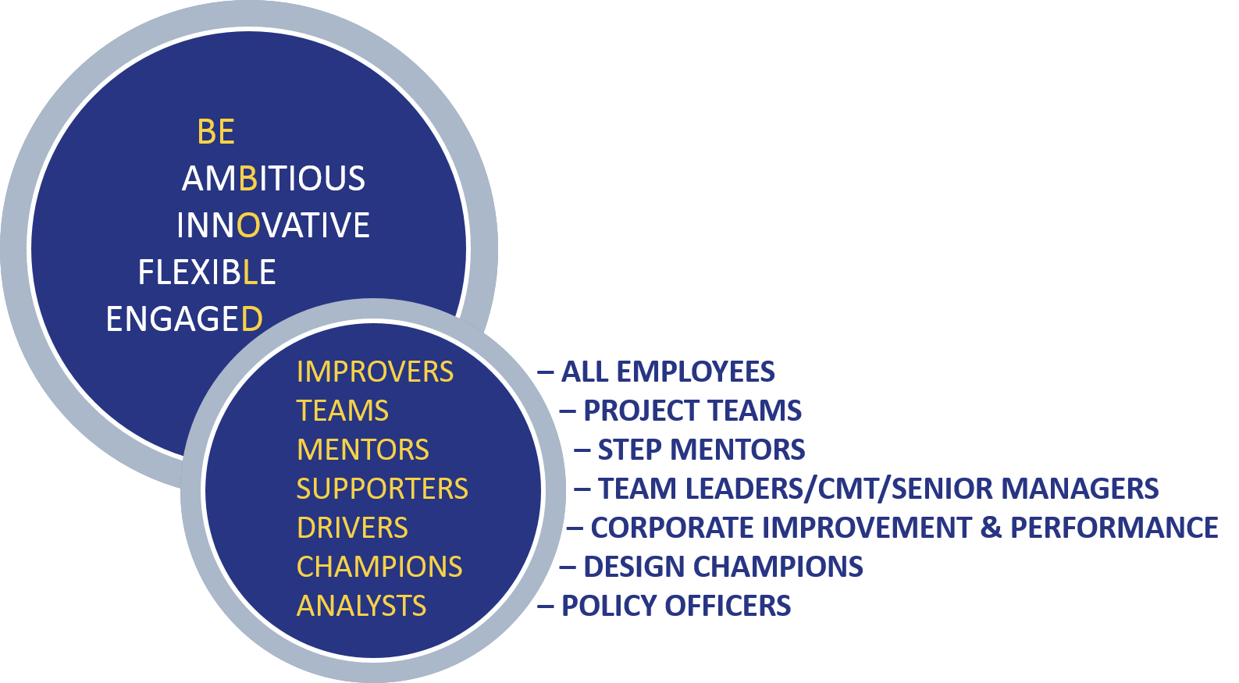

COMMUNICATING C2022
To ensure that what the C2022 programme delivers is well supported by our people and that citizens are clear on what we are trying to achieve, strong communication will be key.

The Council’s website will be the heart of this communication, used prominently and regularly to update on each of the C2022 projects, the Council’s performance measures and progress on the Council Plan and City plan.

The benefit of clear and transparent communication on our progress means that the public can be clear about what the Council’s priorities are and how we are changing as a Council to meet them. All of the work we do in delivering the City Plan, Council plan and C2022 programme will directly affect the public in one way or another and transparency and openness is essential to better engage the public and make them a part of the process.

