**Challenge Poverty Week 2024: 7-13 October 2024**

**Events and activities timetable\***

**In Person and Online events**

|  |  |  |  |
| --- | --- | --- | --- |
| **Date** | **Time** | **Event** | **Location** |
| All Week | - | Keep an eye on DCC social media for updates on what is happening | Online, DCC Facebook |
| Monday 7th October | 13:00 – 14:30 | Fairness Leadership Panel Focus Group with observer from Dundee Partnership Coordinating Group. | City Square |
|  | 11:00 | National Event - Housing and Women Involved in Selling or Exchanging Sex. | Zoom Webinar: [Registration Link](https://us02web.zoom.us/webinar/register/WN_LK7JzKqmQk-f9skYWD3cUA#/registration) |
|  |  |  |  |
| Tuesday 8th October | 11:00 – 15:00 | Circle Mobility Open Day. An opportunity to see the range of mobility aids available to borrow | Circle Mobility (behind the Overgate Centre) |
|  | 11:00 – 15:00 | Home Energy Scotland: Getting Ready for Winter. Focussing on energy saving advice. Other support agencies will also be attending to offer advice. | Overgate Centre, Upper Floor |
|  | 14:00 – 16:00 | Dundee Transport Forum Meeting | DVVA, 10 Constitution Road and via MSN Teams |
|  |  |  |  |
| Wednesday 9th October | 10:00 – 14:00 | Boomerang Fairness Event. Featuring their cosy café, information stalls and lunch club | Boomerang Community Centre, Kemback Street |
|  |  |  |  |
| Thursday 10th October | 11:00 – 13:00 | Strathmartine Community Larder and Taught by Muhammad Cafe – Community Planning Team Visit | Kirkton Community Centre & Library |
|  |  |  |  |
| Friday 11th October | 11:00 – 14:00 | Circle – Dudhope Castle Open Day and Information Event | The Circle, Dudhope Castle, Barrack Road |
|  | 11:30 – 13:30 | Fairness Leadership Panel Event | Maxwell Centre |

* the above list is not exhaustive and there may be other events taking place which are not included in the timetable.

Follow us on our [social media](https://www.facebook.com/officialdundeecity) to see what else is happening!

[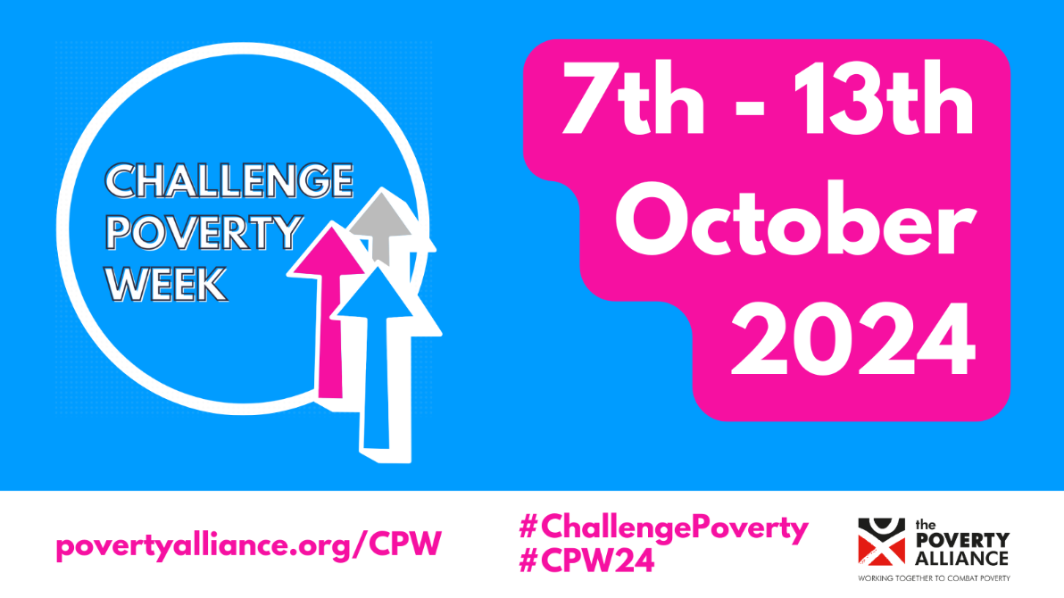](https://www.povertyalliance.org/cpw/)