Dundee City Council

Information Technology Strategy

Dundee City Council
Information Technology Strategy
Table of Contents
Section Page Number
1 Introduction 1
1.1 Scope of the Strategy 1
2 Our IT Vision 3
2.1 DCC Challenges 4
2.2 What will DCC Look Like in the Future? 5
2.3 Dundee's Digital Platform and IT Function for the Future 5
2.4 Transform to a Digital Platform 6
3 Delivering the Vision 8
3.1 Principles / Key Values 8
3.2 Our Aims 8
3.3 Priorities 9
3.4 Future State Operating Model 10
3.5 Our Roadmap 12
Appendix - Risks to Delivering the Strategy 13

Introduction

Scope of the Strategy
Taking a strategic approach in response to the challenges facing public sector services, Dundee City Council (DCC) will build a digital platform that is always available, modern, and citizen-centric serving as the heart of its technology and business architecture. We define a 'digital platform' as a technology-enabled operating model that creates value by using groups of applications and integration technologies to help facilitate collaboration and mobility. The platform connects multiple participants to access data resources, physical and virtual communities and provides channels to enable people to collaborate using scalable technology in a risk managed environment. This platform will be a combination of a small number of integrated applications, connect DCC’s customers and other stakeholders with the Council’s front and back-office processes, while providing an end-to-end, personalised experience using a channel shift to the web (where appropriate) with a significant increase in self-service.
DCC recognises that the decision to build a digital platform in-house will necessitate a movement from a silo-based business application toolset to a customer-centric, integrated set of products, services and applications. With an IT operating model designed to meet the current and evolving future needs of the organisation, its stakeholders and ultimately the citizens of Dundee.
It is envisaged that this 'core' platform will be hosted and run in a hybrid cloud environment, requiring minimal local infrastructure and support. This will provide the IT function more time to focus on service improvement, support the delivery of strategic objectives and to exploit arising opportunities with new and existing technology investments.
In order to build the platform, staff will need to learn new skills and there will have to be a realignment of skills in the IT function to meet the demands of Council Services. The benefits of this realignment will be:
- Improved customer and stakeholder satisfaction
- “Anytime, Anywhere, Any Channel” access for citizens
- Maximum operational efficiency
- Mobility for citizens, elected members and staff
- Greater measurement, availability and transparency of data
- Agility, flexibility and responsiveness
- Increased capacity to collaborate with other public sector partners
Through this core platform, DCC’s ability to provide information out via the channel, at the time and location of a citizen’s choosing, will be possible. This meets the ever increasing demand of society to access local, public services in a manner and at a time of the customer's choosing.
Combined with responsive governance structures, processes and new skills, technology offers a vital link to delivering a unified solution for managing all channels. Allowing a 'publish once and deploy everywhere' focus, across social channels and mobile devices. Customer interactions will be transitioned seamlessly across channels and across DCC service areas, providing a transparent, consistent experience no matter how many channels are used.
Throughout this document, we will use the terms customer, consumer, stakeholder, citizen and partner (one who provides a product or service within the Council, to the Council or on behalf of the Council) to draw attention to the dramatic change in relationships and the approach to developing, delivering and determining the impact and value of Dundee City Council's products and services.

Our IT Vision
Placing Dundee’s ambition to be leaders in innovative digital service delivery at the centre of what we do, DCC IT will provide a secure, integrated portfolio of IT systems and services. We will work closely with our customers to be a valued service partner who delivers technology that enables business transformation.
The IT function will play a significant role in the transition to becoming a 'Digital Council'. By the end of 2023, the DCC IT function will have to transform from its current state to support this transition. Key roles will emerge with greater emphasis and importance being placed on them than in the past. For example, the responsibilities of enterprise architecture, programme and project management will all grow in importance.
Through the use of cloud-based solutions, DCC IT will be enabled to work continuously with Council service teams to help them focus on service re-design. DCC IT will develop new and improved products, services and processes and will think about data and information flows to enable data-informed decision-making.
DCC IT will support the Council’s vision for a “Digital Dundee” and the guiding principles and themes of the Digital Strategy by aligning our strategy and IT services with those of the business and the wider digital landscape.
Underpinning the vision, DCC IT will :
- move from keeping the lights on to continually improving Council service delivery. DCC IT will no longer just be responsible for providing applications and infrastructure. With the rise of automation and cloud consumption, they will be increasingly responsible for providing an integrated technology platform for end-to end, business process services
- move from delivering IT support and technical change projects to delivering business transformation. DCC IT will be proactive to changing business requirements. They will be at the very centre of business transformation initiatives, identifying opportunities for DCC to improve service design and delivery
- move from aligning IT and business strategies to enabling business innovation. DCC IT will ensure that the IT strategy is aligned with that of the Council, and it will expand the possibilities for service innovation through the use of emerging technology as well as informing strategic conversations at an early stage through insight on the art of the possible
Our ambition is to be an enabler of business transformation, where:
- we will have metrics that help us to confirm our processes are delivering outputs in line with citizens and service needs
- we will have metrics that help us demonstrate that services and products are available in line with service priorities and thus outcome focused and citizen-centric
- An 'integrated portfolio' means service design and delivery aiming for minimal/no waste, balanced by cost and quality to enable effective customer-centric public services for Dundee
For the Council's IT function, 'service partner' means working together to design, deliver and improve services from a 'customer point of view' where the 'customer' is part of the Council's workforce, citizens, stakeholders in the community and those beyond Dundee's geographical boundaries such as those who work, visit and contribute to the growth, well-being and sustainability of the city and its surrounding environment.

DCC Challenges
Technology continually changes the way in which people interact with friends, family, services and businesses. Changes continue at pace. For DCC, with its wide range of services, keeping pace with the advancement of technology, new ways of working and communication methods is a constant challenge made more difficult in an environment with ever tighter budgets.
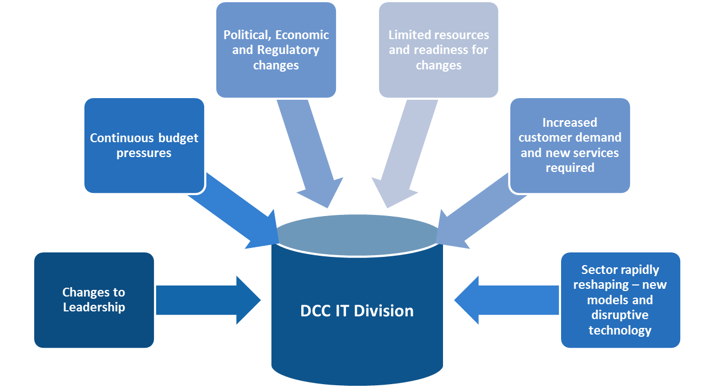
The Council faces a series of challenges which are summarised in the diagram below:
New digital technologies such as wearable devices, mobile applications, smart technologies and massively scalable computing power and data storage are combining with mobile connectivity and social media to transform how organisations and their customers interact. Many industries (personal banking, travel and retail) are unrecognisable from their pre-digital structures.
As this global shift takes place, local government is also undergoing major changes with reduced budgets, localism and commissioning acting as key disruptors to local services. The last ten years has seen a challenging political environment combined with the need to adapt faster to digital customer preferences and behaviour. Local Authorities are under pressure to:
- Re-think their customer strategy and interaction
- Transform their service models to reduce cost
- Redesign and streamline their delivery processes
- Allow citizens to access personalised services
- Work more collaboratively with other public sector agencies
- Reduce costs on an ongoing basis
- Build a more flexible, agile and integrated technology infrastructure
DCC recognises that this last point is crucial to all modern organisations, acting as an essential enabler for the previous points. The DCC Technology Strategy recognises that flexible, agile and integrated technology will only be delivered to the Council and its citizens, if the Council replaces some of the technology, applications and IT practices that are currently deployed with those that enable change.

What will DCC Look Like in the Future?
- More business will take place outside of standard office hours. IT will need to provide support services that meet the service support needs within available resources
- Flexible / agile working will become the norm, for example not in a Council office at an assigned desk, instead working from a partner office, out on the road, home or beyond, employing new patterns of work for example - shifts with early start/finish and evening/weekend work patterns
- Managers will successfully adapt to managing a mobile / flexible workforce. Outputs and outcomes, not presence, will be managed.
- Services continuously explore and engage with the IT function to maximise the use of deployed technologies
- New ways of working with modern technologies will be identified, designed and implemented in collaboration with customers and services.
- Empowered flexible trained staff
- A progressive culture which is diverse: multi-cultural, multi-generational, gender balanced, welcoming and one that takes shape collaborating across, embracing innovation, entrepreneurial mind-sets taking risks, leading and supporting change adoption
- Across the authority, technology enabled systems, services and processes will be owned and managed in partnership
- Collectively measured performance, starting with strategic objectives that are linked by change management initiatives to support the achievement of operational objectives, across departments, divisions, teams and thus to individuals
- IT will work collaboratively with the services to drive and implement changes that are prioritised and linked to the Council's strategic objectives
- If IT doesn't have the capability, we will not just try to make it fit, we will look externally to find the best fit approach to delivery and conduct an options appraisal to ensure the option aligns with our strategic plan and available resources.
In delivering these changes, we believe the following will not change for DCC IT:
- An in-house, robust, centralised, resilient provision of core services
- High levels of staff commitment

Dundee's Digital Platform and IT Function for the Future
IT will deliver Dundee's digital platform. The platform will be unique and ready for our city's future. It will have the following characteristics:
- 'One team' working in/for a city that is investing in its future
- Working for a Council that is striving to make a difference for its citizens e.g. social justice/equality
- Low cost corporate platforms
- Customer first focus to provide a professional service
- We enjoy work more, have a better work/life balance and are more productive
- IT has the freedom, within a clearly defined framework, to innovate and explore leading edge technologies to enable the achievement of our objectives
- Our technologies may be standard (Citrix, SQL, Windows, Cisco) but our solutions are adaptable to pivot when the Council's key challenges change
- Problems and challenges excite us – we are confident we can find an innovative, effective solution
- We have a reputation for being innovative, for offering a challenging and rewarding work environment. We develop and support our staff
- We actively replace outdated operational models and legacy thinking/actions. New ideas are always encouraged, investigated and where aligned, resourced and implemented
- IT prioritises work that achieves better outcomes for the many, which means the function will use tactical partnerships for low value-add and/or commoditised activities

Transform to a Digital Platform
DCC IT will plan for a managed transition to hybrid cloud and where appropriate utilise cloud based services in combination with a series of activities to improve the data centre environment. DCC will consider:
- A cloud based CRM solution that will be placed at the heart of the DCC IT landscape
- Migration of infrastructure to a co-location data centre to reduce risk and improve service availability
- The migration of the following to the cloud:
  - CRM - currently being implemented
  - Cloud productivity tools - this would include mail, collaboration and office applications
  - Document Management (Open Text) - consider appropriateness of moving to a cloud environment
  - Financials (Civica) - consider appropriateness of moving to a cloud environment
  - Social Care (Mosaic) - consider appropriateness of moving from proprietary cloud to a public cloud environment
  - HR (Resourcelink) - consider appropriateness of moving from proprietary cloud to a public cloud environment
- Following this migration (phase 1) there will be a planned programme of migration for other applications in a strategic manner to support Council priorities.
- It should be noted that this approach does not assume the migration of all applications and hardware infrastructure by 2023.
- Access to cloud applications will be achieved by Citrix and non-Citrix methods. (The issues of accreditation and security are noted)
- Integration with non-DCC applications will be a central element and therefore there will be more use of data warehousing and middleware
- The IT function will transition to be more ‘internal consultants’ acting to assist the areas of the council to exploit the technology investment
- The corporate and education streams will move towards greater integration, alignment of technologies and collaboration on projects
- The deployment of Infrastructure as a service (IaaS), platform as a service (PaaS) and software as a service (SaaS) will be integral to IT service delivery

Transform to a Digital Platform
Advantages | Disadvantages
- Allows for significant activity to migrate many legacy applications and deploy new applications in the cloud  - Orchestrated drives to new ways of working across the whole of DCC  - Allows for the ongoing exploitation of existing and all future technology investments  - Allows for the mature partnership working with 3rd party data centres  - Become a change leader in the city / region / Scotland to drive a new level of collaborative working | - This represents a transformation of people, process and technology throughout DCC. This option therefore has a number of risks.  - To ‘transform’ indicates a defined and relatively short time period to complete the majority of activities. This may need a short term increase in additional resource and skills

Delivering the Vision

Principles / Key Values
In order to deliver the vision, DCC IT will employ design-led leadership, partnering internally and externally, using the following principles:
- To enable the people of Dundee to interact digitally with Council services, IT will use design and system thinking to support the redesign of existing services and the creation of new ones
- To make the council more agile and responsive to its service users, we will actively break down barriers and obstacles based on old thinking and legacy methods that hinder rather than advance developments
- To enable our workforce to work efficiently in delivering Council services, maximise productivity and increase employee satisfaction. We will design and continuously improve IT services by listening, engaging and working with our customers and our staff to raise personal awareness of how technology systems and services can enable better service delivery
- To enable better interaction and engagement with the workforce and the public, we will make time for staff to review, innovate, develop and manage key outputs
- To achieve a high level of customer satisfaction we will have a customer centric approach to service delivery and foster customer first thinking by our staff
- To modernise the way the Council does business and interacts with its key stakeholders, IT will streamline the IT estate focusing resource to align the function with the Council's strategic service objectives and related operating model
- To concentrate its resources on key strategic DCC initiatives that use technology as an enabler for digital service delivery, IT will consolidate technologies and standardise the IT service portfolio
- To deliver products and services needed by the City, IT will have repeatable, standardised and continuously improved processes that are designed in collaboration with customers and services.
- To deliver cost effective platforms, IT change will be fully managed, controlled and communicated
- To keep costs down, drive value for money and maximise ROI, we will work closely with services and external partners to prioritise improvements using best practice and emerging good practice in local government service provision, making evidence-based decisions

Our Aims
Using an incremental approach, we will assess and re-evaluate at regular intervals the appropriateness of our objectives and usefulness of our metrics to determine our progress towards the vision and future state operating model.
- Year 1 and 2 – Efficient and effective service supplier with an adaptable operating model and workforce ready for change
- Year 3 – A customer-centric, business service partner providing anytime, anywhere, cloud facilitated delivery of services and data, continuously improving and working in collaboration with Dundee's evolving public service portfolio
- Year 5 – A critical business service partner and recognised value centre leading regional technology innovation for public service delivery, built on a reputation of being customer-centric, outward looking and entrepreneurial

Priorities
DCC and IT will use the following objectives and anticipated metrics to measure progress to the vision over the life of the strategy, 2018 to 2023:

Year 1 and 2 Objectives
- Uses a functional structure that enables the development and delivery of efficient and effective support services flexible to adapt to change
- Developing and enhancing the capability to run IT at multiple speeds
- Change will be fully managed, controlled and communicated
- Integrated IT asset management and request handling solutions deployed
- Planning begins for best use of cloud based services
- Staff will have an end-to-end view of IT’s role in Council service delivery – from the customer to the Council, via back office services and the IT service portfolio, teams and to the individual contribution
Anticipated progress metrics:
- Increasing number of documented services in a service catalogue that shows how services are linked to development and delivery teams
- Reducing low volume, low value services agreed with the Council Management Team

Year 3 Objectives
- Uses a functional structure that streamlines the design and enables the seamless delivery of customer-focussed digital services, that is flexible to adapt to change
- Agile workforce, empowered and eager to facilitate change
- Greater proportion of resources spent in application and data services , focused on the outcome of delivering business intelligence insights and service delivery impact
- Deployment of cloud based service, data and infrastructure platforms, using the best mix of external resources including partnerships, short-term specialists and suppliers of commoditised services that deliver value for money
- Achieve identified benefits, service outcomes and related quality targets within agreed time and budget
- Achieve high levels of IT customer satisfaction by prioritising improvements that are agreed as most important to enabling the achievement of Dundee's strategic service objectives

Year 5 Objectives
- A portfolio of integrated IT services, aligned to Dundee's strategic service objectives and available anywhere anytime
- Continuous service improvement is embedded in every aspect of product and service design, delivery which are directly linked to the impact and value to the city, its people and economy and surrounding environment

Future State Operating Model
In order to deliver a digital platform for DCC, there is a requirement to transform the IT operating model.

Our Operating Principles
- Investment – We make decisions based on best practice from the local government sector and beyond, quantitative and qualitative evidence, the agreed best fit for the customer with a balanced view of value
- Standardisation – Standardise technologies and processes whenever possible using recognised IT service, project management and architecture frameworks e.g. ITIL, TOGAF, COBIT, Prince2, agile development, Cyber Resilience and related ISO standards
- Sourcing – We will align the IT service portfolio objectives through the use of strategic sourcing with an optimal range of suppliers and vendors using evolving good practice in vendor management
- Innovation – We measure innovation success based on user adoption and efficiencies achieved by users, not the implementation of the system
- Governance – We will work within the defined processes and regulations
- Architecture – We will adopt and adapt emerging best practice in enterprise architecture ensuring the application portfolio and IT infrastructure are standardised, resilient, optimised and centrally managed
- Design/Development – Design-led services start with identifying user needs, use methods which are easiest for the customer and within an appropriate budget. It is systemic and considers the whole life of the service
- Security – All design will have security embedded to minimise opportunity of compromise. We will continually review our security architecture to keep our services and data safe
- Staffing – Staff will be professional, knowledgeable and customer focused with clear career pathways. We will continually offer development opportunities for staff
- Benefits – The customer is the final arbiter of our efforts
- Risk – Our appetite for risk will evolve but will always be measured in light of the benefits to be gained from change

Our People
- Stronger relationships built on confidence in existing skills, support to develop new skills and the support to try something new
- Teams are encouraged, empowered and celebrated to progress continuous improvements, making decisions based on cost, Council strategy alignment and IT's service delivery commitments
- Motivation comes from the individual and supported by management
- Staff are motivated to provide excellence as standard
- Teams are empowered to develop innovative solutions within a framework that takes account of both opportunities and constraints across the Council
- Performance will focus on team contribution and be proactively managed, outcomes will be co-created, measurable, agreed and communicated to all stakeholders.
- Expectations will be re-prioritised with the support of the team and management, when appropriate
- All staff will be accountable for their contribution to an output/service productivity and performance
- Systems and processes will be updated to reflect new individual and team service and performance expectations
- More time will be spent proactively enhancing our services and systems, less time being reactive to issues
- A more flexible approach will apply to when work is done including location and hours worked

Future State Operating Model Diagram
The diagram below depicts how the IT function could be arranged and indicates where controls should exist to ensure that appropriate governance exists to deliver the initiatives in the Technology Roadmap:

Our Roadmap
The DCC Technology Strategy Roadmap provides a sequence of high-level activities that will take DCC through the planning and iteration of the Cloud-based Platform (Digital) Architecture and related data model, to the target digital, future state. Whilst much of the strategy may be developed through adoption of an agile development methodology, at the outset DCC will benefit from a high level structure and phasing of activities. The phasing provides an outline structure for the technology transformation stage, highlighting major aspects such as:
- Approval of the strategy and roadmap
- Introduction of a Change Management Policy
- Introduction of a Performance Management Framework
- Implementation of cloud based collaboration and productivity solutions
- Implementation of a Project Management Office
- Audit the Application portfolio
- Migration of server hardware to fully resilient data centres
- Review the Education IT provision model
- Integrate Health and Social Care processes
- Developing a cloud migration plan for applications
- Incorporate Security, Risk and Compliance
- Staff skills assessment and reskilling
- Consider new technologies e.g. AI, Robotics
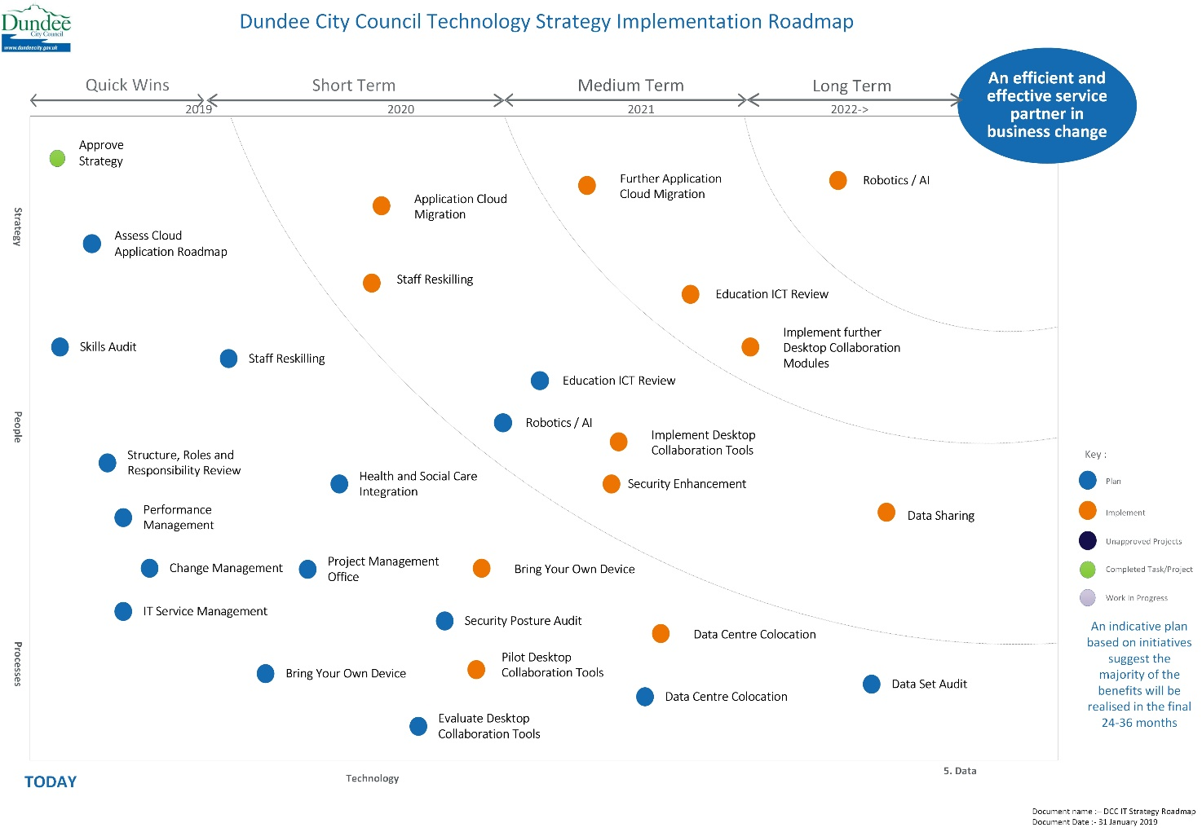

Appendix - Risks to Delivering the Strategy
The following table summarises the risks and issues identified that may impact successful implementation of the strategy:
Risk or Issue ID | Risk or Issue Description | Detail / Impact | Owner
RSK001 | DCC IT may have competing priorities affecting the completion of actions to achieve the agreed project completion dates. | There is a high likelihood this would have an impact on the achievement of anticipated project benefits including knock-on delays to pipeline projects, often increasing in the total cost of investment across a project portfolio.  Leadership could plan in additional support time to help teams prioritise initiatives and free up project team resources to complete in agreed timescales. | DCC Leadership and Senior IT Management
RSK002 | The emergence of competition in the provision of ICT support services could disrupt a funding stream for DCC and thus become a threat to the Schools ICT Service. | With the devolving of budget authority to the school level, the Schools ICT services may be compared against competitive service offerings from external providers.  Leaders in Education and IT should keep a close eye on this fast-paced, nimble niche in the IT provision marketplace | DCC Leadership and Senior IT Management
ISS001 | Difficulty implementing culture and behaviour changes that focus the workforce on building strategic capabilities over tactical solutions | There will always be something important to do. In order to achieve DCC's ambitions, there will need to be accepted trade-offs between prioritising 'business as usual' work and those activities required by the Council to make progress on building the foundations (people, process and technology) to become a 'digital business.'  Senior management across the authority can lead by example providing tips on how to manage competing priorities and actively supporting staff to adapt to new ways of decision-making and prioritisation of work. | ALL
RSK003 | If the IT function does not adapt now they will be 'forced' into decisions by suppliers | External market forces are constantly in motion. With other public services adopting digital platforms and suppliers seeing the business benefits of providing aligned products and services, DCC IT may find it must react to these threats. | DCC IT
RSK004 | The use of cloud services increases Opex spend, whilst budgeting is focused on reducing OpEx spend. The ability to secure additional OpEx funds for services to replace traditional CapEx sources could slow the change programme. | Although it is acknowledged that public sector finance and accounting rules may have not kept pace with private sector practices, the inability for DCC to budget and provide on-going funds for the development of the digital platform could be a significant barrier to achieving the Council's objectives. | Leadership, Finance and Budget holders
RSK005 | Emergence of shadow IT and users purchasing products and services outside of the service catalogue | Service areas have their own budgets that can be spent on IT related products. This can result in siloed systems, increased spend, lack of maintenance and support, risk of data leaks and inefficiencies. | DCC Leadership and Senior IT Management

