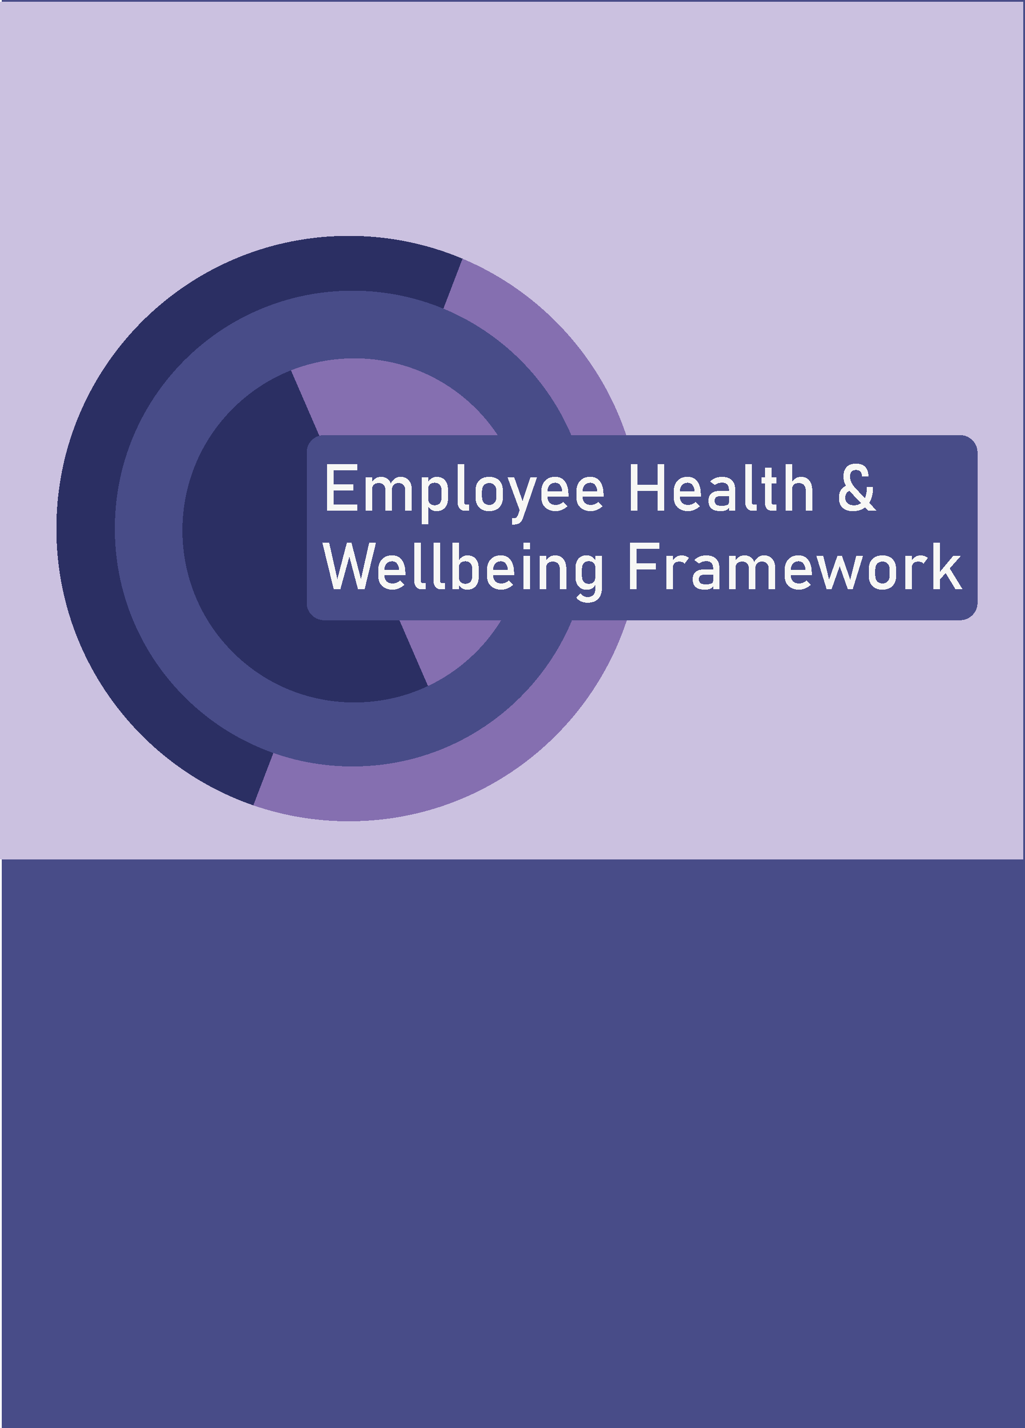

Introduction
Dundee City Council recognises that supporting the health and wellbeing of all our workforce is vital for the delivery of our vision for Dundee.
The Health & Wellbeing Framework 2023 - 2027 is underpinned by the Our People Strategy vision and values.

The Action Plan accompanying this Framework sets out the various initiatives, employee supports, and joint working arrangements that will be in place during the lifetime of the framework and that will support all aspects of workforce health and wellbeing.
We will also build on, and regularly review, our policies and procedures that are in place to support wellbeing in the workplace.
Why does Wellbeing Matter?
The events of 2020 and beyond have highlighted more than ever the importance of good health and wellbeing at work. In addition to economic, work and community disruption, these events created a new focus on the importance of workforce wellbeing. These events also shifted the expectations of the workforce in achieving a healthy work/life balance with compassion and support at the core of how we demonstrate a commitment to wellbeing across the organisation. The Our People Strategy 2022-2027 ensures that employee wellbeing is front and centre and is embedded in our culture.

The council has a large workforce with people from different backgrounds, experience, identities and needs. Our wellbeing framework and action plans will reflect this diversity and support navigation through the challenges that need addressed in order to embrace and value this diversity and support the development of effective wellbeing interventions and outcomes.
Why have a Wellbeing Framework?
A wellbeing framework will support the council to do the following:
• attract new people to the organisation
• engage, value, motivate and retain employees
• create a healthier, more inclusive culture
• improve support for attendance at work and lower sickness absence
• improve performance and development
• improve productivity and success
Some Key Figures
- 115,000 = workers suffering from work-related ill health each year: £302 million = cost of workplace injury and ill health
- There are an estimated 136,000 work-related ill health cases annually. The total represents a rate of 4,870 cases per 100,000 workers
- An average 2.7 million days are lost to work-related ill health each year, at a rate of 1.24 days lost per worker.
- 59% of new or long-standing conditions are stress, depression or anxiety. 24% are musculoskeletal disorders.
- An average 0.7 million days are lost to work-related Musculoskeletal Disorders (MSD) each year, at a rate of 0.3 days lost per worker.
- An average 1.7 million days are lost to work-related stress, depression or anxiety each year, at a rate of 0.76 days
- lost per worker.
- An average 0.5 million days are lost to workplace injury each year, at a rate of 0.21 days lost per worker.
- 29% of employees feel their work impacts negatively on their mental health, with 24% reporting negative impacts on their physical health.
- Nearly half of all employees (45%) report going to work despite not being well enough to do so. Carers and disabled workers are more likely to report such presenteeism.
- 56% of employees experienced a health-related physical condition, while 47% reported experiencing a non-physical one.
- 29% of employees feel their work impacts negatively on their mental health, with 24% reporting negative impacts on their physical health.
The CIPD’s previous UK Working Lives and Good Work Index reports have shown health and wellbeing as having the
strongest relationship with job satisfaction and job enthusiasm out of all job quality dimensions. In addition to its
most direct impact on wellbeing, good mental and physical health can impact individual, and by extension
organisational, performance.
(Sources include: LFS, annual average 2019/20-2021/22, HSE Costs to Britain, 2019/20, Working Lives Scotland, CIPD 2022)

What is a Healthy Workforce & Workplace?
CIPD have identified seven inter-related 'domains' of employee wellbeing, guided by the principle that an effective employee wellbeing framework needs to go far beyond a series of standalone initiatives.
These are as follows:
1. Health
Physical health
Physical safety
Mental health.
2. Good work
Working environment
Good line management
Work demands
Autonomy
Change management
Pay and reward
3. Values/Principles
Leadership
Ethical standards
Inclusion and diversity
4. Collective/Social
Employee engagement
Positive relationships
5. Personal growth
Career development
Emotional
Lifelong learning
Creativity
6. Good lifestyle choices
Physical activity
Healthy eating
7. Financial wellbeing
Fair pay and benefit policies
Retirement planning
Employee financial support
What will this Framework achieve?
1. Health
The Framework will:
Promote best practice for all employees to support physical and mental health and physical safety. This will include access to supports and resources designed to manage, inform and guide actions for good health.
2. Good work
The Framework will:
Underpin activities that continue to make the council an employer of choice, and that support innovation and positive change.
3. Values/Principles
The Framework will:
Use clearly expressed and agreed values to develop leadership at all levels, in a way that shows appreciation and acknowledgment of the council’s diverse workforce. This will incorporate a trauma informed approach to wellbeing.
4. Collective/Social
The Framework will:
Support effective communication, collaboration and relationships.
5. Personal growth
The Framework will:
Create opportunities for personal and collective learning through formal, informal and self-directed access to learning for wellbeing.
6. Good lifestyle choices
The Framework will:
Support activities that foster healthy lifestyle activities.
7. Financial wellbeing
The Framework will:
Highlight access to financial supports, resources, advice and guidance.

Wellbeing is Everyone’s Responsibility
The council has a duty of care to its workforce, in addition to a legal obligation that ensures the health, safety and welfare of employees are protected.
Wellbeing at work is an organisational priority for the council. It is also a personal and individual initiative taken by those who are part of our workforce.
The Council’s Responsibility includes:
Legal compliance with relevant legislation
An effective approach to HR support and guidance
A supportive Occupational Health & Health Assessment and Monitoring process
A clearly articulated employee journey
Values and culture that promote wellbeing
Clear and effective employee communication and engagement
The Manager’s Responsibility includes:
Effective skills, knowledge and awareness of health and wellbeing
Compassionate communication and wellbeing support
Support for appropriate autonomy for teams and individuals
Active encouragement of ongoing learning and development
The Individual Employee’s Responsibility includes:
An awareness of their own wellbeing needs and the obligation to take personal health and wellbeing seriously
Having a positive mindset and embracing change and transformation
Developing personal resilience and embracing opportunities that support and improve personal wellbeing
How will we measure the effectiveness of this Framework?
We will use Employee Surveys and other engagement tools to measure wellbeing
We will use employee absence and other health assessment and monitoring data to track changes and improvements
We will use other forms of feedback such as focus groups and feedback from learning events and training
We will use relevant information from key points in the Employee Journey to measure effectiveness
A Living Document
This Framework is a “living document” and is not an exhaustive list of all the health and wellbeing actions and responses to be undertaken during its lifetime. The council will continue to monitor and respond health and wellbeing need and resources.
For the most up to date wellbeing information, visit the Employee Health and Wellbeing Support Service site, which is regularly updated with news, information, resources and supports.

Our Employee Journey
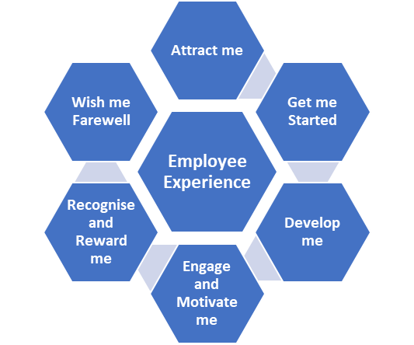

Health & Wellbeing Actions 2023 – 2025
Our Health | Our Good work | Our Values & Principles | Collective & Social Wellbeing | Our Personal Growth | Our Good Lifestyle Choices | Our Financial Wellbeing
Action |  |  |  |  |  |  | Timescale
Redesign and relaunch of Employee Wellbeing Support Service |  |  |  |  |  |  | May 2023
Promotion of regular Health & Wellbeing themes, information and events aligned to Annual Health & Wellbeing Calendar |  |  |  |  |  |  | Annual calendar Jan - Dec
Develop opportunities for increased awareness of Occupational Health supports, including access to occupational health provider newsletters and other relevant employee information |  |  |  |  |  |  | Attendance at quarterly OH meetings
Raise awareness of existing and new Employee Health & Wellbeing benefits including Dental Plans, Cycle to Work Schemes, and partnership activities that promote health & wellbeing activities (eg Park Lives) |  |  |  |  |  |  | Regular promotion on the EH&WSS Site
Launch access to DWP Able Futures programme |  |  |  |  |  |  | April 2023
Review and redesign of supports for all employees and their managers to record and implement supportive discussions to manage health & wellbeing (e.g. review of Stress Discussion Document) |  |  |  |  |  |  | October 2023
Delivery of training and learning opportunities to support health & wellbeing, e.g. Creating a Mentally Healthy Workplace, MAYBO Conflict Management training, Coaching Conversations and Courageous Conversations |  |  |  |  |  |  | Monthly dates on MyLearn
Consider developing a post of Employee Well-being Advisor post. |  |  |  |  |  |  | December 2023
Review and promote training, learning and supports to enable all Managers to effectively undertake proactive and trauma informed Supporting Attendance activities. |  |  |  |  |  |  | December 2023

Health & Wellbeing Actions 2023 – 2025
Our Health | Our Good work | Our Values & Principles | Collective & Social Wellbeing | Our Personal Growth | Our Good Lifestyle Choices | Our Financial Wellbeing
Action |  |  |  |  |  |  | Timescale
Ensure continued implementation of DCC Hybrid Working Policy to support appropriate work/life balance for employees |  |  |  |  |  |  | Ongoing
Introduce a new model of Display Screen Equipment Risk Assessment for all employees |  |  |  |  |  |  | October 2023
Undertake a trauma informed review to managing absence that supports a redesign of the existing Promoting Attendance Policy |  |  |  |  |  |  | April 2024
Develop joint approaches to supporting attendance and ensuring employee wellbeing with Trades Unions, including opportunities for Trades Unions wellbeing resources on re-launched Employee Wellbeing Support Service |  |  |  |  |  |  | Bi-monthly liaison with TUs
Launch Quality Conversations model for developmental conversations |  |  |  |  |  |  | September 2023
Undertake regular Employee Surveys and Employee Pulse Surveys that include health and wellbeing themes, mapping key themes and taking forward opportunities for improvements |  |  |  |  |  |  | As and when required
Ensure an organisational approach to managing change contains relevant health and wellbeing considerations |  |  |  |  |  |  | Ongoing
Implement opportunities for Leadership Development that have trauma informed leadership and wellbeing as integral elements of any programmes |  |  |  |  |  |  | February 2023
Host an annual Recognition Week to celebrate learning achievements across the organisation |  |  |  |  |  |  | Annually in January

Health & Wellbeing Actions 2023 – 2027
Our Health | Our Good work | Our Values & Principles | Collective & Social Wellbeing | Our Personal Growth | Our Good Lifestyle Choices | Our Financial Wellbeing
Action |  |  |  |  |  |  | Timescale
Launch DCC Values Framework |  |  |  |  |  |  | January 2024
Implement a values-based leadership programme |  |  |  |  |  |  | February 2023
Support Community Wealth Building |  |  |  |  |  |  | May 2023
Promote volunteering opportunities |  |  |  |  |  |  | Ongoing
Support access to mentoring within the organisation, and opportunities for access to external mentoring programmes |  |  |  |  |  |  | Ongoing
Develop and launch a new suite of Equalities Training materials |  |  |  |  |  |  | January 2024
Ensure that the Framework and accompanying actions support the Council in meeting its equality duties (general and specific) by supporting equality mainstreaming activities and progressing activities that contribute to the support of equality and human rights of all of the workforce. |  |  |  |  |  |  | Annual mainstreaming report

Health & Wellbeing Actions 2023 – 2027
Our Health | Our Good work | Our Values & Principles | Collective & Social Wellbeing | Our Personal Growth | Our Good Lifestyle Choices | Our Financial Wellbeing
Action |  |  |  |  |  |  | Timescale
Relaunch Leading Team Dundee |  |  |  |  |  |  | August 2023
Explore and promote employee opportunities to take part in collective health and wellbeing activities such as walking groups, health related activities, and other social health and wellbeing activities |  |  |  |  |  |  | Ongoing
Launch Employee Wellbeing Ambassadors model |  |  |  |  |  |  | May 2023
Hold annual Health & Wellbeing Week |  |  |  |  |  |  | May 2023
Promote Reflection and Resilience through Change programme |  |  |  |  |  |  | Ongoing

Health & Wellbeing Actions 2023 – 2027
Our Health | Our Good work | Our Values & Principles | Collective & Social Wellbeing | Our Personal Growth | Our Good Lifestyle Choices | Our Financial Wellbeing
Action |  |  |  |  |  |  | Timescale
Promote the Personal and Professional Development Fund to support accredited learning and development |  |  |  |  |  |  | Ongoing
Review DCC Coaching and Mentoring Framework |  |  |  |  |  |  | January 2024
Link Quality Conversations to the Personal and Professional Development Fund |  |  |  |  |  |  | March 2023
Review Performance Management Framework to embed Health and Wellbeing |  |  |  |  |  |  | June 2024
Develop a model of Skills Utilisation and Succession Planning |  |  |  |  |  |  | January 2025
Design a Skills Network micro-site for access to free learning for all employees |  |  |  |  |  |  | January 2024

Health & Wellbeing Actions 2023 – 2027
Our Health | Our Good work | Our Values & Principles | Collective & Social Wellbeing | Our Personal Growth | Our Good Lifestyle Choices | Our Financial Wellbeing
Action |  |  |  |  |  |  | Timescale
Use Yammer and other communication models to promote activities around health and wellbeing activities such as walking clubs, yoga, healthy eating and health awareness |  |  |  |  |  |  | Ongoing
Promote Employee Benefits schemes such as Vivup |  |  |  |  |  |  | Ongoing

Health & Wellbeing Actions 2023 – 2027
Our Health | Our Good work | Our Values & Principles | Collective & Social Wellbeing | Our Personal Growth | Our Good Lifestyle Choices | Our Financial Wellbeing
Action |  |  |  |  |  |  | Timescale
Promote Retirement Planning and access to Pre-Retirement courses and information |  |  |  |  |  |  | Ongoing
Promote Employee Additional Pension Contribution Scheme |  |  |  |  |  |  | Ongoing
Liaise with Welfare Rights and Third Sector colleagues to promote access to income maximisation opportunities and community-based cost of living supports |  |  |  |  |  |  | June 2023
Launch a harmful Gambling Workforce Charter |  |  |  |  |  |  | August 2023

Health and Safety at Work Act 1974 (HASAWA) and the Management of Health and Safety at Work Regulations 1999

