REPORT TO: SCRUTINY COMMITTEE – 4 DECEMBER 2024

REPORT ON: BI-ANNUAL REPORT ON COMPLAINTS – 2024/2025

REPORT BY: CHIEF EXECUTIVE

REPORT NO: 308-2024

1. PURPOSE

The Bi-Annual Report on Complaints for 2024/25, contained in Appendix 1, presents an update on performance in the first half of 2024/2025, with comparisons to previous periods, and shows how the Council continues to learn from complaints.

2. RECOMMENDATIONS

It is recommended that Committee notes:

- the key performance indicators on complaints closed between 1 April 2024 and 30 September 2024, with trends from previous periods (Section 3 of the report).

- a summary of complaints about the Council received by and determined by the Scottish Public Services Ombudsman during 2023/24 (Section 5).

- examples of the range and volume of transactions the Council has with customers and citizens as a context for the number of complaints (Section 7).

- examples of how complaints have been used to improve services (Section 8).

- examples of compliments received about Council services (Section 9); and

- results of the satisfaction survey sent to people who made complaints (Section 10).

3. FINANCIAL IMPLICATIONS

None.

4. BACKGROUND

4.1 The model Complaints Handling Procedure for Local Authorities requires that regular reports are produced for Elected Members. This report covers complaints close between 1 April and 30 September 2024. It also includes information about complaints regarding the Council which were dealt with by the Ombudsman in 2023/24.
4.2 Benchmarking information from other Scottish Councils, based on analysis by the Scottish Local Authorities Complaint Handlers Network, is also included in the report.

5. OVERVIEW OF PERFORMANCE
5.1 Detailed information is included in the Appendix 1, but key information to highlight is summarised below:
a) The council closed 388 complaints in in the first half of 2024/25, compared to 524 in the same period in 2023/24.
b) 67.4% of Stage 1 complaints were completed within the 5-day target – an increase from 56.4% on the same period in 2023/24. The average number of days taken to close Stage 1 complaints was 5.8, compared to 7.1 in the first half of 2023/24.
c) 49.2% of Stage 2 complaints were completed within the 20-day target, lower than in the first half of 2023/24 (51.7%). The average number of days increased to 28.4, from 26.1 in 2023/24.
d) The top reason for complaints in the first six months of the year was “Failure to provide a service” (26%). The second most common reason for complaints was “Delay in responding to enquiries or queries” (23%). This trend in nature of complaints has remained unchanged in the last three years.
e) Benchmarking information from other Scottish Councils, based on analysis by the Scottish Local Authorities Complaint Handlers Network, shows that in 2023/24 three of the four key performance indicators are worse than our Family Group average or the Scottish average score. These include: the percentage of Stage 1 and Stage 2 complaints closed within the target timescales of 5 and 20 days, and the average number of days taken to close Stage 2 complaints. However, the average number of days to close Stage 1 complaints indicator is significantly better the Family Group average and the Scottish average.
5.2 Any issues reflected in this report will continue to be discussed by the Council Leadership Team, the Complaints Review Group and within individual services. The “Learning from Complaints” section demonstrates the Council’s commitment to continually improve the service that is provided to the citizens of Dundee, as well as the processes to prevent the same issues recurring. A number of complaints led senior managers having discussions within their services about how to ensure that improving customer experience is at the heart of service delivery.

6. STATISTICS FROM THE SCOTTISH PUBLIC SERVICE OMBUDSMAN

6.1 31 complaints were received by the Ombudsman about Dundee City Council in 2023/24, compared to 18 in 2022/23. This represented 2.22% of complaints received by the Ombudsman about all local authorities in the year 2023/24. Out of the 31 complaints, the majority were related to Housing issues.

6.2 The Ombudsman determined 38 cases with outcomes recorded as:

- Advice given – 16
- Early Resolution – 19
- Investigation: Not duly made or withdrawn – 1
- Investigation: Fully upheld – 2

7. POLICY IMPLICATIONS

7.1 This report has been subject to the Pre-IIA Screening Tool and does not make any recommendations for change to strategy, policy, procedures, services, or funding and so has not been subject to an Integrated Impact Assessment. An appropriate senior manager has reviewed and agreed with this assessment.

7.2 The complaints recording database includes a feature that asks those dealing with complaints to note whether any complaints relate to an equalities issue - age, disability, gender, LGBT, race or religion. During the first half of 2024/25, there was one such complaint recorded relating to disability. This complaint has been drawn to the attention of the lead officer with responsibility for equality and diversity and any issues identified will be taken up with the service concerned.

8. CONSULTATIONS

The Council Management Team was consulted in the preparation of this report.

9. BACKGROUND PAPERS

None.

GREGORY COLGAN  CHIEF EXECUTIVE | DATE: 13 NOVEMBER 2024

ANDREA CALDER
HEAD OF CHIEF EXECUTIVE’S SERVICE

APPENDIX 1

Dundee City Council
Bi-annual Report on Complaints

2024-2025

Report by: Chief Executive’s Service

- INTRODUCTION
Dundee City Council values complaints and we use the information from them to improve our services.

We all know that things can go wrong in any organisation which provides services, especially one that has as many and varied interactions with the public as we do.

We treat complaints as a valuable source of customer feedback and strive to deal with them well, carrying out thorough, fair and impartial investigations and making evidence-based decisions.

If something has gone wrong, complaints let us put things right and can also help us to learn lessons, and to improve our processes to prevent the same problems happening again.

- DUNDEE CITY COUNCIL COMPLAINTS PROCESS
We use the Scottish Local Authorities Model Complaints Handling Procedure which defines a complaint as:

“an expression of dissatisfaction about the Council’s action or lack of action or about the standard of service provided by or on its behalf”

Our aim is to resolve complaints quickly, and as close the point of service delivery as possible. The procedure has two stages:

- At Stage 1 of the complaints process, the target is to respond within 5 working days, unless there are exceptional circumstances. this can be extended to up to 10 working days if necessary.

- Stage 2 complaints process is used if the complaint is particularly serious or complex and can’t be dealt with within 10 days, or if the person remains dissatisfied after they’ve had a Stage 1 response.

If the person is still not happy, they can then go to the independent Scottish Public Services Ombudsman.

- KEY PERFORMANCE INDICATORS
The Scottish Public Services Ombudsman placed a duty on councils to report on a bi-annual basis on the Key Performance Indicators relating to complaints handling. Sections below present our performance on complaints in the period from April to September 2024.
  - Total number of complaints closed
The council closed 388 complaints between April and September 2024. This is a considerable reduction on the same period last year, when we closed 524 complaints. We closed: 325 complaints at Stage 1 (Frontline) and 63 at Stage 2 (Investigation). Of the Stage 2 complaints, 33 were opened at this stage, and 20 were escalated from Stage 1.
For closed complaints, the graph at 3.1.1 shows the trend over the last 7 years and the Table at 3.1.2 shows a breakdown by service area and the trend.
The graphs at 3.2 to 3.6 provide details of our performance for the last 3 years in the first half of each year.

3.1.1 Total number of complaints closed in the first half of the last 7 years

The chart below shows the number of complaints closed by service in the first half of the last seven years:
Service | Apr-Sep  2018 | Apr-Sep 2019 | Apr-Sep  2020 | Apr-Sep  2021 | Apr-Sep  2022 | Apr-Sep  2023 | Apr-Sep  2024
Corporate Services | 51 | 35 | 36 | 44 | 47 | 53 | 35
Children and Families
- Education | 47 | 47 | 7 | 29 | 29 | 37 | 43
- Children's Services | 21 | 22 | 19 | 22 | 29 | 25 | 16
- Criminal Justice | 1 | 5 | 0 | 2 | 3 | 1 | 5
Neighbourhood Services
- Housing and Construction | 93 | 78 | 49 | 82 | 69 | 150 | 116
- Environment | 79 | 58 | 61 | 107 | 138 | 148 | 107
- Communities, Safety and Protection | N/A | 7 | 12 | 17 | 20 | 34 | 13
City Development | 29 | 19 | 15 | 25 | 27 | 59 | 43
Chief Executive's | 4 | 2 | 1 | 1 | 0 | 1 | 0
Dundee Health and Social Care Partnership: Social Work | 15 | 23 | 10 | 29 | 18 | 16 | 10
TOTAL | 340 | 296 | 210 | 358 | 380 | 524 | 388

3.2 Stage 1 complaints closed within the target of 5 working days

3.3 Average number of days taken to close Stage 1 complaints

3.4 Stage 2 complaints closed within the target of 20 working days

3.5 Average number of days taken to close Stage 2 complaints

3.6 Outcomes of Stage 1 and Stage 2 complaints closed in the period April - September 2024
325 complaints at Stage 1:

63 complaints at Stage 2:

- NATURE OF COMPLAINTS
The chart below shows the nature of complaints closed in the first half of the year over the last seven years.
 | Apr-Sep  2018 | Apr-Sep  2019 | Apr-Sep  2020 | Apr-Sep  2021 | Apr-Sep  2022 | Apr-Sep  2023 | Apr-Sep  2024
Delay in responding to enquiries and requests | 13.8% | 16.3% | 11.2% | 18.2% | 19.7% | 23.1% | 23%
Failure to meet our service standards | 21.5% | 17.8% | 13.1% | 19.0% | 15.4% | 14.4% | 14%
Treatment by or attitude of a member of staff | 25.1% | 24.8% | 23.8% | 2  1.2% | 19.5% | 20.1% | 21%
Failure to provide a service | 21.1% | 25.6% | 27.1% | 25.2% | 36.7% | 25.0% | 26%
Dissatisfaction with our policy | 12.3% | 11.2% | 15.9% | 12.6% | 6.2% | 11.9% | 11%
Failure to follow the proper administrative process | 6.2% | 4.3% | 8.9% | 3.8% | 2.6% | 5.5% | 5%

- STATISTICS FROM THE SCOTTISH PUBLIC SERVICE OMBUDSMAN FOR 2023/24
31 complaints were received by the Ombudsman about Dundee City Council in 2023/24, compared to 18 in 2022/23.
Subject of complaint: | No of cases:
Education | 1
Environmental Health & Cleansing | 1
Housing | 13
Land and Property | 1
Legal & Admin | 2
Planning | 4
Roads & Transport | 2
Social Work | 4
Subject Unknown (or outside of Jurisdiction) | 3
Total | 31

The Ombudsman determined a total of 38 complaints about Dundee City Council in 2023/24:
Outcome of cases determined: | No of cases:
Advice Given | 16
Early Resolution | 19
Investigation: Fully upheld | 2
Investigation: Not duly made or withdrawn | 1
Total | 38
- NATIONAL COMPLAINTS BENCHMARKING FOR 2023/24
Complaints performance indicators are collected annually from all local authorities in Scotland and annual benchmarking data is available for all Family Groups. Dundee is in Family Group 4. Figures in brackets indicate statistical information for the year 2022/23 for comparison.
  - Key Performance Indicators 2023/24 (and 2022/23, where data was available)
Indicator | Dundee | Family Group 4 | Scottish Average
% of Stage 1 closed within target | 55.7% (68.4%) | 59.1% | 64.6%
% of Stage 2 closed within target | 46.8% (54.4%) | 56.9% | 62.5%
Stage 1 average days | 7.7 (5.0) | 14.2 (12.1) | 9.4 (7.0)
Stage 2 average days | 27.8 (26.1) | 24.9 (19.7) | - (19.3)

6.2 Outcomes of complaints in 2023/24 (and 2022/23)

Stage 1 complaints:
Outcome | Dundee | Family Group 4 | Scottish Average
Upheld | 24.9% (21.4%) | 29.8% (29.8%) | 31.1% (39.3%)
Not Upheld | 48.1% (59.1%) | 33.0% (32.4%) | 36.1% (27.2%)
Partially Upheld | 12.8% (9.2%) | 23.1% (24.5%) | 17.1% (16.8%)
Resolved | 14.2% (10.2%) | 14.1% (13.3%) | 15.7% (16.7%)

Stage 2 complaints:
Outcome | Dundee | Family Group 4 | Scottish Average
Upheld | 21.9% (14.4%) | 20.1% (28.4%) | 18.2% (30.4%)
Not Upheld | 58.2% (48.8%) | 46.1% (38.9%) | 52.6% (42.1%)
Partially Upheld | 15.6% (27.2%) | 26.9% (19.1%) | 25.3% (20.0%)
Resolved | 4.3% (9.6%) | 7.0% (13.7%) | 3.9% (7.7%)

- EXAMPLES OF ANNUAL CUSTOMER TRANSACTIONS WITH THE COUNCIL
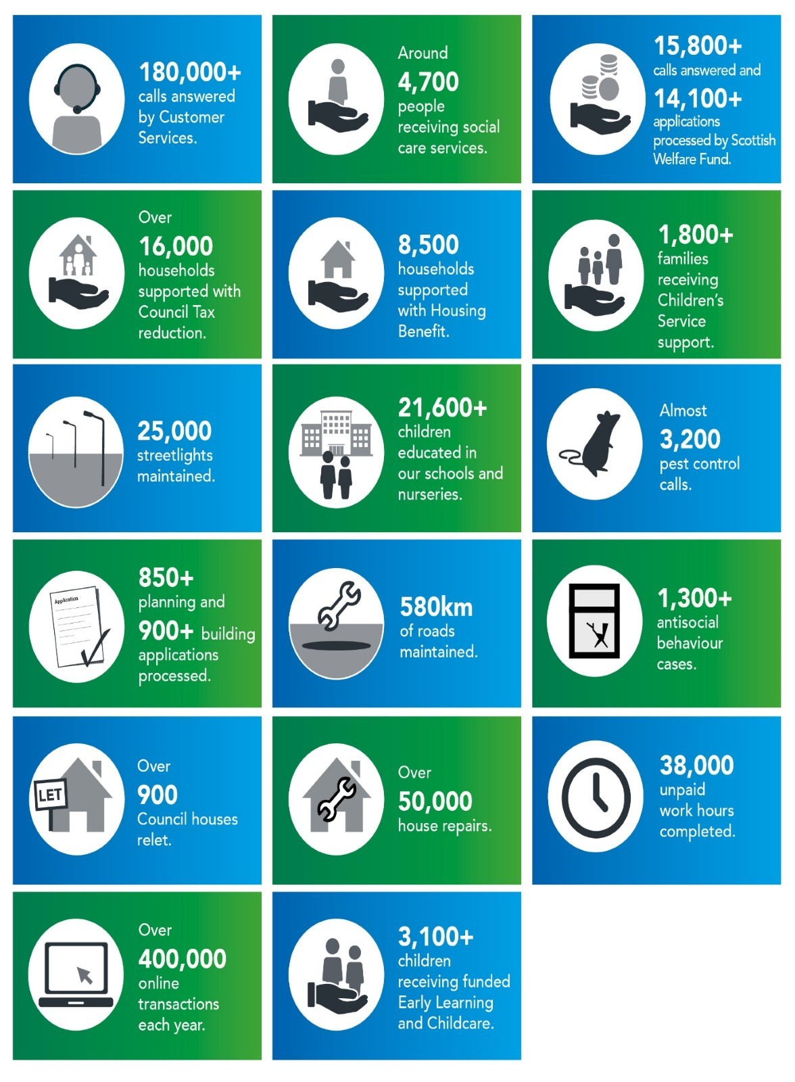
- LEARNING FROM COMPLAINTS
Officers closing off a complaint as upheld or partially upheld are asked to identify planned service improvements, designed to prevent similar issues recurring. These often involve speaking to individual employees, arranging training for teams on correct use of procedures and customer care standards, or close supervision for a period.

In addition to these actions following complaints, below are some examples of how complaints were used to identify wider process/service improvements during the first half of 2024/25:

A customer complained that... | We listened, we acted...
One of our waste management teams missed a recycling bin collection three times | All bins on this route have been serviced and the route will be monitored to ensure this isn’t repeated.
The council’s housing repairs unit had long delays in carrying out survey related to damp and mold in his home | The service has now hired an external contractor to deal with the backlog of reported damp and mold cases, to carry out our surveys and repairs in a timely manner.
Tenement on the opposite side of their street overflows 4 days of the week, causing seagulls to empty contents of bin onto street | The service will monitor the area over the next couple of months to see if there is a requirement for extra Euro Bins, or collections.
A client’s Housing Benefit took up to 4 weeks to be updated following a reduction in her wages, which meant she was left in financial difficulties while waiting for an increase in her benefit entitlement. | Staff will escalate cases and requests as a priority where a delay may cause the customer severe financial hardship.
Parent of a Polish schoolchild complained that teachers removed her child’s surname from an awards presentation script due to difficulties in pronunciation. | The school introduced a procedure for recording pupils’ surnames so that staff can replay and practice pronouncing them, to ensure all children’s names are included and celebrated.
Customer applied for a Council Tax exemption in October 2023, supplied documents and has not heard until April 2024. | The team will look to improve communication regarding such requests going forward.
Customer was unhappy with the poor quality of her property following a mutual exchange process. | The mutual exchange process is to be reviewed to ensure the quality of property meets all the standards prior to the swap being arranged.
Customer was frustrated that no one at DCC appeared to answer calls or return messages left on voicemails, after waiting for an hour for his call to be answered and finally hanging up. | IT have removed the overflow skillset entirely to ensure that this does not happen again
A parent of a school child complained that there had not been appropriate communication from the school around the bullying issues they reported, and that there had been no outcome reported to them as to the procedures taken to address the behaviour of the child displaying bullying behaviour. | The school arranged a meeting with the parent to discuss and devise a plan for going forward, which will be regularly reviewed, with timescales agreed with the parent. The meetings will be recorded in the school to ensure that any bullying behaviours are logged along with any support that the child affected may need.

- COMPLIMENTS
In addition to complaints, the Council also receives a number of compliments from members of the public, who are satisfied with the service they have been provided with. Below are the compliments which were submitted by our customers between April and September 2024/25 on the 'Tell Us About Good Service' form on the Council's website, or directly to the Customer Services Team.

Ms X wishes to convey the fact that we are all brilliant & work hard & she is thankful for all the service.
I feel I have to email about the exceptional lady who helped myself and my dad go through the process of reporting my mums death. It’s in moments like this when myself and dad were in new territory and the lady we spoke to was absolutely outstanding I cannot praise her enough for the help and compassion she showed us and she actually made me giggle in an emotional time which is what we needed. Her explanations and guidance were absolutely first class and guided us on our phone appointment and what we would need. Cannot thank her enough what a star.
I spoke with X twice. Once on 24/04/2024 and again on 10/05/2024. She was extremely knowledgeable, helpful, kind, understanding and overall just provided a great service. She definitely deserves recognition for such wonderful service.
Reported a repair yesterday about loose slabs on stairs. The workmen were out today and fixed them. They have done a great job, thank you.
A lady on a housing repair call who got a joiner in an urgent call to one of my community patients who was stuck in chair from the previous day, she was very kind and reassuring. Also, the elderly lady was very grateful to the joiner who was aware she'd been stuck from the day before, he gave her a new lock, left spare keys and made her a cup of tea and gave her something to eat before we got there Thankyou to them both. From a community nurse :)
I would just like to highlight what an excellent worker we had today in Buttars Place. The euro bins in the street hadn’t been emptied all week due to resurfacing work. The street was in an absolute mess due to bins overflowing and birds ripping at the bags. Once the bin lorry had been down another council worker came along in his van and cleaned the whole street. The street looks immaculate - better than it did before! This is extremely appreciated by the residents and thank you to the worker for doing such a great job.
I came from Australia to further research my ancestry in Dundee. I was introduced to volunteer Josh who helps out at the local history library. Well this young man was outstanding, brilliant in sourcing documentation on my great grandfather. I was thrilled with his effort, great knowledge on where to look and what to do. He even directed us to the dwelling where my great grandfather lived! So thoughtful and knew his stuff! Josh would be a fantastic asset to take on full time. His knowledge is invaluable and his work ethic exemplary. We can’t thank Josh enough. Sincerely made my trip to Dundee worthwhile. Thanks again Josh and best wishes for your future.
I just want to congratulate DCC for all the wildflower sowing in the city...especially along Riverside and Lochee Road...it fair lifts the spirits. Thank you and please consider sowing more areas next year...its so good for the bees and insects.
I really appreciate you cut the nettle on the path from the Ancrum road allotments along the rail.
Entrance to Morven Terrace. This has successfully been done. Many thanks.
I'm very grateful to you that the forgotten roadwork sign was removed promptly after I contacted you. Thank you very much!
My bin and neighbour's brown bins have been collected so promptly after I contacted you. It was an impressive service. Thank you very much.
I would like to acknowledge the excellent customer service given by a gentleman named S.
After many attempts to speak with someone he happened to answer the telephone and solved the problems I experienced with paying a LEZ notification. He called me back as he said he would and understood the problems I was experiencing and resolved them all. Excellent!!!!
I am emailing with regards to my telephone call to your Council Tax department this morning regarding my account, the outstanding balances for 2023 and 2024. I spoke to a lovely lady called who helped me with my inquiry and informed me of how much I would have to pay each month (As I have never received a Council Tax Demand for this year). She was very accommodating and sympathetic, not to mention non-judgemental. She helped me sort things out and, reassured me after I received two reminder letters threatening me with a Summary Warrant, that no further action would be taken. I'd like it noted how helpful this lady was. And that she went above and beyond to help me. It just shows that there are kind and helpful people at Dundee City Council. Which in my experience is a rarity with you people.
A customer passed her compliments and thanks to one of our customer services adviser’s line manager. She wanted it noted that the adviser listened to her, understood her complaint and was compassionate. There should be more advisers like her on our phoneline and she is a credit to Dundee City Council.
We received a nice call from a Mrs X. who called to thank the customer services adviser for her lovely service last Friday and patience. She explained that she called a few times and spoke with the female adviser who was very kind and helpful and she wanted to acknowledge that.

- SATISFACTION SURVEY
The model Complaints Handling Procedure requires the Council to report on a measure of customer satisfaction with its complaints process. To do this, we issue quarterly surveys to people who have made complaints. Since the survey sample consists entirely of people who have made a complaint, many of which are not upheld, it may not be surprising that satisfaction levels are not particularly high.
In the first quarter the survey was sent to 145 customers who had their complaint closed between April and June 2024, and we received 46 responses. Out of 133 surveys sent to customers who had their complaint dealt with between July and September received 39 responses, giving a total of 85 responses. Caution must be exercised due to the small sample who return the survey and the fact that those who remain unhappy may be more motivated to do so.
Question 1: Please indicate the extent to which you agree or disagree with the statements below:

Question 2: I was told if the response was going to take longer than the set timescales (5 working days at Stage 1 and 20 working days at Stage 2)

Questions 3: What service was your complaint about?

Question 4: Overall, how satisfied, or dissatisfied are you with the outcome of your complaint?

