Strategic Environmental Assessment

of the

Draft Dundee Outdoor Access Strategy 2012-17

Environmental Report
January 2012

Contents

1. Non-technical summary 3
1.1. Introduction 3
1.1.1. Purpose of this Environmental Report 3
1.1.2. Key Facts 4
1.1.4. SEA activities to date 7
2. Plan context 12
2.1. Description of the Outdoor Access Strategy 12
2.2. Relationship with other Plans, Programmes and Strategies 13
2.3. Relevant aspects of the current state of the environment 14
2.4. Environmental Problems 21
2.5. Likely evolution of the environment without the Dundee Outdoor Access Strategy 23
2.6. SEA Objectives 23
3. Assessment of environmental effects and measures envisaged for prevention, reduction and offset of significant adverse effects 25
3.1. Alternatives to which SEA was applied 25
3.2. Assessment Methods 25
3.3. Summary of the assessment of the Dundee Outdoor Access Strategy 27
3.4. Assessment of alternatives - cumulative and synergistic effects 28
3.5. Measures envisaged for the prevention, reduction and offsetting of significant adverse effects 30
4. Monitoring 32
5. Next steps 34
Appendix A: Links to other PPS and environmental objectives 35
Appendix B: Full assessment results 38
Appendix C: The Conservation (Natural Habitats, &c.) Regulations 1994 51
Appendix D: Designated Sites 52
List of Scheduled Ancient Monuments 52

1. Non-technical summary

1.1. Introduction

1.1.1. Purpose of this Environmental Report

As part of the preparation of the Dundee Outdoor Access Strategy 2012-17, Dundee City Council is carrying out a Strategic Environmental Assessment (SEA). SEA is a systematic method for considering the likely environmental effects of certain Plans, Programmes or Strategies (PPS). SEA aims to:

- integrate environmental factors into PPS preparation and decision-making;
- improve PPS and enhance environmental protection;
- increase public participation in decision making; and
- facilitate openness and transparency of decision-making.

SEA is required by the Environmental Assessment (Scotland) Act 2005. The key SEA stages are:

Screening determining whether the PPS is likely to have significant environmental effects and whether an SEA is required

Scoping deciding on the scope and level of detail of the Environmental Report, and the consultation period for the report – this is done in consultation with Scottish Natural Heritage, The Scottish Ministers (Historic Scotland) and the Scottish Environment Protection Agency

Environmental publishing an Environmental Report on the PPS and its
Report environmental effects, and consulting on that report

Adoption providing information on: the adopted PPS; how consultation comments have been taken into account; and methods for monitoring the significant environmental effects of the implementation of the PPS

Monitoring monitoring significant environmental effects in such a manner so as to also enable the Responsible Authority to identify any unforeseen adverse effects at an early stage and undertake appropriate remedial action.

The purpose of this Environmental Report is to:

- provide information on the Dundee Outdoor Access Strategy 2012-17;

- identify, describe and evaluate the likely significant effects of the Dundee Outdoor Access Strategy 2012-17, and any reasonable alternatives;

- provide an early and effective opportunity for the Consultation Authorities and the public to offer views on any aspect of this Environmental Report.

1.1.2. Key Facts
Name of Responsible Authority | Dundee City Council
Title of PPS | Dundee Outdoor Access Strategy 2012-17
What prompted the Strategy (e.g. legislative, regulatory or administrative provision) | Review of the 2005-2010 A Liveable City, Dundee Outdoor Access Strategy.
Subject (e.g. transport) | Outdoor Access
Period covered by Strategy | 2012 - 2017
Frequency of updates | Every 5 years
Area covered by Strategy | Dundee City Local Authority Area
Purpose of Strategy | The strategy directs outdoor access provision in Dundee, setting strategic framework and practical action. It is the city’s response to the Land Reform Act, encouraging active travel and the use of green spaces for health, recreation and well-being.
Objectives of Strategy | To help guide investment and management of our city's open spaces to be accessible and more attractive and enjoyable for all.  To encourage responsible access and promote access rights.  To ensure the council delivers its duties and uses its powers to uphold its statutory requirements.  To help Dundee become a healthy and sustainable city.
Contact point | John Whyman  Outdoor Access Officer,  Dundee City Council Environment Department,  353, Clepington Road,  Dundee DD3 5PL.

1.1.3. Key Findings
The main results of the assessment process are:

The Strategy may influence and be influenced by a range of other plans, programmes and environmental objectives relating to the topics scoped into the Environmental Assessment (biodiversity, flora, fauna, human health, material assets, landscapes and cultural heritage). These plans, programmes and objectives are from a range of sources and include both local and national documents.

An assessment was made of the relevant aspects of the current state of the environment in relation to the topics scoped into this report. This provides a baseline from which to assess the Strategy and its potential effects. The report outlines the sites which are of most importance to the assessment and provides data on the usage of currently signposted and promoted path networks in Dundee.

The Strategy carries forward continual development from the previous outdoor access strategies for Dundee. Many of the objectives and priority projects described in the strategy are carried forward from the previous outdoor access strategies for the City of Dundee, revised to demonstrate contribution to the Dundee Single Outcome Agreement, while continuing to link to the Local Community Plans. Some objects and priority projects have already been included in SEA Environmental Reports for the Public Open Space Strategy and the Core Path Plan. The emphasis of the Outdoor Access Strategy of 2005-2010 was on participation, which continues into the new strategy, although there are new opportunities for health promotion and community engagement.

Environmental problems related to the Outdoor Access Strategy include:
- the promotion and signposting of paths may increase visitor numbers to sites of important natural and cultural heritage sites and increase potential damage to these sites through legitimate access and antisocial behaviour
- the potential for disturbance to the Firth of Tay site and to European Protected Species
- the threat of invasive weed species, particularly along riparian routes
- the unauthorised or illegal access as use of motorised forms of recreation, damaging sites and features
- areas of local landscape and amenity significance are locations which are likely to be desired for developing access, could be affected by extending the path networks, or their longer term maintenance and associated infrastructure
- attractive areas can be particularly sensitive to disturbance
- the potential for cumulative effects of increased use of paths networks
- the increased maintenance burden with an increasing path network

The environmental protection objectives relevant to the Strategy are:
- To maintain and enhance biodiversity, flora, and fauna
- To avoid damage or disturbance to European Protected Species and provide positive opportunities.
- Provide appropriate opportunities for people to come into contact with and appreciate wildlife and wild places
- Provide opportunities for healthy outdoor activities
- Maintain and improve the material assets of paths and green space
- To conserve and where appropriate enhance the historic environment and cultural heritage
- Promote access to the historic environment
- To maintain and enhance the quality of landscapes and townscapes.
- To improve the quality of surroundings

These objectives have been used to assess the strategy, so that for each key Action an assessment has been made as to the likely effects against each of the above environmental objectives. The cumulative and synergistic effects were also assessed.
In general the adoption of the Strategy is likely to have a positive overall effect on the Dundee environment. The strategy promotes access to areas of natural, landscape and cultural heritage importance, as these tend to be popular places for people to visit, but also to take into consideration land management and any negative environmental impacts. The strategy will be used to promote responsible access to such sites and additional interpretation materials will be used to encourage responsible path use. The strategy also presents opportunities for habitat and landscape enhancements and access improvements to a variety of landscapes and townscapes, with the potential for education, volunteering and community stewardship to sustain value and benefit. Negative effects of the strategy were found to be that additional signage may provide more clutter on the landscape and there is potential that with increased use there could be an increase of litter, graffiti and user conflict in open spaces.

It is possible that the effect of any impacts that do arise may become increasingly significant when combined with other factors. This is likely to be the case where there is development of the rest of the path network and construction activities occurring concurrently with any core path activities. There are construction elements to the proposed Strategy, and some paths may be extended or upgraded through future funding opportunities.

The development and promotion of the strategy and its outcomes will increase awareness of the outdoor access and bring improvements in access to the Dundee area, whilst bringing support to other sustainable transport initiatives by linking in with local and regional public transport hubs and supporting the development and improvement of the network for active travel purposes.

Mitigation measures considered in the Environmental Report include:

- give consideration to the location of the habitats used by protected species and/or cultural important sites and select paths accordingly - alternative routes selected where necessary
- use promotional materials, signage and information to encourage sustainable use of paths and highlight sites of ecological or historical importance
- use promotional materials and police access to prevent conflict
- collect data on path usage and assess any disturbance or damage through regular path audits and visitor surveys
- encourage increased use of paths by legitimate users to discourage illegitimate use
- patrol and police access routes to deter illegitimate use
- select paths where land management conflicts and pressure on individual sites can be mitigated or avoided
- adopt waste management and maintenance strategies along access routes especially core paths
- use of improved specification and new materials to reduce long term maintenance of the expanding path network asset

Monitoring of the effects of implementing the Outdoor Access Strategy will be undertaken by regimes currently in place for monitoring the Public Open Space Strategy and the Single Outcome Agreement indicators. Information about Outdoor Access Strategy Outcomes will be collated annually and form part of an overall report on access related work across the Dundee City area, provided to the Local Access Forum at its AGM in April.

1.1.4. SEA activities to date
The SEA process began in September 2010 when a Screening Report was issued for consultation. Scottish Natural Heritage determined that the Outdoor Access Strategy had the potential to result in significant environmental effects. The both Historic Scotland and Scottish Environment Protection Agency determined that whilst the Plan may have positive environmental effects at the local level it was unlikely that there would be significant environmental effects with regards to their areas of interest.

A scoping report was issued in January 2011 and comments were received from the Consultation Authorities in February 2011. The main comments received from the Consultation Authorities are outlined in Table 2 below.

Table 2: Comments on the Scoping Report
Scoping Report | SNH | Historic Scotland | SEPA
Background Information | No comment | No comment | SEPA found the information provided in this section to be useful
Relationship with other plans and programmes | Provided a list of additional plans, programmes, policies and environmental objectives to be analysed for their relationship to the Outdoor Access Strategy and advised of superseded documents. | Commented that NPPG5 and NPPG18 were superseded by Scottish Planning Policy 23 Planning and the Historic Environment which in turn was superseded in February 2010 by Scottish Planning Policy (SPP). This list should also include Scottish Historic Environment Policy (SHEP) which outlines Scottish Minister’s policies on the Historic Environment and is produced by Historic Scotland.  Provided the key environmental protection objective of the legislation and policy framework i.e. ‘to protect and, where appropriate, enhance the historic environment’. | SEPA note that a comprehensive list of the plans, programmes and environmental objectives that are to be analysed in the Environmental Report has been provided.
Current state of the environment | Suggested a baseline of lengths of existing paths, cycle routes and equestrian routes data to assist in the prediction of the potential impacts.  Suggested information about designated sites should include notified interest or conservation objectives.  Suggested baseline information should include data on the use of existing access network.  Suggested the report should include a description of the likely evolution of the environment without the strategy. | Requested that Category C(S) list buildings should be considered with A and B listed buildings.  Provided sources of information for historic buildings gardens and landscapes. | Requested a summary of the likely changes to the environment if the Strategy is not implemented be provided in the Environmental Report.
Scope of assessment and level of detail | Subject to specific comments, SNH is content with the scope and level of detail proposed for the Environmental Assessment. | HS is content with the scope and level of detail proposed for the Environmental Assessment, noting that in the screening process HS assessed that it would be unlikely for the strategy to have significant negative impact. Include comment on why historical environment was scoped in. | SEPA are content with the proposed scope of the assessment.  Provide some further justification to why these topics can be scoped out rather than just referring to SEPA’s opinion.
Mitigation | Framework should identify where mitigation is desirable. | The Environmental Report should provide information on the measures proposed to mitigate any significant environmental effects likely to arise through the implementation of the strategy. As you will be aware, mitigation may involve making changes to the strategy and/or developing more detailed mitigation proposals to be implemented as the strategy is delivered. It would be helpful in the Environmental Report to clearly describe any changes made to the strategy as a result of the environmental assessment. It would also be helpful to identify who will be responsible for ensuring that any mitigation measures are taken forward as the strategy is implemented. | Where significant environmental effects are identified as a result of the assessment, the Environmental Report should clearly set out mitigation measures which are proposed to prevent, reduce and offset significant effects on the environment resulting from the implementation of the Strategy. These should follow the mitigation hierarchy (avoid, reduce, remedy or compensate). SEPA consider that mitigation is a crucial part of SEA in that it offers an opportunity to not only address potential adverse effects of a plan, but also to make a plan even more positive than it already may be (enhancement measures).  One of the most important ways to mitigate significant environmental effects identified through the assessment is to make changes to the plan itself so that significant effects are avoided. The Environmental Report should therefore identify any changes made to the Strategy as a result of the environmental assessment.  Set out all mitigation measures proposed in a way that clearly identified: (1) the measures required, (2) when they would be required and (3) who will be required to implement them.
Significant issues | Recommend specific reference to European Protected Species, maintaining links between features and national and local Biodiversity Action Plan (BAP) species/habitats.  Figure 4.2, under Biodiversity, Flora and Fauna, needs to make clear the implications for the higher level designated areas. The baseline information will establish the number, location, type of sites and conservation interest. For example, the potential effect of the strategy should ensure that the integrity of all internationally designated sites within or adjacent to the council boundary is protected and preserved.  The strategy has the potential to create the conditions to improve health in Dundee and  additional aspects could be included under Human Health in Figure 5.3. For example, a  problem could be that the network does not meet the needs of people of all ages and abilities which would be a deterrent to encouraging people to be more active. Another example might be health walks which make an important contribution but may be vulnerable to reductions in resources. There are clear links to outcomes in the Single Outcome Agreement such as  intermediate outcome 3h which states that ‘All Dundee children and young people have more active lifestyles’.  While the Green Circular Route is an important resource and links important spaces there are likely to be other locations where paths have the potential for an adverse effect on sites of natural heritage interest. | No comment | No comment
SEA Objectives | The environmental objectives of the strategy need to be established and reviewed against the SEA objectives for comparability. | No comment | SEPA supports the development of SEA objectives.
Assessment Methodology | The list of alternatives is noted but suggest there is scope to combine one or two to give clearer difference between options.  The environmental objectives of the strategy need to be established and reviewed against the SEA objectives for comparability.  Reasoning column to provide clearer explanations. Framework should identify where mitigation is desirable. | HS note that a matrix approach is proposed for the assessment (Figure 7.1). The use of the criteria for each of the environmental topics in column one should help focus the assessment. The inclusion of a column in the matrix for reasoning and additional comments will aid in identifying mitigation for any adverse effects identified.  When monitoring the effects of the strategy, indicators chosen for the historic environment should reflect both the actions to be taken within the strategy and the potential significant effects identified in the course of the SEA. | The environmental assessment should be carried out on all aspects of the Strategy that are likely to result in significant environmental effects including objectives, policies and proposals/actions.  SEPA notes that the assessment will be undertaken using a matrix and welcome the use of a column within the matrix to provide the reasoning for the scored impacts to help allow the Consultation Authorities to understand how the results of the assessment were reached.
Consultation period for the Environmental Report | SNH is content with the proposed 6 week consultation period | HS is content with the proposed 6 week consultation period. | SEPA is content with the proposed 6 week consultation period.

2. Plan context

2.1. Description of the Outdoor Access Strategy
The Land Reform (Scotland) Act 2003 established the right of responsible access to most of Scotland's outdoors. This right applies to people involved in non-motorised activities such as walking, cycling, horse riding and canoeing.

Dundee City Council is preparing an Outdoor Access Strategy which will direct outdoor access provision in Dundee. This is a major review of the City's 2005-2010 Access Strategy. Outdoor access includes all non--motorised travel, in and around our city and enjoying the outdoors in our green open space. This is often using paths through and linking our parks, woods and countryside, but also the active travel in built up areas between communities, their local facilities and work opportunities. The strategy aims to ensure socially inclusive, well planned outdoor which improves health, supports sustainable travel and improves quality of life. Dundee has many attractive open spaces throughout the city. Planning access to and through these spaces improves their benefit to our everyday lives and substantially contributes to 9 out of the 11 Outcomes of Dundee’s Single Outcome Agreement (SOA).

The Outdoor Access Strategy sits in a hierarchy of strategies and plans to the Pubic Open Space Strategy with Dundee Tree and Urban Forestry Policy and the Dundee Play Strategy. These documents together guide Dundee agencies in use and provision of our green and open spaces.

Dundee Community Plan
Public Open Space Strategy
Outdoor Access Strategy
Environment Strategy
Sport and Physical Activity Strategy
Core Paths Plan
Health Strategy

Tree and Urban Forestry Policy

Outdoor Play Area Strategy
Local Transport Strategy

The structure of the Outdoor Access Strategy follows its development. Consultation generated the Aims and Key Issues. The Aims have been arranged to explain their contribution to the Community Plan Key Themes and contribution to the outcomes of the Single Outcome Agreement. Key Issues have been listed under each of the Aims. Key Actions have been developed to address the Key Issues and these Key Issues have been assessed for their environmental impact in Appendix B.

The Outdoor Access Strategy aims to deliver the following:

- Dundee’s greenspaces, waterways and built environment will create attractive corridors and recreational spaces for all to enjoy

- Dundee’s citizens will be aware of their access rights and their responsibilities under the Scottish Outdoor Access Code and use them appropriately

- Dundee City Council will uphold its statutory requirements of the Land Reform (Scotland) Act 2003 by delivering its duties and using related powers

- Dundee’s citizens will be more active in their travel and recreation, with improved physical fitness and mental well-being

- Dundee will have paths, cycleways and public spaces of the highest quality, which are accessible, safer, well maintained and fully used by all

Once the formal consultation is completed, and provided there are no outstanding objections, the Plan will be adopted by the Council. The Strategy will be published and will be available on the Dundee City Council website www.dundeecity.gov.uk/outaccess/ as well as in Libraries across the City. Rolling annual Action Plans will be prepared to ensure delivery of the strategy. The strategy will then be reviewed and updated every 5 years.

2.2. Relationship with other Plans, Programmes and Strategies

The Plan may influence and be influenced by a range of other plans, programmes and environmental objectives. A review of such documents was undertaken during the scoping stage of the SEA process and the findings were reported in the Scoping Report.
Further analysis has taken place and recommendations have been made as to how the requirements of other plans, programmes and strategies and environmental protection objectives can be incorporated into the Outdoor Access Strategy.

The full analysis is available in Appendix A of this report. The key points from this analysis in relation to SEA objectives relevant to the Dundee Outdoor Access Strategy are:

Biodiversity, Flora and Fauna
In relation to biodiversity, flora and fauna the Nature Conservation (Scotland) Act 2004, which implements the EC Directives 92/43/EEC "the Habitats Directive" and 79/409/EEC "the Birds Directive", is of particular importance to the Dundee Outdoor Access Strategy. In this act a duty is placed on all public bodies to further the conservation of biodiversity. The Outdoor Access Strategy provides opportunities for habitat creation alongside new or improved paths, provides opportunities for local people to enjoy and appreciate local biodiversity in woodlands, at the coast or across meadows. The Strategy will also promote the value of our green spaces for education, interpretational events and practical conservation and ensures that these activities are accessible to everyone. Ultimately responsible use and volunteer support of green spaces help to discourage irresponsible access and help to retain local political interest and retain budgets for maintenance and enhancement.

Human Health
Implementation of Dundee Outdoor Access Strategy will contribute to increasing physical activity in green spaces which is accepted as having a significant role to play in improving physical health and mental wellbeing. This use of green spaces is recognised in Dundee's Joint Health Improvement Plan 2005-2008 and Sport and Physical Activity Strategy 2010-2015.

Material Assets
Council owned open spaces and owned and adopted paths are part of Dundee's asset management. Paths and open spaces whether council owned or not are part of the outdoor access and community assets for the city. Ensuring that these assets are linked meaningfully is the function of the Core Path Plan. Dundee Outdoor Access Strategy commits to maintaining and developing the asset.

Cultural Heritage
The Historic Environment is defined in Section 16(3) of the Public Appointments and Public Bodies etc. (Scotland) Act 2003 as "...any or all of the structures and places in Scotland of historical, archaeological or architectural interest or importance". Scottish Historic Environment Policy 1 (Section 2) builds on this definition by identifying that the historic environment encompasses built heritage features (ancient monuments, archaeological sites and landscapes, historic buildings, townscapes, parks, gardens, and designed landscapes as well as marine heritage) and the context or setting in which they sit, and the patterns of past use, in landscapes and within soil, and also in our towns, villages and streets. The historic environment also has less tangible aspects recognised as the historical, artistic, literary, linguistic and scenic associations of places and landscapes.
Previous Outdoor Access Strategies have helped add to Dundee's cultural heritage with community art installations, historical trails and interpretational signs at local historical sites.

Landscape
A number of documents are relevant to the Outdoor Access Strategy which outline best practice in urban and landscape design. When implementing the Outdoor Access Strategy on the ground these National, Regional and Local guidelines should be followed, taking into account the appropriate sections from the Landscape Character Assessment. The Outdoor Access Strategy has the potential to create positive opportunities for the restoration of landscape features such as dry stone dykes and hedges in areas next to paths through external funding opportunities, and to ensure paths add to the landscape through good design. Interpretational information may be able to help people understand the landscapes around them.

2.3. Relevant aspects of the current state of the environment
Schedule 3 of the Environmental Assessment (Scotland) Act 2005 requires that the Environmental Report includes a description of “the relevant aspects of the current state of the environment and the likely evolution thereof without implementation of the plan or programme”, and “the environmental characteristics of areas likely to be significantly affected”. This section aims to describe the environmental context within which the Dundee Outdoor Access Strategy will operate and the constraints and targets that this context imposes on the strategy.

Topics scoped out of the environmental assessment
The topics of air, water, soil, climatic factors, and population were scoped out of the environmental assessment. The topics under SEPA's area of interest (air, water, soil, climatic factors) were scoped out due to their response to the screening stage of the SEA process. The local authority agreed with SEPA's comment that whilst there may be positive environmental impacts in these areas at the local level, it is unlikely that there would be a significant environmental impact. The local authority also decided to scope out population from the environmental assessment.

The main reason for scoping out these topics from the environmental assessment is that whilst there may be a general increase in path use due to increased promotion and signage, it is unlikely that this increase will be significant enough to impact upon air, water, soil, climatic factors and pollution. While a modal shift away from motorised transport would be highly beneficial, it is more likely this would be as a result of a radical transport strategy than an Outdoor Access Strategy.

The Historic Environment was scoped in to the assessment because Dundee's cultural heritage is seen as been valuable in promoting the city as a visitor destination. Local history has been the subject of local walking and cycling trails, and historical features including buildings, standing stones, graves and landscapes are spread through our green spaces, in which the Dundee Outdoor Access Strategy may impact. Inclusion also gives an opportunity to highlight the positive impact of improved access on the historic and cultural environment.

These topics may be scoped in to the SEA when it is reviewed alongside the Outdoor Access Strategy in the future. This could be due to the result of monitoring of the existing strategy, or to the inclusion of new actions in a future revision.

Biodiversity, Flora and Fauna
Dundee has several sites which are important for the conservation and protection of biodiversity. In particular, the Firth of Tay Estuary is a high quality site for biodiversity. A number of designations have been assigned to it along the Dundee City Council area.

The Local Plan for Dundee City identifies the following sites of importance for their biodiversity, flora and fauna, the boundaries of which can be seen in the Natural Heritage Sites map in Appendix D:

- 1 Special Area of Conservation (SAC) and Special Protection Area (SPA) site:
  - the Tay Estuary
- 2 Ramsar Wetland Sites:
  - Broughty Ferry Beach
  - Inner Tay Estuary
- 2 Sites of Special Scientific Interest:
  - Monifieth Bay
  - Invergowrie Bay
  - (also Fowlis Den Site of Special Scientific Interest which shares a boundary with the local authority area)
- 3 Local Nature Reserves (LNRs):
  - Broughty Ferry
  - Inner Tay Estuary
  - Trottick Ponds
- 49 Nature Conservation Sites
- 41 Community Wildlife Sites

A habitats and species survey carried out in 2000 found that Dundee has many semi-natural woodlands, and grasslands with patches of relatively high local conservation value. There is great diversity in the types of woodlands, grasslands, tall herb and ephemeral vegetation communities, while other areas such as swamps, coastlands and heathland are sparse. Woodlands play a particularly important role in supporting Dundee's populations of red squirrels, bats, and a variety of birdlife.

In addition to these designated sites, there are other habitats within the Dundee City area that are important to wildlife and natural heritage. Of particular interest are the European Protected Species: bats, otters and dolphins.

The Bat Conservation Trust carried out surveys in Dundee in 2007 reported in Dundee City Bat Project Report. Volunteers of the Dundee Bat Group have continued to carry out surveys, and data will be used if disturbance to buildings or older trees is possible as a result access projects.

There are some locations in Dundee where otters may be present. Potential otter sites include the Trottick Ponds LNR and the Murroes Burn.

Over the last decade increasing numbers of dolphins have been visiting the River Tay in the summer months and dolphin watching is becoming a popular activity both on and off-shore. It will be possible to carry out dolphin watching activities from some core paths, particularly Broughty Ferry Esplanade. Dundee City Council has entered into discussions with SNH and other relevant organisations to agree a dolphin watching policy. The agreed policy will be promoted to those using Broughty Ferry for launching.

Human Health
The strategy has the capacity to improve human health by providing facilities for increasing physical activity and improving mental wellbeing. Many people (64% 2003 figures) in Tayside do not meet the guideline daily minimum physical activity, and it is suspected that as health issues are particularly prevalent in Dundee (average life expectancy is only 76.6 years 2009 figures), local physical activity levels are probably correspondingly lower in the city.

Material Assets
Dundee has a large open space asset (1393 hectares, 22% of the area) and many well connected access routes including 82 Core Paths (total 181.8km) and some well promoted routes such as 2 National Cycle Network routes and the Green Circular. There are also 5 promoted cycle routes (16.5km) mainly off road. Routes at Camperdown Play Area, Trottick Ponds LNR, Broughty Ferry LNR, Templeton Art and Yellow Trails, Ninewells Arboretum and The Miley have been improved specifically to allow for wheelchair and/or push chair access. Many other routes through Parks are tarmac and are level providing excellent paths for wheelchair users. Water bodies of the Tay Estuary and Clatto Reservoir provide opportunities for canoeing and sailing.

A network of other paths through green spaces provides other routes for cycling, horse riding and walking. While there are no promoted bridleways, Templeton Woods, and Trottick Ponds are regular riding routes. While there are some paths in parks which are too steep for cyclists and have steps, all other paths are available to cyclists. Made paths through most parks total over 34.4km (quantified in Appendix E), but there are many, many paths through pocket green spaces especially around housing, measurements of which have not yet been recorded.

Cultural Heritage
Dundee has a rich and varied cultural heritage and there are several areas where the historic environment has great significance. The Cultural Heritage Sites map in Appendix D gives an overview of the locations of Scheduled Ancient Monuments, Conservation Areas and Listed Buildings.

There are 14 Scheduled Ancient Monuments in Dundee. They cover a range of structures, from standing stones, souterrains and standing stones to forts and castles.

Many of the 17 Conservation Areas in Dundee relate to its industrial heritage, such as the Blackness Industrial Area, where there are a number of important mill buildings from Dundee's jute production, and the Trottick Mill Ponds area in the north of the city. The Broughty Ferry area is also important, both as an example of a fishing village and as an area where the wealthy owners of jute factories built mansion houses.

There are 82 Grade A Listed Buildings, 566 Grade B Listed Buildings and 247 Grade C(s) Listed Buildings in Dundee.

Historic parks and gardens are also an important part of the City's cultural heritage. The Dundee Public Open Space Strategy identifies several 'City Heritage Parks', including the Dighty Linear Park, The Law, Stobsmuir Ponds, the Firth of Tay Linear Park, Reres Hill, Dudhope Park, and Trottick Mill Ponds Local Nature Reserve. Heritage walking leaflets include Dundee Women's Trail, Dundee Railway Heritage Trail, and Broughty Ferry Heritage Trail.

Landscape
Dundee's landscape is constantly changing, with major redevelopments taking place in the City Centre, Waterfront, Whitfield, Hilltown and Lochee. These redevelopments will enhance opportunities for access and green corridors, and will assist in the creation of some of the aspirational links in the plan. There are also new developments taking place within the city and on the outskirts, which are changing the current landscape of the city. These include not only new buildings, but associated features, such as soft landscaping and sustainable urban drainage systems.

Dundee has a large number of parks and open spaces which contribute to its landscape. The Dundee Public Open Space Strategy identifies a hierarchy of parks within the City. This goes from Country Parks, City Heritage Parks and City Recreation Parks to Neighbourhood Parks and Local Parks and Open Spaces. At the top end of this hierarchy is Camperdown Country Park, which includes Clatto Country Park and Templeton Woods. The City Recreation Parks are parks which offer places for sport, recreation, play, or just somewhere to walk or sit. Caird Park, Dawson Park, Baxter Park, Balgay Park, South Road Park, and the Broughty Ferry Esplanade and Beach. There are three areas in Dundee which have the designation of Gardens and Designed Landscapes. These are Balgay Park, Baxter Park, and Camperdown House. The design of these and other parks utilise path routes and features controlling views and structuring planting layout.

The coastal landscape is an integral part of Dundee's setting and character. Some is natural or semi-natural e.g. Riverside Nature Park, Grassy Beach, Broughty Ferry Dunes. Some is developed e.g. city centre developments and Port Authority area. The path along the coast and at the Waterfront makes the connection between the town and the Tay

Countryside areas lie to the north and west of the city, and although there are housing developments underway or planned for these areas, the countryside feel of these areas is still important.

Current trends relating to the use of paths and green spaces in Dundee
Signposted and promoted path networks include the Dundee Green Circular (circumnavigates Dundee) Dundee Greenways West (City Centre to Green Circular via Balgay Park, Ninewells Hospital and South Road Park) and East (City Centre to Green Circular via University of Dundee (Gardyne Road Campus) and Dawson Park).

A recent 'Get Active Getting There' project by Sustrans increased the network of signposted and promoted paths in the West of Dundee. As part of the project a survey of two of the paths in the area was undertaken, over a 4 day period in March 2007. The paths are quite different in their use and provide a background of the type of use that core paths might receive. Diagram 1 below shows the daily average of the number of people using both of the paths by type of activity undertaken.

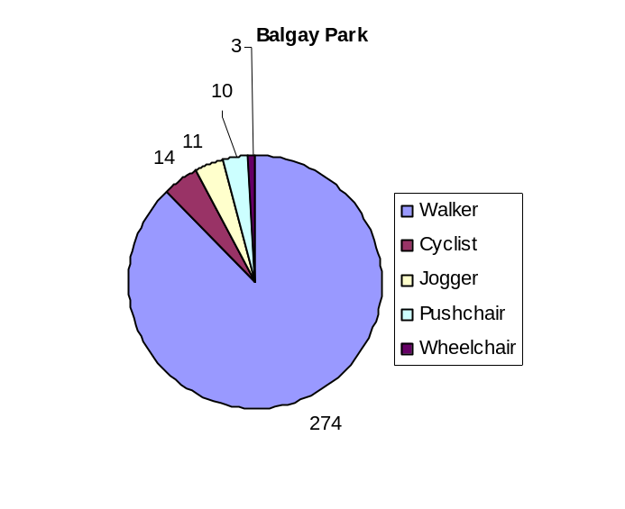
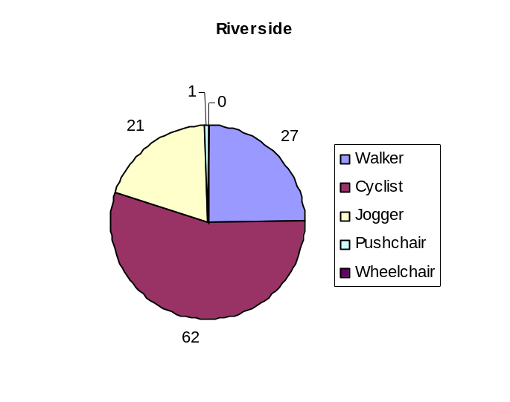
Diagram 1: daily average of number of people using paths by activity type
The path in Balgay Park has been used by walkers for many years. As part of the Dundee's Greenways project it was signposted and resurfaced in August 2006. This allowed cyclists to use the route as well as walkers. In comparison the path along Riverside Drive, is a well-established cycle route popular with commuters and has an ongoing programme of surface upgrading. In Balgay Park 50% of the respondents said that they used the route daily throughout the year, whereas at Riverside 33% said they used the route daily in the spring and summer and 20% said they used the route daily in the autumn and winter.

Peoples journey purpose (diagram 2) and reasons for using that particular path (diagram 3) reinforce the view that the Riverside path is well used by commuters, whilst the Balgay path is used more for recreational purposes.
In both cases just over 25% of the respondents were aware of recent path improvements and only 3% said that this had encouraged them to use the route more often.

Diagram 2: Sustrans survey of path users - journey purpose
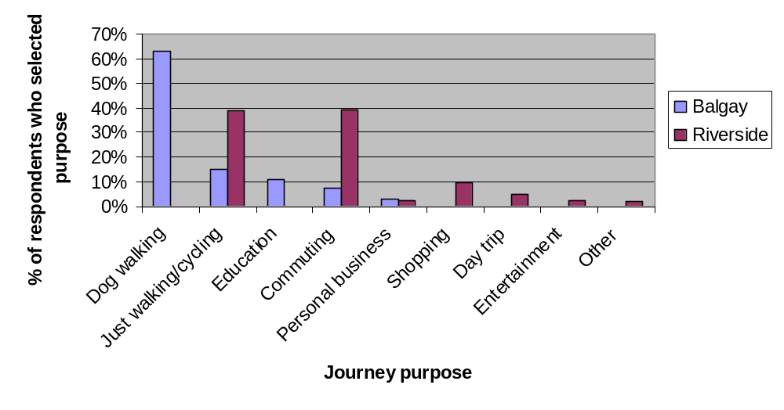
Diagram 3: Sustrans survey of path users - reason for path use
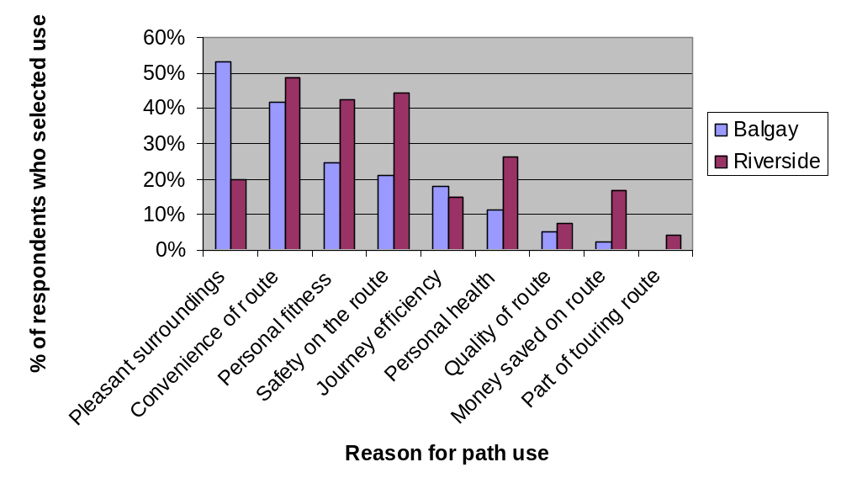
Longer term monitoring has been carried out at Templeton Woods. An interview-questionnaire survey of visitor numbers, demographics and opinions has been carried out in 2001, 2006 and 2010 by Dundee City Council.

Diagram 4: Templeton Woods survey of path users - reason for use

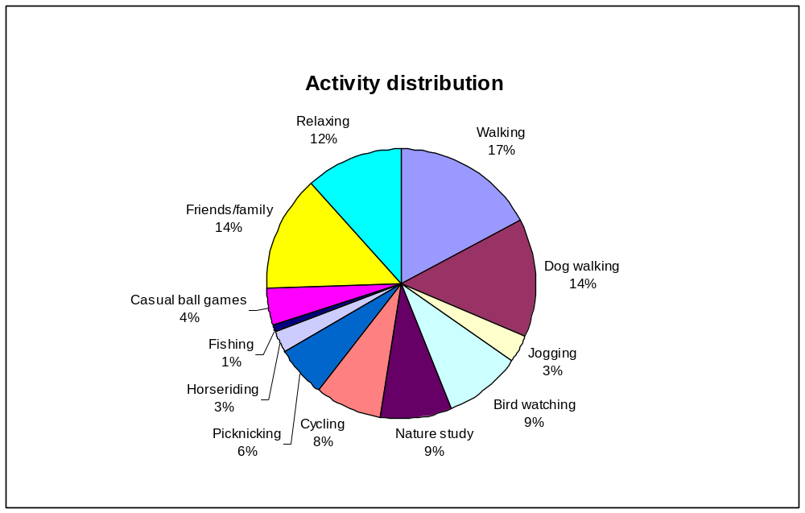
Individual respondents may have indicated more than one activity.

Diagram 4: Templeton Woods survey of path users - age and gender distribution
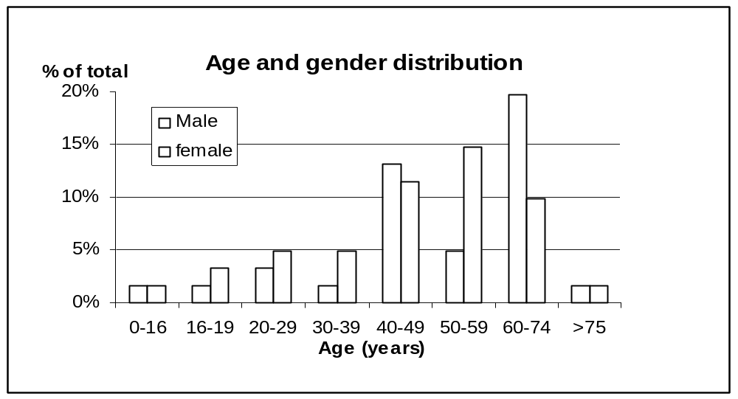
Templeton Woods has been a resource for outdoor recreation for many years. This is reflected in the survey, with many regular long term visitors. Many have been visiting the woods for several decades; the longest reported times since first visit were fifty-six years, by a man using the woods for mountain biking and a dog-walker who has been visiting for 60 years. The period of time since first visit averaged 14 years the same as 2006.

Most visitors stay in the woods for 1-2 hours, only 3/61 respondents stayed for less than 30 minutes, 3 stayed for more than 2 hours. The average time spent in the woods is 71 minutes (80 minutes in 2006).

There has been regular management of the woods for decades, and periods of investment in the path network, including through the Manpower Services of the 70's and 80's and more recently through Forestry Commission funding. This investment includes the installation of automatic visitor counters, which will assist with the monitoring of access here, and identify trends in visitor numbers, similar to the figures from the Green Circular.

Counter Data
Country Park
Camperdown Country Park Entrance vehicle counter
224,000 average annual inward vehicle movements (Sep 2007- Feb2011)
626 average daily inward vehicle movements (Sep 2007- Feb2011)
4180 highest daily inward vehicle movement (4th Sep 2010)
Templeton Woods Car Park cycle and vehicle counter
98.5 average daily inward vehicle movements (Mar 11 - Aug 11)
200 highest daily inward vehicle movements (22 Jun 2011)
Templeton Woods Counter
7.4 average daily horse movements (14/4/11 - 25/6/11) High 39 on 17/6/11
144 average daily walker movements (6/5/11 - 25/6/11) High 348 on 17/6/11
19.9 average daily cycle movements (14/4/11 - 25/6/11) High 77 on 22/4/11
Green Circular Riverside Cycle counter
94 average daily cycle movements (15/2/11 - 25/8/11) High 178 on 3/8/11
34,000 estimated annual cycle movements

2.4. Environmental Problems
Schedule 3 paragraph 4 of the Environmental Assessment (Scotland) Act 2005 requires that the Environmental Report includes a description of existing environmental problems, in particular those relating to any areas of particular environmental importance. The purpose of this section is to explain how existing environmental problems will affect or be affected by the Dundee Outdoor Access Strategy, and whether the Strategy is likely to aggravate, reduce or otherwise affect existing environmental problems. Relevant environmental problems are summarised in Table 4.

Table 4: Environmental problems relevant to the Outdoor Access Strategy
Problem | Supporting data | Implications
Biodiversity, flora and fauna
Promotion and signposting of paths may increase visitor numbers to environmentally sensitive sites | SNH | Mitigation may be required to avoid disturbance and habitat damage.
Potential for disturbance to the Firth of Tay Natura site | SNH | Access to the water by crafts may disturb biodiversity at the water's edge and in deeper water. Mitigation may be required.
Potential for disturbance to European Protected Species e.g. otters, bats | SNH  Tayside BAP | Where disturbance to protected species is perceived, action will be required and approved by SNH.
Threat of invasive weed species, particularly along riparian routes. | SNH | Invasive plant species will compromise pleasant access experience and biodiversity. Action to control will be required where there is a problem.
Unauthorised or illegal access using motorised forms of recreation, damaging sites and features. | Problems at Camperdown tackled through Police initiative. | Reduces visitor experience as well as disturbing wildlife and ripping up habitats.
Potential for disturbance and damage to natural heritage sites | Green Circular Route Audits  Green Circular Maintenance Policy | Mitigation may be required to avoid disturbance and habitat damage.
Human Health
Conflict between users | Complaints received | Increases stress of visitors and puts people off revisiting.
People not using green spaces and remain inactive with poor health. | Health surveys | Health problems linked to inactivity remain prevalent.
Material Assets
Wear and erosion of paths | Green Circular (and other) Route Audits | Paths become un welcoming or impassable by target users.
Path network underused | Visitor Surveys | Asset is under utilised.
Cultural Heritage
Promotion and signposting of paths may increase visitor numbers to areas important for their historic features | Historic Scotland  Arts Heritage Section within Dundee City Council | Mitigation may be required to avoid disturbance and physical damage.
Potential for disturbance and damage to cultural heritage sites | Green Circular Route Audits | Mitigation may be required to avoid disturbance and damage.
Landscape
New paths and infrastructure could reduce visual amenity of landscapes. | Landscape Design Team within Dundee City Council  Dundee TWIG | The strategy area contains areas of local landscape and amenity significance.  These are also locations which are likely to be desired for developing access, such as Riverside, Dundee Law and could be affected by path networks, their longer term maintenance and associated infrastructure.
Increased use could reduce visual amenity of landscapes. | SNH | The strategy has the potential for higher environmental impact if access is increased in more sensitive sites. Certain attractive areas can be particularly sensitive to this through disturbance.
Potential for cumulative effects of increased use of paths networks. | SUSTRANS active survey of South West Dundee  Green Circular Route Audits | Mitigation may be required.
Mitigation is described in section 3.5

2.5. Likely evolution of the environment without the Dundee Outdoor Access Strategy
The SEA process is designed to identify what impacts the adoption of the Strategy to have on the environment. The SEA Directive also requires that the evolution of the environment in the absence of the Strategy is examined.

Without the Dundee Outdoor Access Strategy, access development will have no city wide direction. This could lead to:-
  - Losing opportunities for developing access (such as Aspirational Core Paths)
  - Losing opportunities for linking infrastructure development to community need, and the creation of poorly linked new settlements
  - Failure to fund projects because of lack of evidence of need
  - Damage to habitats through lack of well assessed new routes
  - Damage to historic sites as visitors make their own paths to sites
  - Disturbance to ground nesting birds by dogs and walkers
  - Disturbance to dolphins and birds of the Tay by jet skiers
  - Deterioration of the path network asset
  - Losing opportunities for promoting access opportunities
  - Consequently reduced physical activity in our community.
Outdoor access would continue, but would not be proactively managed.

2.6. SEA Objectives
The following SEA objectives have been included as measures against which the environmental impacts of the Dundee Outdoor Access Strategy will be assessed.

Biodiversity, Flora & Fauna
- To maintain and enhance biodiversity, flora, and fauna
- To avoid damage or disturbance to European Protected Species and provide positive opportunities.
- Provide appropriate opportunities for people to come into contact with and appreciate wildlife and wild places

Human Health
- Provide opportunities for healthy outdoor activities

Material Assets
- Improve path provision
- Maintain paths and green space

Cultural Heritage
- To conserve and where appropriate enhance the historic environment and cultural heritage
- Promote access to the historic environment

Landscape
- To maintain and enhance the quality of landscapes and townscapes.
- To improve the quality of surroundings

3. Assessment of environmental effects and measures envisaged for prevention, reduction and offset of significant adverse effects

3.1. Alternatives to which SEA was applied
The SEA Directive and the Environmental Assessment (Scotland) Act require the Environmental Report to consider the impacts of alternatives to the proposed plan. The SEA Directive and the Environmental Assessment (Scotland) Act require the Environmental Report to consider the impacts of alternatives to the proposed plan. While Local Authorities are not required to produce Outdoor Access Strategies, a strategy is seen as good practice.

There are some alternatives to the strategy:-
- Do not produce and use a new Outdoor Access Strategy. Unlike the Core Path Plan, there is no legislative requirement to produce an Outdoor Access Strategy. Without a strategy, the development of access is not cohesive and longer term planning is difficult.
- Continue using the 2005-2010 Outdoor Access Strategy. This alternative is outdated. Most of the actions from the 2005 Dundee Outdoor Access are complete or have been realise to be impractical. Since the 2005 strategy, the Core Path Plan has been produced and the Local Community Plan has been revised, other opportunities have been identified.
- Prepare a minor revision or supplement to the 2005-2010 Outdoor Access Strategy. This alternative still relies too heavily on out dated information.
- Change the emphasis of the strategy. The Outdoor Access Strategy looks at outdoor access in the widest sense possible for Dundee. Alternatively strategies could be developed for different users (eg a cycling strategy) or access in and around different wards or communities. A single source framework has been proven to work well in Dundee, with the previous access strategy.
- Contribute to a Regional Access Strategy. Dundee could team up with neighbouring authorities to produce a strategy covering a wider area. Dundee is an urban area with significantly different community needs to its neighbours, where the majority of open space is local authority owned. A strategy for the city best serves our citizens.

Alternatives to the content and proposals contained within the Strategy have also been considered as part of the Strategy development, and been assessed through the matrix in Appendix B.

3.2. Assessment Methods
The reasonable alternatives described above have been assessed against the range of environmental issues set out in Schedule 3 of the Environmental Assessment (Scotland) Act 2005. Comments from the Consultation Authorities (SNH, SEPA, Historic Scotland) have been taken into account regarding the methods, scope and level of detail in this Environmental Report.

The Key Issues have been assessed for their impact.

Table 5 gives an example of the framework drawn up for this assessment.

Table 5. Framework used to assess the Dundee Outdoor Access Strategy
Aim 1: | Key Issue 1a | Key Issue 1b | Key Issue 1c
Aim 1: | Extend the multi use path network through green spaces including access to the Dighty at Linlathen. | Reducing barriers to access. Paths need upgraded to accommodate a wider variety of users. | Infrastructure – Seating, signage, paths, lighting as appropriate and opportunities to improve need to be identified. Public art and interpretation make the outdoors more appealing.
Dundee’s greenspaces, waterways and built environment will create attractive corridors and recreational spaces for all to enjoy
SEA Topic and critera | Impacts |  |  | Reasoning
Biodiversity, Flora & Fauna
Avoid harm to protected species | o | o | o | The wildlife impact of path construction will be minimal, through consultation with Countryside Rangers. New paths will increase use of green spaces, but this will be focused on the paths, avoiding any delicate habitats.
Conserve and enhance natural / semi-natural habitats | o | o | + | The wildlife impact of path construction will be minimal, through consultation with Countryside Rangers.
Avoid damage to wildlife and geological sites designated for their conservation interest | o | o | o | The wildlife impact of path construction will be minimal, through consultation with Countryside Rangers.
Provide opportunities for people to come into contact with and appreciate wildlife and wild places. | ++ | ++ | ++ | Signage will improve understanding.
Human Health
Provide opportunities for healthy outdoor activities | ++ | ++ | ++ | More people using green spaces for active recreation will improve more people's health and wellbeing.
Material Assets
Maintain paths and green space | - | ++ | - | While good specification paths take little maintenance, new paths and infrastructure will add increased burden on maintenance budgets, which will bee protected.
Improve path provision | ++ | ++ | ++ | Path improvement will add to the asset.
Cultural Heritage
 | o | o | + | The cultural impact of path construction will be minimal, through consultation with museum staff. New paths will increase use of cultural spaces, but this will be focused on the paths, avoiding any delicate areas. Signage will improve understanding.
Landscape |  |  |  | .
 | + | + | +
Key
++ / + significant/minor positive environmental effects
-- / - significant/minor negative environmental effects
o no significant environmental effects
? uncertain environmental effects
Duration of effect =
LT (long term), MT (medium term), ST (short term), perm (permanent), temp (temporary)

3.3. Summary of the assessment of the Dundee Outdoor Access Strategy
The Dundee Outdoor Access Strategy was assessed using the framework shown earlier. A summary of the assessment findings is shown in Table 6, and the full findings are shown in Appendix B.

Table 6. Summary of assessment findings
Topic | SEA Objectives | Likely significant impact | Comments
Biodiversity, Flora & Fauna | To maintain and enhance biodiversity, flora, and fauna  To avoid damage or disturbance to European Protected Species and provide positive opportunities. | Positive | In general the plan promotes access to areas of natural heritage importance, as these tend to be popular places for people to visit.  Interpretation, leaflets or boards, explaining and promoting responsible use of the path network and surrounding areas will be encouraged.  Policies on protected species, e.g. dolphin watching, will be promoted.  Opportunities for habitat enhancements alongside core paths will be sought to develop wildlife corridors.  Appropriate assessments will be undertaken where required before adopting aspirational core paths.  The majority of the paths exist and are already popular.  Access to natural heritage sites will be monitored.
Human Health | Provide opportunities for healthy outdoor activities | Positive | The Outdoor Access Strategy includes many actions which should make a healthy, active lifestyle available to everyone.
Material Assets | Maintain paths and green space  Improve path provision | Positive | Path infrastructure is straight forward to maintain, especially if they are built to a high quality.  The strategy provides for the increase in the material asset.
Cultural Heritage | To conserve and where appropriate enhance the historic environment and cultural heritage  To promote access to the historic environment | Positive | The Strategy promotes sites of cultural heritage, but also to takes into consideration land management and negative environmental impacts.  The plan will promote responsible access to places of cultural and historic significance.  Potential to explore promotion of cultural heritage of path networks and associated sites through the arts e.g. drama, sculpture, poetry.  Access to cultural heritage sites will be monitored.
Landscape | To maintain and enhance the quality of landscapes and townscapes.  To improve quality of surroundings | Positive | Positive opportunities exist to improve access to a variety of landscapes and townscapes via core paths. There is also potential to introduce landscape features which compliment, or add interest to, the setting.  There is potential that with increased use there could be an increase of litter and graffiti along Core Paths. The Strategy includes the promotion of the Outdoor Access Code. With enforcement of laws and management rules, anti social behaviour should be controlled.

3.4. Assessment of alternatives - cumulative and synergistic effects
As the above assessment shows, there are very few individual environmental impacts that are likely to arise as a result of adopting the proposed Outdoor Access Strategy. A further assessment of the cumulative impact of the Outdoor Access Strategy itself is shown in Table 7, where each of the criteria used for including policy actions have been checked for compatibility with SEA topics and the interrelationship of SEA topics.

Table 7: Potential cumulative impact of the Dundee Outdoor Access Strategy

SEA Topic | Outdoor Access Strategy Aims  - Dundee's green spaces, waterways and built environment will create attractive corridors and recreational spaces for all to enjoy.  - Dundee's citizens will be aware of their access rights and responsibilities under the Scottish Outdoor Access Code and use them appropriately.  - Dundee City Council will uphold its statutory requirements of the Land Reform (Scotland) Act 2003 by delivering its duties and using related powers.  - Dundee's citizens will be more active in their travel and recreation, with improved physical health and mental well-being.  - Dundee will have paths, cycleways and public spaces of the highest quality, which are accessible, safer, well maintained and fully used by all. |  |  |  |  | Potential cumulative impact of the CPP
SEA Topic | 1. | 2. | 3. | 4. | 5.
Biodiversity etc | + | + | + | o | + | neutral/ positive
Human Health | + | + | + | + | + | positive
Material Assets | + | + | + | + | o | positive
Cultural Heritage | + | o | + | + | o | neutral/ positive
Landscape | + | + | + | + | + | positive
Interrelation-ship | + | + | + | + | + | positive
It is possible that the effect of any impacts that do arise may become increasingly significant when combined with other factors.

The Strategy is likely to raise awareness of sites of historic and natural heritage and may increase footfall and could add to the numbers of people already drawn to these sites through other activities to promote such sites e.g. the Dundee Roots festival, Countryside Ranger events. It is not likely that the cumulative and synergistic impacts of such promotion will be significant.

The development and promotion of the Strategy as a whole will increase awareness of the path network and may bring improvements in access to the Dundee area through linking with other local and national strategies and programmes, including sustainable travel networks and hubs. As long as the routes are assessed in line with the Strategy objectives, these will only have beneficial impacts.

Table 8: Potential cumulative impact of the Dundee Outdoor Access Strategy
SEA Topic | Outdoor Access Strategy Aims  - Dundee's green spaces, waterways and built environment will create attractive corridors and recreational spaces for all to enjoy.  - Dundee's citizens will be aware of their access rights and responsibilities under the Scottish Outdoor Access Code and use them appropriately.  - Dundee City Council will uphold its statutory requirements of the Land Reform (Scotland) Act 2003 by delivering its duties and using related powers.  - Dundee's citizens will be more active in their travel and recreation, with improved physical health and mental well-being.  - Dundee will have paths, cycleways and public spaces of the highest quality, which are accessible, safer, well maintained and fully used by all. |  |  |  |  | Potential cumulative impact of the CPP
SEA Topic | 1. | 2. | 3. | 4. | 5.
Biodiversity etc | o | + | + | o | + | neutral/ positive
Human Health | + | o | + | + | + | positive
Material Assets | + | o/+ | + | o | o | neutral
Cultural Heritage | o | o | + | o | o | neutral
Landscape | + | + | + | o | o | neutral/ positive
Interrelation-ship | + | o | + | o | o | neutral
Alternative Actions

The alternative Actions which have been considered have less positive impact and therefore are less desirable and should not be adopted by the strategy.

3.5. Measures envisaged for the prevention, reduction and offsetting of significant adverse effects
Schedule 3 paragraph 7 of the Environmental Assessment (Scotland) Act 2005 requires an explanation of “the measures envisaged to prevent, reduce and as fully as possible offset any significant adverse effects on the environment of implementing the plan or programme.” Table 8 sets out any environmental problems that are likely to remain on implementation of the Strategy and summarises proposed measures for the prevention, reduction and offset of significant adverse effects.

Table 8. Measures envisaged for the prevention, reduction and offsetting of any significant adverse effects

SEA issue | Existing problem? | Impact of PPS | Proposed measures for the reduction/prevention and offset of significant adverse effects
Biodiversity, flora and fauna | Yes: People enjoy coming into contact with wildlife and wild places, but do not always think of the consequences of their actions and they could potentially disturb European Protected Species or cause damage to sites such as the Firth of Tay Ramsar site. | Potential for slight negative impact | Consider the location of the habitats used by protected species and select paths accordingly -alternative routes selected where necessary. Proposed Action 1E  Use promotional materials to encourage sustainable use of paths and highlight sites of ecological importance. Proposed Actions 2B and 5D  Monitor importance sites including the Tay Estuary for irresponsible access. Proposed Action 5C
Biodiversity, flora and fauna | Yes: problems of illegal use of motorbikes etc in green spaces around the north of the City. | Mainly neutral impact | The removal of barriers along routes may increase motorbike use; however, the improvement of sites to encourage legitimate access should discourage illegitimate users. Proposed Action 5A
Human Health | Yes: conflict between users increases with increased use. | Potential for negative impact | Promote and enforce regulations such as the Land Reform Act and Dangerous Dogs Act. Proposed Actions 2B and 3B
Material Asset | Yes: Cumulative effects of increased use of paths networks. | Potential for negative impact | Use improved materials and specification to ensure increased durability of path infrastructure. Proposed Action 5E  Carry out regular path condition  audits. Proposed Action 1D
Cultural Heritage | Yes: People enjoy visiting sites of cultural and historic importance, but do not always think of the consequences of their actions and they could potentially cause damage to sites and features. | Potential for slight negative impact | Use promotional materials to encourage sustainable use of paths and highlight sites of cultural importance. Proposed Actions 4J and 2B  When selecting core paths use criteria that helps to avoid or mitigate potential land management conflicts and pressure on individual sites. Proposed Actions 1E  Monitor importance sites for irresponsible access. Proposed Action 5C
Landscape | Yes: People enjoy visiting sites of high landscape value, but do not always think of the consequences of their actions and they could potentially cause damage to sites and features. | Potential for slight negative impact | Opportunity to implement the reinstatement of valued features such as walls and hedges alongside core path networks.  Monitor importance sites for irresponsible access. Proposed Action 5C
Landscape | Yes: Litter and dog waste can be a problem along some paths | Slight negative impact | Promote and enforce regulations such as the Land Reform Act and Parks Management rules. Proposed Actions 2B and 3B
Landscape | Yes: Cumulative effects of increased use of paths networks. | Slight negative impact | Further assessment and ongoing monitoring will be required. Proposed Action 1D

4. Monitoring

Section 19 of the Environmental Assessment (Scotland) Act 2005 requires the Responsible Authority to monitor significant environmental effects of the implementation of the Plan, Policy or Strategy. This must be done in such a way as to also identify adverse effects and to take appropriate remedial action. Unforeseen effects (positive and negative) may be identified through future studies and surveys and these will be incorporated into future revisions.

Monitoring of the effects of implementing the Outdoor Access Strategy will be undertaken by the Outdoor Access Strategy Steering Group and Dundee Local Access Forum. Further monitoring information may come from regimes currently in place for local authority infrastructure and maintenance through routine monitoring by the environmental authorities. Information about management, maintenance and development of core paths will be collated annually and form part of an overall report on access related work across the Dundee City area.

Developing and implementing the Dundee Public Open Space Strategy (of which the Outdoor Access Strategy is an appendix) is an action within Dundee's Single Outcome Agreement (SOA) Delivery Plan (see Intermediate Outcome 11f 'An attractive and sustainable natural environment'). A related performance indicator on the "reported public satisfaction levels with local environment and facilities" is also included. Performance is monitored using the Online Plan and Performance Monitoring database. Six monthly progress reports on SOA delivery are submitted to the Dundee Partnership Management Group including its partners in the Scottish Government. An SOA Annual Performance Report is prepared and presented to Committee for approval, then submitted to the Scottish Government in September.

Specific monitoring activities will include, but will not be restricted to:

- Unadopted Core Path surveys carried out by the Environment Dept and path network volunteers including: numbers of people on the route, path and verge condition, sufficiency of signage, and any barriers on the routes.
- Adopted path surveys carried out by the Planning and Transportation Dept
- Bridge surveys carried out by the Planning and Transportation Dept
- Red squirrel surveys conducted by the Countryside Ranger Service
- Bat surveys conducted by the Bat Conservation Trust
- Other relevant natural and cultural heritage surveys
- Health Surveys by NHS
- Visitor Surveys and counter data
- Land Reform Scotland Act monitoring for Scottish Government
- Dundee Census as reported in About Dundee
- Invasive Species surveys, especially of Giant Hogweed along the Dighty Burn

5. Next steps
The Draft Outdoor Access Strategy is to be prepared by February 2012; it is then to be made available for formal consultation alongside the Draft SEA. The consultation period will be at least 6 weeks. The plans will be made available for inspection on the Dundee City Council Website during this period and Dundee House. After this consultation period the Strategy and accompanying SEA will be adopted by Dundee City Council provided that there are no outstanding objections.

The Outdoor Access Strategy will be subject to review in 5 yearly reviews. This will provide an opportunity to develop the plan and to reflect upon the findings of the SEA and environmental monitoring.

The anticipated milestones in the development of the Draft Outdoor Access Strategy and its SEA, and the dates when these are expected to be completed are:

- Febraury 2012 - Completion of the Draft Outdoor Access Strategy and Environmental Report

- 16th March 2012 - Formal Consultation begins

- 27th April 2012 - Formal Consultation ends

- To be confirmed - Adoption and publication of the Dundee Outdoor Access Strategy 2012-17 and SEA statement

Appendix A: Links to other PPS and environmental objectives
Name of PPS /environmental protection objective | Main requirements of plan/ programme/ objective | How it affects or is affected by the Dundee Outdoor Access Strategy 2011-17
A Liveable City, Dundee Outdoor Access Strategy 2005-2010. | A framework for the future planning, development and management of outdoor access within Dundee. | It will be superseded by the Dundee Outdoor Access Strategy 2012-17.
Dundee Core Path Plan | Required by Land Reform Act 2003, the plan protects and promotes access routes across the city. | The Core Path Plan delivers some of the outcomes of the Outdoor Access strategy.
Dundee Public Open Space Strategy 2008 | The strategy provides a framework for the management of Public Open Space in Dundee. Now a requirement of Scottish Planning Policy | Supports the development of an Access Strategy and for actions relating to green networks and access routes
Dundee Local Plan, 2005 | Sets out the statutory development plan land use planning policies and proposals at local level. | The Outdoor Access Strategy will influence the local plan land use and development policies and proposals in relation to outdoor access, and sustainable transport.
Dundee Partnership Environment Strategy, 2007 | Setting an agenda for embedding an environmental agenda through the cross cutting theme groups of the Dundee Partnership | The Outdoor Access Strategy will help to deliver a number of actions highlighted across the Partnership Strategy themes.
Dundee Single Outcome Agreement | The Dundee SOA sets out the joint commitment between the Dundee Partnership and the Scottish Government to the delivery of an agreed set of outcomes for Dundee. | The Outdoor Access Strategy aspires to contribute to 9 out of the 11 Outcomes of Dundee’s Single Outcome Agreement (SOA).
Angus Core Path Plan 2010 | Required by Land Reform Act 2003, the plan protects and promotes access routes across Angus. | The Outdoor Access Strategy will have to ensure cross boundary routes are continuous, and liaison with neighbours is considered.
Perth and Kinross, Core Path Plan 2008 | Required by Land Reform Act 2003, the plan protects and promotes access routes across Perth and Kinross. | The Outdoor Access Strategy will have to ensure cross boundary routes are continuous, and liaison with neighbours is considered.
TACTRAN Regional Transport Strategy | Sets short, medium, and long term vision and objectives for transport delivery in the Tayside and Central area, aspiring to develop an integrated and sustainable transport system which is accessible to all. | Promotes sustainable travel choices of walking and cycling, including cross boundary links and travel to work areas.
Tayside Landscape Character Assessment-Scottish Natural Heritage 1999 | Classifies landscapes into general types to enable better understanding of them and their better conservation, restoration, management and enhancement. | Supports the preparation of countryside recreation and access strategies for the different landscape types.
Tayside LBAP | Supports local biodiversity whilst contributing to conservation and enhancement of UK biodiversity priorities. Provides a long-term plan for the support of Tayside’s wildlife and habitats. | Identifies at risk local species and habitats to be protected and enhanced within the Tayside Region.
PAN 65 | Provides advice on the role of the planning system in protecting and enhancing existing open spaces and providing high quality new spaces. | Linking access routes to the quality and accessibility of Open Space
Nature Conservation (Scotland) Act 2004 | Sets out measures to conserve biodiversity and to protect and enhance the biological and geological natural heritage | Identifies species, habitats and designations which are protected.
EU Birds and Habitats Directives 1992 | Sets outs Europe's Nature Conservation policies, listing species and habitat types which are protected across Europe. | Identifies species and habitats for which legal protection applies.
The Offshore Marine Conservation (Natural Habitats, &c.) Regulations 2007 | Ensures that activities in maritime seas (12-200 miles from the coast) are consistent with those permitted in the EU Birds and Habitats Directives. | Activities 12 miles from coast may be influenced by action or craft launched from Dundee.
Designing Places: a policy statement for Scotland (Scottish Executive 2008) | A general statement setting out the aspirations for urban design and to demonstrating how design can contribute to the quality of our lives. | Guides urban design to ensure welcoming, safe and sustainable environments.
European Protected Species, Development Sites and the Planning System: interim guidance for local authorities on licensing arrangements (October 2001) | Provides guidance where European Protected Species (including Dolphins, bats and otter) are present. Structures the licensing system to ensure wildlife on development sites are treated professionally. | Experts will be required to advise planners and developers in the conservation of European Protected Species.
Scottish Rural Development Programme 2007-2013 | A programme of economic, environmental and social measures, worth some £1.5 billion, designed to develop rural Scotland | An important source of funding for access and related improvements, progressing government targets.
Scottish Planning Policy 2010 | Advises on Government policy for Development Plans including provision of open space and physical activity. | Confirms that access rights are material considerations in determining planning applications. Outlines the role of local authority in safeguarding archaeological and natural heritage whilst developing its use for education and recreation.

Appendix B: Full assessment results
This section gives the full assessment of the Dundee Outdoor Access Strategy against SEA criteria by Strategy Actions and Key Issues. Relevant Key Issues are grouped as they are in the Strategy within each Aim. An assessment is made of whether or not the SEA criteria are met, an explanatory comment is also provided on each SEA objective.

Proposed  Aim 1: | Action 1A | Alternative to 1A
Proposed  Aim 1: | Extend multi use path network, prioritised by the Core Path Plan, new housing and road development and consultation. Complete Core Path 22 | Retain current path network without extension
Dundee’s greenspaces, waterways and built environment will create attractive corridors and recreational spaces for all to enjoy
SEA Topic and criteria | Impacts |  |  | Reasoning
Biodiversity, Flora & Fauna
Avoid harm to protected species | -/+ | o |  | Most of the habitats in Dundee (except the Tay Estuary) are urban and relatively robust. However, impact of path construction on protected species will be avoided if possible. If unavoidable, mitigation hierarchy actions will be agreed. Habitat damage will be localised, and opportunities for habitat improvement will be taken. Use of green spaces will increase, but the paths will aim to avoid delicate habitats.  The reduced intervention alternative would have less positive and/or negative impacts on biodiversity (although some locations may remain undisturbed), but would reduce the accessibility of green spaces and reduce the potential contact and appreciation possible.
Conserve and enhance natural / semi-natural habitats | -/+ | o
Avoid damage to wildlife and geological sites designated for their conservation interest | -/+ | +
Provide opportunities for people to come into contact with and appreciate wildlife and wild places. | ++ | -
Human Health
Provide opportunities for healthy outdoor activities | ++ | o |  | Extending the path network allows more people to use green spaces for active recreation improving more people's health and wellbeing.
Material Assets
Maintain paths and green space | + | o |  | While extending the path network increases maintenance needs, improved design and materials extends life spans (requires Action 5E)
Improve path provision | ++ | -
Cultural Heritage
Protect historic buildings, archaeological sites and other culturally important features in both urban and rural settings | -/+ | o |  | Construction design will ensure there is no localised impact on heritage sites. New paths and facilities should encourage visitors to respect and local sites, steering access to less sensitive areas.
Support the positive management of cultural heritage resources | + | o
Landscape
Protect and enhance the landscape and townscape, particularly in designated areas | o | o |  | Path and furniture design by our Landscape Architects will aim to fit and enhance the visual environment.  Increased well designed local access will improve perceptions of local neighbourhoods (not if Alternative 1A in implemented).  Litter and graffiti may increase with increased use. Access furniture which is vandalised repeatedly may have to be removed. Education and maintenance programmes will have to be in place to address.
Improve satisfaction of people with their neighbourhoods as places to live | ++ | -
Decrease litter and graffiti in towns and countryside | - | o

Proposed  Aim 1: continued | Action 1B | Alternative to 1B | Action 1C
Proposed  Aim 1: continued | Remove barriers and improve chicanes and entrances. | Retain barriers and chicanes at entrances. | Improve seating, signage, paths and lighting.
Dundee’s greenspaces, waterways and built environment will create attractive corridors and recreational spaces for all to enjoy
SEA Topic and criteria | Impacts |  |  | Reasoning
Biodiversity, Flora & Fauna
Avoid harm to protected species | o | o | o | Signage, events and community involvement and consultation will improve understanding.  The reduced intervention alternative would reduce the accessibility of green spaces and reduce the potential contact and appreciation possible.
Conserve and enhance natural / semi-natural habitats | o | o | o
Avoid damage to wildlife and geological sites designated for their conservation interest | o | o | o
Provide opportunities for people to come into contact with and appreciate wildlife and wild places. | ++ | - | ++
Human Health
Provide opportunities for healthy outdoor activities | ++ | - | ++ | Maintaining current routes and keeping green spaces attractive keep them appealing to use for healthy activity.
Material Assets
Maintain paths and green space | o | o | ++ | The material asset includes the path and associated furniture. In some locations and for short periods of time, barriers may be required as part of the asset and not be a burden on it.
Improve path provision | ++ | - | ++
Cultural Heritage
Protect historic buildings, archaeological sites and other culturally important features in both urban and rural settings | -/+ | + | o | Retaining barriers to access may deter some users, they will also deter legitimate users who encourage appropriate use. Signage will improve understanding.
Support the positive management of cultural heritage resources | o | -/+ | +
Landscape
Protect and enhance the landscape and townscape, particularly in designated areas | + | - | + | Retaining barriers may keep anti social activity such as motorcycle use and possibly litter and graffiti at a low level. However not increasing the path network and reducing access by mobility scooters may reduce local satisfaction. The landscape will not benefit from well design paths and will suffer from retention of ugly barriers and chicanes
Improve satisfaction of people with their neighbourhoods as places to live | -/+ | -/+ | -/+
Decrease litter and graffiti in towns and countryside | o | ++ | -/+

Proposed  Aim 1: | Action 1D | Action 1E
Proposed  Aim 1: | Audit and maintain the Green Circular and other existing paths. | Enhance the natural quality and character of Dundee green space.
Dundee’s greenspaces, waterways and built environment will create attractive corridors and recreational spaces for all to enjoy
SEA Topic and criteria | Impacts |  |  | Reasoning
Biodiversity, Flora & Fauna
Avoid harm to protected species | o/+ | + |  | Maintaining current routes will not have any negative effect on green areas, although may be beneficial by encouraging people to stay clear of sensitive sites.  Conservation projects with contractors or volunteers will be planned to enhance biodiversity, and provide opportunities for public engagement.
Conserve and enhance natural / semi-natural habitats | o | ++
Avoid damage to wildlife and geological sites designated for their conservation interest | o | ++
Provide opportunities for people to come into contact with and appreciate wildlife and wild places. | o | ++
Human Health
Provide opportunities for healthy outdoor activities | + | + |  | Maintaining current routes and keeping green spaces attractive keep them appealing to use for healthy activity. Regular practical conservation tasks help keep activity levels up.
Material Assets
Maintain paths and green space | ++ | + |  | Audited and maintained paths and enhanced green spaces retain their value as assets.
Improve path provision | ++ | +
Cultural Heritage
Protect historic buildings, archaeological sites and other culturally important features in both urban and rural settings | o/+ | + |  | Maintaining current routes will not have any negative effect on green areas, although may be beneficial by encouraging people to stay clear of sensitive sites.  Enhancement of green spaces needs to reflect the cultural heritage. Volunteer opportunities may be available.
Support the positive management of cultural heritage resources | o | +
Landscape
Protect and enhance the landscape and townscape, particularly in designated areas | + | ++ |  | Maintaining current routes will retain landscape value. Paths are often seen as part of designed landscapes. Maintained and enhanced paths and green spaces are more appealing to use. While litter can be harder to collect in more natural vegetation, such as scrub and hedgerow, these green spaces are often more resistant to damage than formal green spaces such as wear on lawns or vandalism in formal beds.
Improve satisfaction of people with their neighbourhoods as places to live | ++ | ++
Decrease litter and graffiti in towns and countryside | ++ | +

Proposed  Aim 2: | Action 2A | Alternative 2A | Action 2B
Proposed  Aim 2: | Link paths to neighbouring authorities and prepare policy for cross-boundary issues. | Manage access routes within Dundee boundary, without cross boundary liaison | Promotion of Scottish Outdoor Access Code Use media such as website, leaflets, events and others. Liaise with private land owners and user groups
Dundee’s citizens will be aware of their access rights and their responsibilities under the Scottish Outdoor Access Code and use them appropriately

SEA Topic and criteria | Impacts |  |  | Reasoning
Biodiversity, Flora & Fauna
Avoid harm to protected species | -/+ | o | + | Well planned paths which cross boundaries will need to be assessed for biodiversity impact both sides of the boundary, but these paths are important to encourage people to explore and appreciate their wider surroundings.  The promotion of SOAC and landowner and user group liaison will reduce the impact of access to sensitive sites.
Conserve and enhance natural / semi-natural habitats | -/+ | o | +
Avoid damage to wildlife and geological sites designated for their conservation interest | -/+ | o | +
Provide opportunities for people to come into contact with and appreciate wildlife and wild places. | + | - | +
Human Health
Provide opportunities for healthy outdoor activities | + | - | + | Cross boundary access extends opportunities for healthy activity. Engagement through SOAC also encourages physical activity.
Material Assets
Maintain paths and green space | + | o | + | Responsible access can reduce wear to trails. Liaison with landowners and neighbouring authority can increase the connected path network. Increased cross boundary liaison can increase opportunities for external funding.
Improve path provision | + | o | +
Cultural Heritage
Protect historic buildings, archaeological sites and other culturally important features in both urban and rural settings | -/+ | o | + | Well planned paths which cross boundaries will need to be assessed for cultural heritage impact both sides of the boundary, but these paths are important encourage people to explore and appreciate their wider surroundings. Promotion of SOAC encourages respect for cultural heritage sites.
Support the positive management of cultural heritage resources | o | o | o
Landscape
Protect and enhance the landscape and townscape, particularly in designated areas | + | o | + | Landscapes cross boundaries and liaison will help retain consistency.  SOAC encourages respect and promotion and enforcement will benefit the treatment of neighbourhoods including litter and graffiti which may increase with increase use of paths crossing boundaries for example.
Improve satisfaction of people with their neighbourhoods as places to live | o | - | +
Decrease litter and graffiti in towns and countryside | - | + | ++

Proposed  Aim 3: | Action 3A | Action 3B | Action 3C
Proposed  Aim 3: | Core Paths kept open and fit for purpose. Plan is kept up to date. | Employ an Access Officer to deal with access issues complaints and support land owners, managers and users. | Dundee Local Access Forum (and sub groups) are supported.
Dundee City Council will uphold its statutory requirements of the Land Reform (Scotland) Act 2003 by delivering its duties and using related powers

SEA Topic and criteria | Impacts |  |  | Reasoning
Biodiversity, Flora & Fauna
Avoid harm to protected species | + | o | o | Keeping Core Paths open will encourage people to stick to the paths, protecting delicate habitats close-by. An Access Officer and Dundee Local Access Forum (DLAF) will help the local authority deal with access which is disturbing wildlife, including providing guidance for visitors such as the Tay Wildlife Watching guidance.  The Core Paths allow access to green places providing opportunities to engage with wildlife, and the Local Access Forum is looking at Heritage trails to encourage appreciation and understanding.
Conserve and enhance natural / semi-natural habitats | + | + | +
Avoid damage to wildlife and geological sites designated for their conservation interest | + | + | +
Provide opportunities for people to come into contact with and appreciate wildlife and wild places. | ++ | + | ++
Human Health
Provide opportunities for healthy outdoor activities | ++ | o | + | The Core Paths provide a network of active travel routes, which the Local Access Forum help guide and promote.  With increased use of open space, there is increased likelihood of conflict between users. Mitigation may include policing and amending local Management Rules to ensure responsible access.
Material Assets
Maintain paths and green space | ++ | ++ | ++ | The Access Officer and DLAF will ensure that the Core Path assets are retained and enhanced.
Improve path provision | ++ | ++ | ++
Cultural Heritage
Protect historic buildings, archaeological sites and other culturally important features in both urban and rural settings | o | + | + | Maintaining current access routes will have a neutral affect on local cultural sites.  The Access Officer and DLAF will support the management of access away from delicate sites and to develop projects to interpret and enhance cultural features.
Support the positive management of cultural heritage resources | o | + | +
Landscape
Protect and enhance the landscape and townscape, particularly in designated areas | + | + | + | The retention of core paths will retain the value of paths and associated features in the landscape. Open Core Paths continue to allow people to enjoy and appreciate their local surroundings, although graffiti and litter may increase with increased use.  The Access Officer and DLAF work to enhance landscape. DLAF allows people to become involved in decision making to help improve their local neighbourhood.
Improve satisfaction of people with their neighbourhoods as places to live | ++ | + | +
Decrease litter and graffiti in towns and countryside | o | + | +

Proposed  Aim 4: | Action 4A | Action 4B | Alternative to 4B
Proposed  Aim 4: | Access to the outdoors is promoted as the best way to increase physical activity and to improve physical and mental health. | New retail, housing and road developments are required to include cycling and walking provision prior to Planning Permission. | New retail and housing developments only along the Green Circular need to plan link routes prior to Planning Approval.
Dundee’s citizens will be more active in their travel and recreation, with improved physical fitness and mental well-being

SEA Topic and criteria | Impacts |  |  | Reasoning
Biodiversity, Flora & Fauna
Avoid harm to protected species | o | -/o | -/o | There is the potential for new paths and increased visitor pressure to disturb habitats and protected species, but also for people to enjoy the outdoors and our local biodiversity. The impact of paths and access should be considered at the initiation of a project such as with Planning Application for a new development and mitigation included at that time. Paths will impact considerably less than the developments they serve in Dundee's mainly urban situation.  Restricting link routes only to developments near the Green Circular will limit opportunities for green space appreciation.
Conserve and enhance natural / semi-natural habitats | o | -/o | -/o
Avoid damage to wildlife and geological sites designated for their conservation interest | o | -/o | -/o
Provide opportunities for people to come into contact with and appreciate wildlife and wild places. | + | ++ | +
Human Health
Provide opportunities for healthy outdoor activities | ++ | ++ | + | New paths from new houses and promotion of access will increase the use of the outdoors for active travel etc. Restricting link routes only to developments near the Green Circular will limit opportunities for healthy activity.
Material Assets
Maintain paths and green space | - | + | + | Increased use and a larger network will increase wear and stretch revenue budgets, unless new solutions used (Action 5E). Alternative 4B reduces maintenance burden, also limits the benefit to the asset.
Improve path provision | o | ++ | +
Cultural Heritage
Protect historic buildings, archaeological sites and other culturally important features in both urban and rural settings | - | o | o | There is the potential for increased outdoor activity to damage sensitive cultural sites, but also these to be better managed due to the increased access. In a recent project for example, Myrekirk Stone Circle has had to be protected but public awareness has been raised.
Support the positive management of cultural heritage resources | + | o | o
Landscape
Protect and enhance the landscape and townscape, particularly in designated areas | - | + | - | While new paths and promoted access may increase activities which lead to litter etc, paths should help new housing fit into the landscape and help people enjoy their local surroundings.  Alternative 4B means that some new housing and their communities will be left without well thought out walking and cycling links to their surrounding areas, or well designed paths in their landscapes.
Improve satisfaction of people with their neighbourhoods as places to live | + | ++ | -
Decrease litter and graffiti in towns and countryside | - | - | -

Proposed  Aim 4: | Action 4C | Action 4D | Action 4E
Proposed  Aim 4: | Promoted and safe walking, cycling and horse riding routes link green spaces, schools and places of work with residential areas. | Volunteers and Sustrans work with landowners and City Council to maintain and improve path network. | Travel Planning. Maintain dundeetravelinfo .com. Recognition of value of Active Travel will feature in Dundee Local Plan.
Dundee’s citizens will be more active in their travel and recreation, with improved physical fitness and mental well-being

SEA Topic and criteria | Impacts |  |  | Reasoning
Biodiversity, Flora & Fauna
Avoid harm to protected species | o | o | o | There is the potential for increased visitor pressure to disturb habitats and protected species, but also for people to enjoy the outdoors and our local biodiversity. The impact of promoted access should be considered at the initiation of a project and mitigation included at that time.
Conserve and enhance natural / semi-natural habitats | o | o | o
Avoid damage to wildlife and geological sites designated for their conservation interest | o | o | o
Provide opportunities for people to come into contact with and appreciate wildlife and wild places. | + | ++ | o
Human Health
Provide opportunities for healthy outdoor activities | ++ | ++ | ++ | Providing opportunities for regular active volunteering or active travel increases physical activity.
Material Assets
Maintain paths and green space | - | ++ | - | Encouraging more active travel will add wear and maintenance burden to the path budgets, however path volunteers can help improve the paths very economically.
Improve path provision | + | + | o
Cultural Heritage
Protect historic buildings, archaeological sites and other culturally important features in both urban and rural settings | o | + | o | There is the potential for increased outdoor activity to damage sensitive cultural sites, but also these to be better managed due to the increased access. Volunteers may be able assist the protection and promotion of cultural heritage.
Support the positive management of cultural heritage resources | o | + | o
Landscape
Protect and enhance the landscape and townscape, particularly in designated areas | - | + | o | Volunteers can significantly improve local areas, combat graffiti and litter and increase perceptions of neighbourhoods. Information about travel routes can increase knowledge of local areas, improving satisfaction.
Improve satisfaction of people with their neighbourhoods as places to live | + | ++ | +
Decrease litter and graffiti in towns and countryside | - | ++ | o

Proposed  Aim 4: | Action 4F | Action 4G
Proposed  Aim 4: | Park and Stride. Investigate locations of Park and Cycle Schemes at the West and East of Dundee. | Support volunteer projects including health walks leaders, path volunteers, local access forum.
Dundee’s citizens will be more active in their travel and recreation, with improved physical fitness and mental well-being

SEA Topic and criteria | Impacts |  |  | Reasoning
Biodiversity, Flora & Fauna
Avoid harm to protected species | -/+ | o |  | A new parking area for cyclists could have landscape impact which will have to be assessed and mediated. An existing car park should be used.  Involving volunteers in our open spaces increases engagement with these spaces  While the increase use of open spaces may disturb wildlife, supporting this increase with organised groups and promoted routes away from delicate areas will help control impact.  Encouraging and guiding volunteering will provide opportunities for people to carry out practical improvements to habitats, and increase appreciation of wild spaces.
Conserve and enhance natural / semi-natural habitats | -/+ | +
Avoid damage to wildlife and geological sites designated for their conservation interest | -/+ | +
Provide opportunities for people to come into contact with and appreciate wildlife and wild places. | o | ++
Human Health
Provide opportunities for healthy outdoor activities | ++ | ++ |  | These projects increase physical activity.
Material Assets
Maintain paths and green space | - | ++ |  | While volunteers can help maintain paths and green spaces, increase use will increase wear and maintenance.
Improve path provision | + | +
Cultural Heritage
Protect historic buildings, archaeological sites and other culturally important features in both urban and rural settings | o | + |  | The location of any new park and cycle location would have to be assessed to prevent damage.  Volunteers may be able assist the protection and promotion of cultural heritage.  Increased use in led groups is unlikely to increase wear, and promoted routes etc will guide people to be responsible.
Support the positive management of cultural heritage resources | o | +
Landscape
Protect and enhance the landscape and townscape, particularly in designated areas | +/- | + |  | A new parking area for cyclists could have landscape impact which will have to be assessed and mediated. An existing car park should be used.  Volunteer projects have the capacity to improve our green spaces, and to improve local people's satisfaction with their neighbourhoods.  Increased guided activity will reduce anti social behaviour, and promotional material will encourage responsible access.
Improve satisfaction of people with their neighbourhoods as places to live | +/- | ++
Decrease litter and graffiti in towns and countryside | - | ++

Proposed  Aim 4: | Action 4H | Alternative to 4H | Action 4I
Proposed  Aim 4: | Support Health Walks groups, routes and volunteers.  Link to social and green prescriptions and health professional referrals. | Deliver Health Walks only through staff walk leaders and promoted through the internet | Capitalise on opportunities for promotion such as infrastructure improvement and Cyclathon, cycle tours and bike week, and cycle training schemes.
Dundee’s citizens will be more active in their travel and recreation, with improved physical fitness and mental well-being

SEA Topic and criteria | Impacts |  |  | Reasoning
Biodiversity, Flora & Fauna
Avoid harm to protected species | o | o | - | Health walks delivered only through staff leaders will limit the number walking groups and will be more liable to be short lived during funding cuts.
Conserve and enhance natural / semi-natural habitats | o | o | o
Avoid damage to wildlife and geological sites designated for their conservation interest | o | o | o
Provide opportunities for people to come into contact with and appreciate wildlife and wild places. | ++ | + | +
Human Health
Provide opportunities for healthy outdoor activities | ++ | + | ++ | These projects get people out and about and more physically active.
Material Assets
Maintain paths and green space | - | o | - | Promoting routes increases visitors and increases wear.
Improve path provision | o | o | o | Promoting routes increases visitors and increases wear.
Cultural Heritage
Protect historic buildings, archaeological sites and other culturally important features in both urban and rural settings | o | o | o | It is unlikely that led health walks will impact on historical sites, although they may raise awareness, although relying on paid staff will reduce the capacity of possible positive outputs.
Support the positive management of cultural heritage resources | o | o | o
Landscape
Protect and enhance the landscape and townscape, particularly in designated areas | o | o | o | Alternative 4H does not maximize the capacity of health walks by not utilising volunteers or health practitioners
Improve satisfaction of people with their neighbourhoods as places to live | ++ | - | o
Decrease litter and graffiti in towns and countryside | + | + | o

Proposed  Aim 4: | Action 4J | Action 4K
Proposed  Aim 4: | Investigate projects to be developed as Heritage Trails such as Dighty Trail and Tay Trail. | Maintain and reprint Dundee Cycle Map. New opportunities for promotion need to be capitalised on to renew public interest.
Dundee’s citizens will be more active in their travel and recreation, with improved physical fitness and mental well-being

SEA Topic and criteria | Impacts |  |  | Reasoning
Biodiversity, Flora & Fauna
Avoid harm to protected species | +/- | o |  | Trails and maps aim to increase the use of our accessible open spaces, and could lead to disturbance and habitat damage. Trails will need to be designed with delicate areas in mind and information given to help visitors enjoy biodiversity without disturbing it. Example Tay wildlife watch code
Conserve and enhance natural / semi-natural habitats | +/- | o
Avoid damage to wildlife and geological sites designated for their conservation interest | +/- | o
Provide opportunities for people to come into contact with and appreciate wildlife and wild places. | + | +
Human Health
Provide opportunities for healthy outdoor activities | + | ++ |  | These alternatives limit the benefits of paths and walking groups.
Material Assets
Maintain paths and green space | - | - |  | Increased promotion, increases use and wear on the asset.
Improve path provision | o | o |  | Increased promotion, increases use and wear on the asset.
Cultural Heritage
Protect historic buildings, archaeological sites and other culturally important features in both urban and rural settings | o | o |  | The promoted routes are designed to avoid damage to sensitive sites, and are on current, well made wide paths or roads.  Heritage trails encourage appreciation of our heritage and may lead to greater management.
Support the positive management of cultural heritage resources | + | o
Landscape
Protect and enhance the landscape and townscape, particularly in designated areas | + | o |  | The promotion of routes may increase visitor pressure and littering. Guidance needs to be provided on the leaflets etc. These trails encourage visits by local people and encourages there understanding and appreciation of their local environment.
Improve satisfaction of people with their neighbourhoods as places to live | ++ | +
Decrease litter and graffiti in towns and countryside | - | -

Proposed  Aim 5: | Action 5A | Action 5B | Action 5C
Proposed  Aim 5: | Remove barriers to access. Safe crossing points are required for busy roads. Fund alternative Green Circular / NCN at Docks, to allow young people and walkers access. | Improve seating, signage, surfaces, cycle trails, horse trails and lighting etc to make access simple and appealing. | Liaise with Community Safety Wardens, police and park and leisure staff to control problems of illegal motor vehicles/craft in open spaces and Tay estuary.
Dundee will have paths, cycleways and public spaces of the highest quality, which are accessible, safer, well maintained and fully used by all

SEA Topic and criteria | Impacts |  |  | Reasoning
Biodiversity, Flora & Fauna
Avoid harm to protected species | - | - | + | Removing barriers may allow more illegal motor vehicle use which could damage and disturb habitats and wildlife. This will have to be considered before barriers are removed to encourage wheelchair, pushchair, tandem etc users.  Providing more facilities will encourage visitors to stay longer and return more frequently, adding to disturbance, but also allowing greater appreciation of wildlife.  Action 5C provides for control of problems caused by 5A and 5B
Conserve and enhance natural / semi-natural habitats | - | - | +
Avoid damage to wildlife and geological sites designated for their conservation interest | - | - | +
Provide opportunities for people to come into contact with and appreciate wildlife and wild places. | + | + | +
Human Health
Provide opportunities for healthy outdoor activities | ++ | ++ | o | Removing barriers and including seats allow those less able to use open spaces for physical activity.
Material Assets
Maintain paths and green space | - | o | + | Allowing freer access will increase maintenance because of increased use. 5C will reduce motorcycle use, extending the life of paths.
Improve path provision | - | o | o
Cultural Heritage
Protect historic buildings, archaeological sites and other culturally important features in both urban and rural settings | o | o | o | It is not considered likely that these projects will cause any significant impact on the local cultural sites
Support the positive management of cultural heritage resources | o | o | o
Landscape
Protect and enhance the landscape and townscape, particularly in designated areas | o | +/- | o | Altering barriers and providing seats etc leading to increased use, will help improve local satisfaction.  New seats and lights etc may be targeted for graffiti.  Local patrolling and policing will reduce graffiti and anti social behaviour.
Improve satisfaction of people with their neighbourhoods as places to live | + | + | +
Decrease litter and graffiti in towns and countryside | o | -- | ++

Proposed  Aim 5: | Action 5D | Action 5E | Alternative to 5E
Proposed  Aim 5: | New opportunities for promotion need to be capitalised on to renew public interest. | Opportunities for new solutions in outdoor access will be provided in Dundee green spaces wherever possible. | Utilise traditional methods in access projects Dundee green spaces.
Dundee will have paths, cycleways and public spaces of the highest quality, which are accessible, safer, well maintained and fully used by all

SEA Topic and criteria | Impacts |  |  | Reasoning
Biodiversity, Flora & Fauna
Avoid harm to protected species | o | -/+ | -/+ | Novel solutions such as new materials, technology or designs will have to be tested on less sensitive areas, but will have to demonstrate improved qualities such as ease of maintenance, reduced costs and ease of use for all to be successful.  New promotional aids or activities could increase the number of people accessing the environment and could increase pressure on sensitive areas, but also promoting the opportunities for volunteering.  Mitigation may be needed. An example is the use of solar lights which may increase visits after dark, which may need to be screened to reduce impact on natural diurnal rhythms.
Conserve and enhance natural / semi-natural habitats | o | -/+ | -/+
Avoid damage to wildlife and geological sites designated for their conservation interest | o | -/+ | -/+
Provide opportunities for people to come into contact with and appreciate wildlife and wild places. | + | + | +
Human Health
Provide opportunities for healthy outdoor activities | + | + | o | New solutions will make access to the outdoors easier and more attractive to enjoy actively.
Material Assets
Maintain paths and green space | o | + | - | New path design should add value to the path resource and reduce maintenance. A good example is the use of recycled plastic to replace rotten timber steps.
Improve path provision | o | + | o
Cultural Heritage
Protect historic buildings, archaeological sites and other culturally important features in both urban and rural settings | o | -/+ | -/+ | New technology will not impact on cultural sites unless there is a significant increase in visitors to these sites, and in this case visitor management mitigation will be required, such as protective fencing.  Promotional materials will include information on volunteer opportunities.
Support the positive management of cultural heritage resources | + | o | o
Landscape
Protect and enhance the landscape and townscape, particularly in designated areas | o | -/+ | + | New technology does not always fit in to the landscape. Brightly coloured tarmac and solar lights are only suitable in urban locations for example. New materials may also have implications for vandalism and graffiti removal.  Promotion increases appreciation of our surroundings.
Improve satisfaction of people with their neighbourhoods as places to live | + | -/+ | -/+
Decrease litter and graffiti in towns and countryside | o | -/+ | -/+

Appendix C: The Conservation (Natural Habitats, &c.) Regulations 1994

Grant of licences for certain purposes
44.—(1) Regulations 39, 41 and 43 do not apply to anything done for any of the following purposes under and in accordance with the terms of a licence granted by the appropriate authority.
(2) The purposes referred to in paragraph (1) are-
(a) scientific or educational purposes;
(b) ringing or marking, or examining any ring or mark on, wild animals;
(c) conserving wild animals or wild plants or introducing them to particular areas;
(d) protecting any zoological or botanical collection;
(e) preserving public health or public safety or other imperative reasons of overriding public interest including those of a social or economic nature and beneficial consequences of primary importance for the environment;
(f) preventing the spread of disease; or
(g) preventing serious damage to livestock, foodstuffs for livestock, crops, vegetables, fruit, growing timber or any other form of property or to fisheries.
(3) The appropriate authority shall not grant a licence under this regulation unless they are satisfied-
(a) that there is no satisfactory alternative, and
(b) that the action authorised will not be detrimental to the maintenance of the population of the species concerned at a favourable conservation status in their natural range.
(4) For the purposes of this regulation "the appropriate authority" means-
(a) in the case of a licence under any of sub-paragraphs (a) to (d) of paragraph (2), the appropriate nature conservation body; and
(b) in the case of a licence under any of sub-paragraphs (e) to (g) of that paragraph, the agriculture Minister.
(5) The agriculture Minister shall from time to time consult with the nature conservation bodies as to the exercise of his functions under this regulation; and he shall not grant a licence of any description unless he has been advised by the appropriate nature conservation body as to the circumstances in which, in their opinion, licences of that description should be granted.

Appendix D: Designated Sites

List of Scheduled Ancient Monuments

- Wishart Arch, East Port of Dundee
- Stone Circle, Gourdie
- Paddock Stone, standing stone 90m NE of Greystone House
- Powrie Castle, Powrie
- Cairn Greg, cairn 430m ESE of North Gates
- Fort, Dundee Law
- Benvie, enclosure 50m SE of Benvie Church
- Souterrains, 250m NNE of Mains of Grey
- Souterrain, 250m NE of Barns of Claverhouse
- Souterrain, 100m SE of North Gates
- Cursus and barrows SW of Greystane Lodge
- Site of Hospital of St. John the Baptist, Broughty Ferry Road
- Claypotts Castle
- Broughty Ferry Castle

List of Conservation Areas

  - Lochee
  - Logie
  - Broughty Ferry
  - Trottick
  - West Ferry
  - Grove
  - Forthill
  - Reres Hill
  - Baxter Park
  - Maryfield
  - West End Suburbs
  - West End Lanes
  - Law Terraces
  - Blackness
  - University
  - Central
  - Crescents

List of Natural Heritage Sites

- The Tay Estuary Special Area of Conservation and Special Protection Area
- Broughty Ferry Beach Ramsar Site
- Inner Tay Estuary Ramsar Site
- Monifieth Bay Site of Special Scientific Interest
- Invergowrie Bay Site of Special Scientific Interest
- Fowlis Den Site of Special Scientific Interest (not actually in the authority area, but shares a boundary)
- Broughty Ferry Local Nature Reserve
- Inner Tay Estuary Local Nature Reserve
- Trottick Ponds Local Nature Reserve

Nature Conservation Sites | Community Wildlife Sites
- Swallow Hotel  - Denhead of Gray  - Technology Park (1)  - Technology Park (2)  - Technology Park (3)  - Camperdown Park (South)  - Camperdown Park (North)  - Clatto  - Baldragonwood  - Dismantled Railway (Balfield)  - Dudhope  - Law Hill  - Baldovan  - Balmuirfield  - Former DRI  - Railyards  - Caird Park  - Mill O Mains  - Trottick (1)  - Trottick (2)  - Trottick (3)  - Finlathen (1)  - Finlathen (2)  - B/Ferry Rd (1)  - B/Ferry Rd (2)  - B/Ferry Rd (3)  - B/Ferry Rd (4)  - Longhaugh Quarry  - Middleton Wood  - Braeview  - St Saviours  - Whitfield Cottages  - Baluniefield  - West Pitkerro Rd (1)  - West Pitkerro Rd (2)  - Pitkerro Mill  - Pitkerro Mill (2)  - Drumsturdy Wood (1)  - Drumsturdy Wood (2)  - West Pitkerro (1)  - West Pitkerro (2)  - Anton Rd  - Linlathen  - Balgillo East  - Panmuirfield  - Reres Hill  - Shiell Street  - Dighty (Pitkerro Rd)  - BalgayHill | - Camperdown Park  - Clatto (South)  - Clatto, Baldragon Wood  - Baldovan  - Balmuirefield  - Derwent Avenue  - Gillburn Rd  - Dundee to Newtyle Railway (dis  - Balgay Park  - Roseangle  - Lochee Rd  - Dundee Law  - Mains Terrace  - Den O Mains  - Trottick (1)  - Trottick (2)  - Trottick (3)  - Finlathen (West)  - Fillathen (East)  - Former Longhaugh Quarry  - Dighty (Pitkerro)  - Whitfield (North 1)  - Whitfield (North 2)  - Broughty Ferry Rd  - Dighty (Douglas)  - Drumgeith Rd  - Balunefield  - West Pitkerro Rd (South)  - West Pitkerro Rd (North)  - Kellas Rd  - B/F Station  - B/Ferry Beach (2)  - Reres Hill  - Balgillo  - Linlathen  - Linlathen (North)  - Dighty (West Pitkerro)  - Mill O Mains  - Shiell Street  - B/Ferry Beach  - Panmuirfield

Map of Natural Heritage Sites
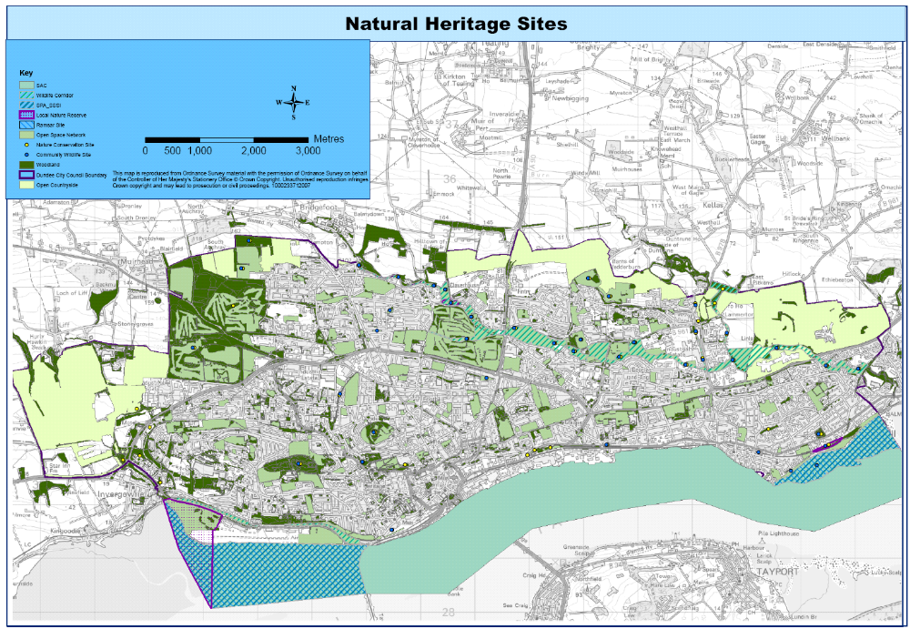
Map of Cultural Heritage Sites
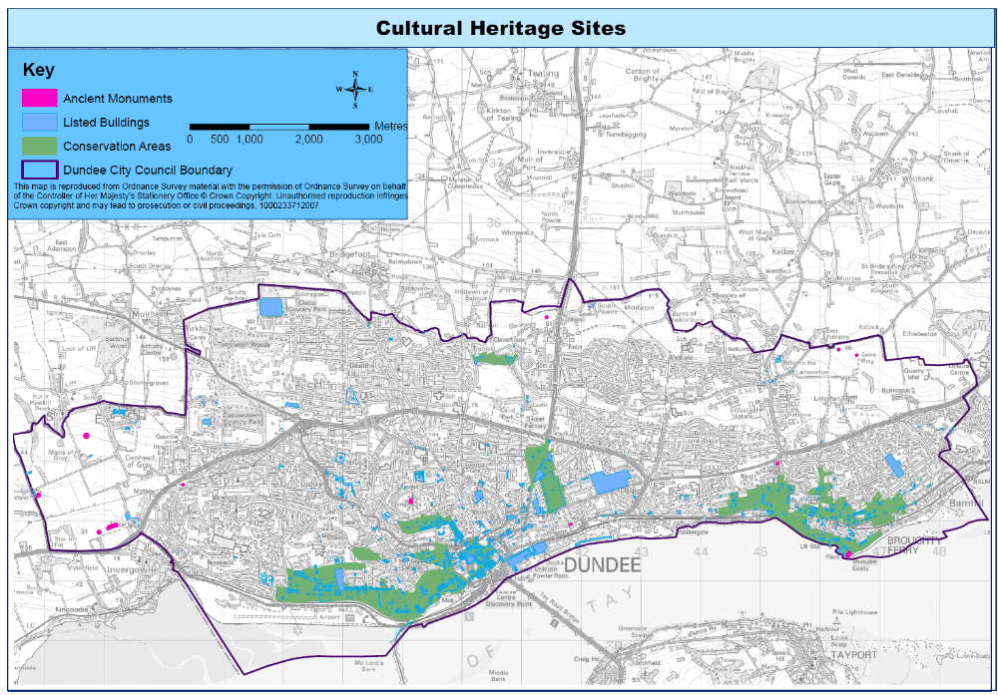
Appendix E. Made and maintained path network
(excluding Core Paths)

Country Parks
Camperdown 1.9km
Templeton Woods 3.6km
Clatto 2.2km
City Parks
Caird Park, 1.9km
Dawson Park, 2.0km
Baxter Park, 1.4km
Greater Balgay Park, (including Balgay Hill, Lochee Park and Victoria Park), 6.7km
South Rd Park, 2.1km
Broughty Ferry Esplanade and beach (including Castle Green, Windmill Garden and Barnhill Rock Garden).0.7km
City Heritage Parks
Dighty Linear Park (including Trottick Ponds LNR 0km, Mill o Mains Park 0.4km, Finlathon Park 1.5km, Bell Tree Park 0.7km) 2.6km
The Law 1.2km,
Stobsmuir Ponds 0.5km,
Firth of Tay Linear Park (including Riverside Nature Park), 3.2km
Reres Hill 0.9km,
Dudhope Park 1.4km,
Trottick Ponds Local Nature Reserve (see Dighty Linear Park above)
Duntrune Demonstration Garden 0km.
Neighbourhood Parks
Magdelene Green 0.1km,
Orchar Park 0.2km,
Finlathon Park (see Dighty Linear Park above),
Whitfield Green (under development),
Fintry Park 0.8km,
Fairmuir Park 0.3km,
Middleton Community Woodland 0.7km
Broughty Ferry Local Nature Reserve 0km
The Miley 0km.

Total in these spaces 34.4km made paths which are not Core Paths

