Dundee City Council

Blue Badge Application Form
Please complete all relevant sections of the application form and supply the appropriate documents to confirm your address, identity and evidence of eligibility. When completing this form you may find the accompanying guidance notes are helpful. The local authority may refuse to issue a badge if you do not provide adequate evidence that you meet the eligibility criteria.
Section 1 – Information about the applicant - Under 3
If you are completing the form on behalf of an applicant who is under 3, please provide their details in
appropriate sections and sign the form on their behalf.
Further guidance on completing this form can be found in the accompanying guidance note.
First names (in full):
Surname:
Surname at birth:
Gender: Male
Place of Birth:
Female
Town:
Country:
Date of Birth (DD/MM/YYYY):
/
/
Child Registration Number:
(see Section 1 of the accompanying guidance notes)
Current address and contact details:
Postcode:
Home Tel:
Mobile Tel:
Email:
Previous address, if different in the last three years:
Postcode:
Do you currently hold a Blue Badge, or have you held a Blue Badge before?
Page 1
Yes:
No:
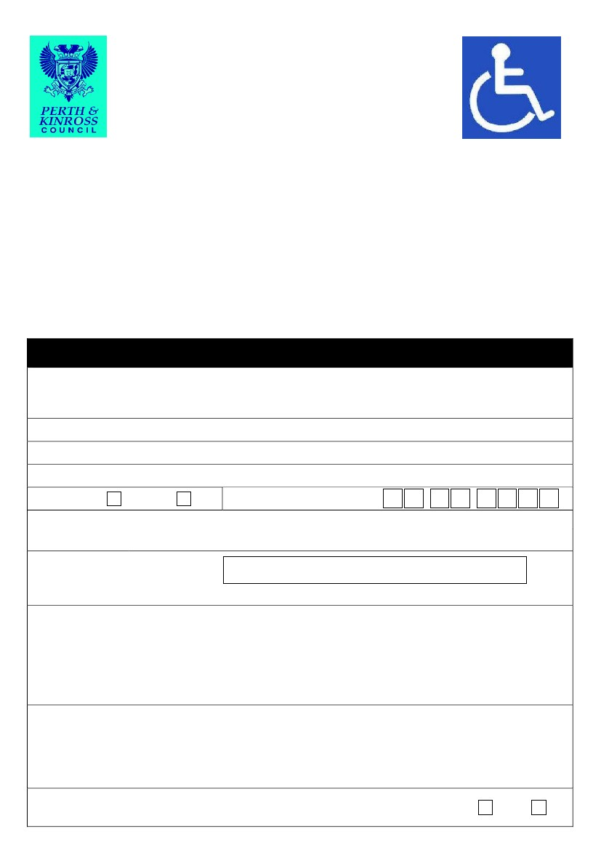
If you would like support to complete this application, please contact Customer Services Team, Dundee House, 50 North Lindsay Street, Dundee, DD1 1QE

If you have:
Which local authority issued you with the last badge?
What is the serial number on the last badge?
What is the expiry date of the last badge?
Proof of your address, dated within the last 12 months:
We need to check that you are a resident in this local authority area before we can process your application.
Please provide original documentation where relevant:
I am applying on behalf of an applicant who does not pay Council Tax and is under the age
of 3.
Proof of your identity:
We need to check the child’s identity to reduce the potential for fraudulent applications for a Blue Badge.
You must attach a photocopy of one of the following as proof of the child’s identity:
Birth certificate / adoption certificate
Passport
Do not send original documents as these will not be returned.
Photographs:
You will need to enclose a recent passport standard photograph of the applicant. The photograph needs to show the applicant’s full face so that the holder can be easily identified. No one else should be in the photograph. The photograph will be placed on the back of the badge and will not be visible when the badge is being displayed in the vehicle. Please ensure that the applicant’s name and date of birth is on the back of the photograph.
Badge issue fee:
The current fee is - £20
Payment will only be taken if your application for a Blue Badge is successful. You will only be issued with a Blue Badge once your payment has been received. Please don’t make payment now.

Please nominate the vehicle registration
number(s) for the main cars in which you
intend to use the Blue Badge:
(Up to three registration numbers should be
nominated, but please remember that other
vehicles can be used)
Section 2 – Questions for ‘subject to further assessment’ applicants under the
age of three
[Regulation 4(3)]
These questions are intended for children under the age of three who may be eligible for a Blue Badge
because:
•
•
They have a condition requiring the transportation of bulky medical equipment at all times; or
They must always be kept near a motor vehicle on account of a condition so that they can, if
necessary, be treated for that condition in the vehicle or taken quickly in the vehicle to a place
where they can be so treated.
If you are unsure whether these questions apply to your child, and then please read the guidance notes enclosed
with this application form.
Page 2
Are you applying on behalf of a child under the age of three who has a condition requiring
transportation of bulky medical equipment at all times?
Yes:
No:
If YES, please state what type of equipment is required:
Are you applying on behalf of a child under the age of three who has a condition that requires that
they must be always kept near a motor vehicle so that they can, if necessary, be treated for that
condition on the vehicle or be taken quickly in the vehicle to a place where they can be treated?
Yes:
No:
If YES, please describe the child’s medical condition
If you have answered yes to either of the questions above please enclose a letter from a healthcare
professional that has been involved in your child’s treatment (for example your GP or paediatrician)
giving details of the child’s medical condition and the type of medical equipment they need
Section 3 - Declarations and signatures
These questions are intended to be answered by all applicants for a Blue Badge
3a) Mandatory declarations about the information you have provided and the
application process
- Please read the following declarations carefully.
- Please tick all relevant boxes to indicate that you have read and understood each declaration.
- Not ticking one of these declarations may mean we are unable to issue you with a Blue Badge.
- Providing fraudulent information may result in prosecution.

If you don’t provide us with the information on this form we won’t be able to verify your eligibility. All information relating to this application will be handled in line with data protection laws. The data controller is Dundee City Council and you can contact our data protection officer at infogov@dundeecity.gov.uk
We use the information you provide in this form to check your eligibility and process your application. The information may be shared within the local authority, with other local authorities, the police and parking enforcement officers to detect and prevent fraud.
Page 3
Any medical information that you have supplied to support this application is sensitive personal data and will only be disclosed to third parties as necessary for the operation and administration of the Blue Badge scheme, and to other Government Departments or agencies, to validate proof of entitlement or as otherwise required by law.
We keep information relating to this application for up to 3 years. For more information about how we process information, please contact us or visit https://www.dundeecity.gov.uk/sites/default/files/publications/dataprotectionpolicy.pdf

Declarations to be completed by all applicants
I confirm that, as far as I know, the details I have provided are complete and accurate. I realise that
you may take action against me if I have provided false information in this application form.
I understand that I must promptly inform my local authority of any changes that may affect the
entitlement to a badge.
I confirm that the child’s photograph I have submitted with the application is a true likeness.
I understand that, if the application is successful, I must not allow any other person to use the badge
for their benefit and that I must only use the badge in accordance with the rules of the scheme as set
out in the “Blue Badge scheme in Scotland: Rights and responsibilities of a Blue Badge holder” leaflet
which will be sent to me with the badge.
I understand that the child must not hold more than one valid Blue Badge at any time.
I understand that the local authority may need to contact an accredited healthcare professional for the
purpose of obtaining further information in support of the application.
I understand that they may be required to undertake an assessment with a healthcare professional
who is independent of their existing care and treatment, in order to determine their eligibility for a Blue
Badge.
3b) Your consent to use your information to improve the service you receive
Please read and tick the following optional declarations that you consent to. Ticking these boxes will help to
improve the service we can offer you
I consent to the local authority checking any information already held by the local authority’s Social
Services department on the basis that:
• It can help determine the eligibility for a Blue Badge;
• It may speed up the processing of the application;
• It may enable a decision to be made without the need for a mobility assessment.
I agree to the disclosure of the information included in this form to other local authority
departments/service providers so that I can be informed about other local authority services that may
be of benefit to the badge holder.
3c) Checklist of documents you may need to enclose
Please ensure you have enclosed all of the relevant documents for the sections of this application form that
you have completed. We have provided a checklist below to help remind u of what you need to enclose.
Section 1 – Information about you
Proof of your address, dated within the last 12 months.
A photocopy of proof of the child’s identity.
A passport-style photograph of the child with their name on the back.
Page 4

Section 2 – Children under the age of three
A letter from a healthcare professional that has been involved in the child’s treatment, giving details of
condition and type of medical equipment needed.
3d) Your signature against the declarations in Section3a and 3b
Your signature:
Date of
application:
Please print your
name here:
(DD/MM/YYYY):
/
/
Please return this form and relevant documents to:

Dundee Health & Social Care Partnership Tel: 01382 438335 or 438326
Floor 2
Dundee House
50 North Lindsay Street
Dundee
DD1 1NF
Misuse of the badge is a criminal offence and can lead to a fine.
Please be aware of your Blue Badge expiry date. Once this has been reached you must return the Badge to Dundee City Council as it is no longer valid – even if you are awaiting receipt of your new Blue Badge
Page 5

Blue Badge Application Form - Guidance Notes
What sections of the application form should I complete?
All applicants should complete Section 1 and Section 3
Applicants will also need to complete:
•
Section 2 if the applicant is a child under the age of 3 who must be accompanied by bulky medical
equipment or who needs to be kept near a vehicle at all times, either for treatment, or for transportation
to a location where treatment can be performed.
Section 1 - Information about the child
All fields should be filled in.
As you are applying for a Blue Badge on behalf of someone under the age of 3, then you will need to
provide their Child Registration Number. This can be found on Child Benefit documentation.
There are questions for those who have already held a Blue Badge or who have a Blue Badge which is due
to expire shortly. Applicants should note that only one badge will be valid for one applicant at the same
time. The serial number can be found on the front of the badge.
Proof of the child’s address and identity
Address:
Proof of address should be in the form, of a copy of the current Child Benefit Award Letter bearing the
child’s name and address. This must be submitted with your application.
Identity:
A photocopy of one of the following must be submitted with the application: the birth/adoption
certificate, or passport.

The individual certifying the documents should include the text: “This copy is a true likeness of the
original” alongside their signature. They should also print their name and occupation alongside this
information.
Badge fee:
If your application is successful there is a charge of £20.00 payable at West District Housing Office 3 Sinclair Street DD2 3DA, East District Housing Office 169 Pitkerro Road DD4 8ES & Dundee House 50 North Lindsey Street Dundee DD1 IQE

Cheques/Postal Orders should be made payable to Dundee City Council. Cash payments will also be
accepted. Payments can be made online at www.dundeecity.gov.uk – Pay for it – Parking – Blue Badge
Your local authority will only issue successful applicants with a Blue Badge once payment of the required
fee has been received.
Page 6

Other information
You should also provide the Vehicle Registration Numbers of up to three vehicles in which you are most
likely to use a Blue Badge if your application is successful. This information helps local authorities with
their enforcement of the Blue Badge scheme rules, but please note that you can use a Blue Badge in other
vehicles too.
Section 2 – Questions for ‘subject to further assessment’ applicants under the age of three
Section 2 should be completed on behalf of:
• children under three years of age who have a medical condition which means that they must always be
accompanied by bulky medical equipment which cannot be carried around with the child without great
difficulty; or
• children under three years of age who have a medical condition which means that they need to be kept
near a vehicle at all times, either for treatment, or for transportation to a location where treatment can
be performed.
A parent or guardian must apply on behalf of a child under the age of three.
The list of bulky medical equipment referred to above may include:
• ventilators;
• suction machines;
• feed pumps;
• parenteral equipment;
• syringe drivers;
• oxygen administration equipment;
• continuous oxygen saturation monitoring equipment; and
• casts and associated medical equipment for the correction of hip dysplasia.
A local authority may issue a badge if the equipment is always needed and cannot be carried without great
difficulty.
Examples of highly unstable medical conditions that mean children who have them may need quick access
to transport to hospital or home are:
• tracheostomies;
• severe epilepsy/fitting;
• highly unstable diabetes; and
• terminal illnesses that prevent children from spending any more than brief moments outside and who
need a quick route home.
Please note that the above lists are not exhaustive, to allow for new advances in technology and treatment
equipment.
You must enclose a letter from a healthcare professional that has been involved in your child’s treatment
(for example your GP or paediatrician) giving details of the child’s medical condition and the type of medical
equipment they need, The letter should include a reference to your child’s home address to provide your
local authority with proof of residence.
Section 3 – Declarations and signatures
Section 3a): The relevant mandatory declarations must be completed by all applicants, since they underpin
the terms of applying for a Blue Badge. Please take the time to read and understand these declarations,
since not ticking those that are relevant to your applicant may result in your local authority being unable to
accept your Blue Badge application.
Section 3b): You may wish to tick the optional declarations in order to speed up your application and
improve the service you receive from your local authority. In doing so, you will be providing specific
consent to your authority to allow them to share information about you with relevant departments and
service providers within the authority.
Page 7

Section 3c): All applicants must sign and date the form prior to submitting it.
A local authority may refuse to issue a badge if they have reason to believe that the applicant is not who
they claim to be or that the badge would be used by someone other than the person to whom it has been
issued.
If your badge application is successful, the leaflet “The Blue Badge Scheme - Rights and responsibilities in
Scotland” will be sent to you with the badge. This leaflet explains the rules of the Scheme and how you
should use the badge properly. The leaflet can be viewed on the publications section of Transport
Scotland’s Blue Badge website: (www.transportscotland.gov.uk/road/policy/blue-badge-scheme)
Page 8

