

Supporting Learners Policy and Guidance Framework (2-18)

For Nursery and School Communities in Dundee

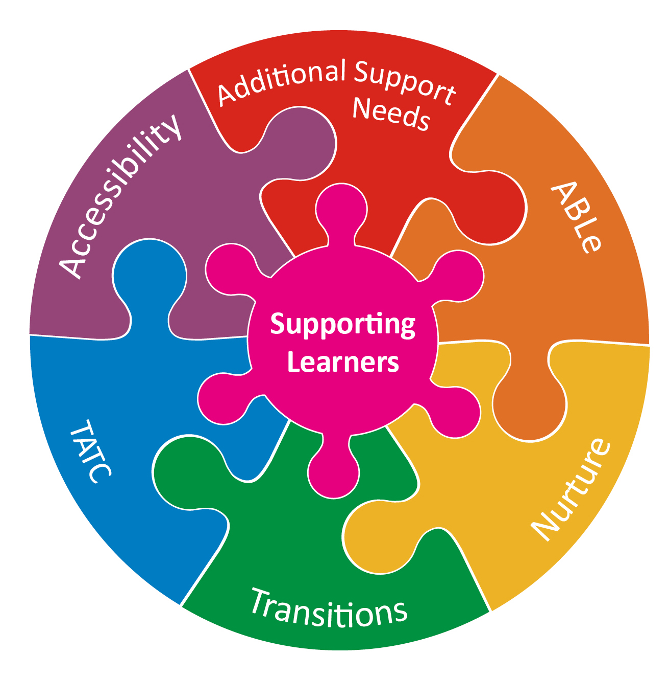

Our Vision: Our children and young people will have the best start in life and Dundee will be the best place in Scotland to grow up.

Our 5 priorities are to ensure all children and young people including those with ASN:
- have the best start in life, are cared for and supported to learn in nurturing environments
- will be meaningfully engaged with learning and combined with high quality learning experiences, all children and young people will extend their potential
- are physically, mentally and emotionally healthy
- who experience particular inequalities and disadvantage will achieve health, wellbeing and educational outcomes comparable with all other children and young people
- are safe and protected from harm at home, in schools and the community.
1.0 Introduction
  - This policy framework is designed to promote the continuous improvement of an inclusive service, developing the capacity in all nursery and school settings to meet the learning and wellbeing needs of all children and young people.

  - This policy takes account of both national legislation/ policy frameworks and local strategic plans relevant to supporting learners, as shown in diagram below

Scottish Government National Legislation and Guidance

The National Improvement Framework (2016)
Equalities Act (2010)
Additional Support for Learning (Scotland) Act (2004, & code of practice 2017

Standards in Scotland’s Schools Act (2000)

Children and Young People (Scotland) Act (2014)
Dundee City Council Strategic Guidance
GIRFEC
Autism Strategy
Equality and Accessibility Strategy

Attainment Challenge
Tayside Plan & Local Outcome Improvement Plan
Supporting Learners Policy and Guidance Framework
How Good Is Our School 4
3.1
Tayside Children’s Plan
Local Improvement Plan
How Good is Our School 4 (2015)

Education Scotland Act (2016)
City Plan
DCC Education Plan
- Our Aims:

The aims of this policy are:
- to ensure the legislative duties relating to additional support needs are being met;
- to ensure that all individual children and young people are included and achieving within their local schools as much as possible;
- to guide and support progress in developing nurturing schools;
- to ensure the implementation of a robust staged model of assessment and intervention including identification of those pupils in need of targeted or specialist support
- to develop and support the confidence and skill levels of staff

- Legislative Duties

- ASL Act (2004) amended 2009/2018
A child or young person is said to have additional support needs if they need more or different support to what is normally provided in schools or preschool settings to children of the same age. The term ‘additional support needs’ applies to children or young people who, for whatever reason, require additional support, in the long or short term, in order to help them make the most of their school education and to be included fully in their learning. Children or young people may require additional support for a wide variety of reasons

Schools and nurseries must:
- make adequate and efficient provision for the additional support required for each child or young person with additional support needs, subject to certain exceptions
- make arrangements to identify, meet and review the additional support needs,
- presume that all looked after children and young people have additional support needs unless the authority determine that they do not require additional support to enable them to benefit from school education
- consider whether each looked after child or young person for whose school education the authority is responsible requires a co-ordinated support plan
- provide the education manager with relevant data as requested to allow for planning and reporting to government
- provide parents of children with additional support needs and eligible children and young people with all of the information they are required to publish under the Act
- assess the capacity and impact on wellbeing of a child over the age of 12 years to be able to exercise their rights in respect of additional support for learning, where a child of this age seeks to exercise any right under the Act
- provide those children or young people, who need one, with a co-ordinated support plan and keep this plan under regular review
- have information about how additional support needs will be met in the school handbook
- provide independent and free mediation services for those parents and young people who want to use such services and publish information on these services
- have in place arrangements for resolving disputes
- at least 12 months prior to the expected school leaving date, request and take account of information and advice from appropriate agencies likely to make provision for the child or young person when he or she leaves school and no later than 6 months before the child or young person is expected to leave school provide information to whichever appropriate agency or agencies, as the authority think appropriate, may be responsible for supporting the young person once he or she leaves school, if the child (where the child has attained the age of 12 and has capacity), the child’s parent or young person agrees

Code of practice https://www.gov.scot/publications/supporting-childrens-learning-statutory-guidance-education-additional-support-learning-scotland/

- Equalities Act (2010)
Dundee City Council provided e-learning and an annual whole city training on your duties under this act. This training is mandatory for all DCC employees. A key point to remember is that you are required under this Act to take positive steps to ensure that disabled students of those with protected characteristics can fully participate in the education and other benefits, facilities and services provided. This is called the ‘reasonable adjustments’ duty https://www.gov.uk/guidance/equality-act-2010-guidance

- Presumption of Mainstream (2019)
Education authorities have a duty to provide education in a mainstream setting unless certain exceptions apply.
This guidance outlines key features of inclusive practice. https://www.gov.scot/publications/guidance-presumption-provide-education-mainstream-setting/

- Children and Young People’s Act 2014
The Children and Young People (Scotland) Act 2014 put the UNCRC into a Scottish statute for the first time. Underpinned by the national approach, Getting it Right for Every Child (GIRFEC), the 2014 Act also establishes a new legal framework within which services are to work together in support of children, young people and families. It encourages Scottish public bodies to consider children’s rights and requires them to prepare reports on what they are doing to progress children’s rights. Three main themes that run through the Act:
a) The child's views should be taken into account in decisions that affect their lives;
b) The welfare of the child is the paramount consideration;
c) No court or hearing should make an order, unless the court or hearing considers that to do so would be better for the child than making no order at all (known as the 'no order' principle).

You will find most of the relevant duties in the ASL Act code of practice which has already been mentioned.

- Roles and Responsibilities

The roles and responsibilities of Children & Families Service staff in relation to the above legislation are as follows:

Central team are responsible for supporting nurseries and schools in the implementation of this policy by:
- Monitoring the impact of this policy framework through School Improvement Partnerships and the relevant quality improvement frameworks (HGIOS 4; HGIOELCC)
- making effective use of data for long term planning of provision to meet needs
- planning strategically with senior managers in the Health & Social Care Partnership to ensure transitions to adult life are effective
- planning strategically with senior managers within the Children & Families Service to ensure that implementation of the Children & Young People’s Act (2014) is closely aligned to the requirements of other complementary legislation.
- facilitating a range of training and development opportunities for all staff
- working with families and other partners to plan, develop and deliver appropriate provision in the most appropriate learning environment possible
- providing an appropriate range of support services and partnership arrangements with other agencies
- ensuring regular reviews of this policy
- ensuring children and young people’s views are heard and acted upon

The Head Teacher is responsible for the implementation of this policy by:
- developing and promoting individual school guidance on Supporting Learners based on the principles within this policy
- ensuring that the school maintains an up-to-date database/register of all pupils with additional support needs (Appendix 1)
- promoting an inclusive ethos which values all children and young people equally and which delivers flexible support as required.
- prioritising staffing in order to support for children with additional support needs
- ensuring that staff have opportunities for Professional Reflection and Development (PRD)
- ensuring that all staff, all pupils, all parents and the Parent Council are aware of the Authority and school Supporting Learning Policies and Guidance
- ensuring that the both the Authority and the school Supporting Learning Policies and Guidelines are fully implemented and the school’s policy is reviewed on a regular basis
- using the Supporting Learners Management Groups (SLMGs) to ensure consistency of approach to support needs of the children and young people in their community

All teaching staff are responsible for the implementation of this policy by:
- developing meaningful relationships with children and working constructively with parents
- adapting the learning environment to ensure inclusive pedagogy
- planning effectively for the class, groups and individuals and differentiating the curriculum accordingly.
- devising, where appropriate, group or individual learning plans (ABLe), Individual Care Plans or contributing to a Single Child’s Plan as appropriate
- ensuring effective communication/consultation with support staff to enable strategies to be meaningfully implemented
- adjusting daily timetable to maximizes support
- Incorporating suggested strategies, resources and advice whenever possible
- assessing and reporting on the progress made by each pupil
- working collaboratively with colleagues and parents to help identify and address the needs of all children and young people
- sharing experience and good practice of supporting learning with colleagues and being receptive to those of others
- taking account of the assessment and outcomes to be achieved in any individual Child’s Plan

Parents, Carers and Pupils should be involved in implementation of this policy by

- Schools working in partnership with parents and carers.
- Parents are encouraged to attend collective and individual meetings held in schools.
- Parents, carers and pupils are involved, informed, consulted and included in both the life of the school community and their education.
- Children and Families Service have processes in place to gain pupil and parent/carers voices

- Staged Intervention Model

Staged intervention is used as a means of identification, assessment, planning, recording and review to meet the learning needs of children and young people. A staged intervention and assessment process is in place to enable practitioners to assess and meet learners’ needs.

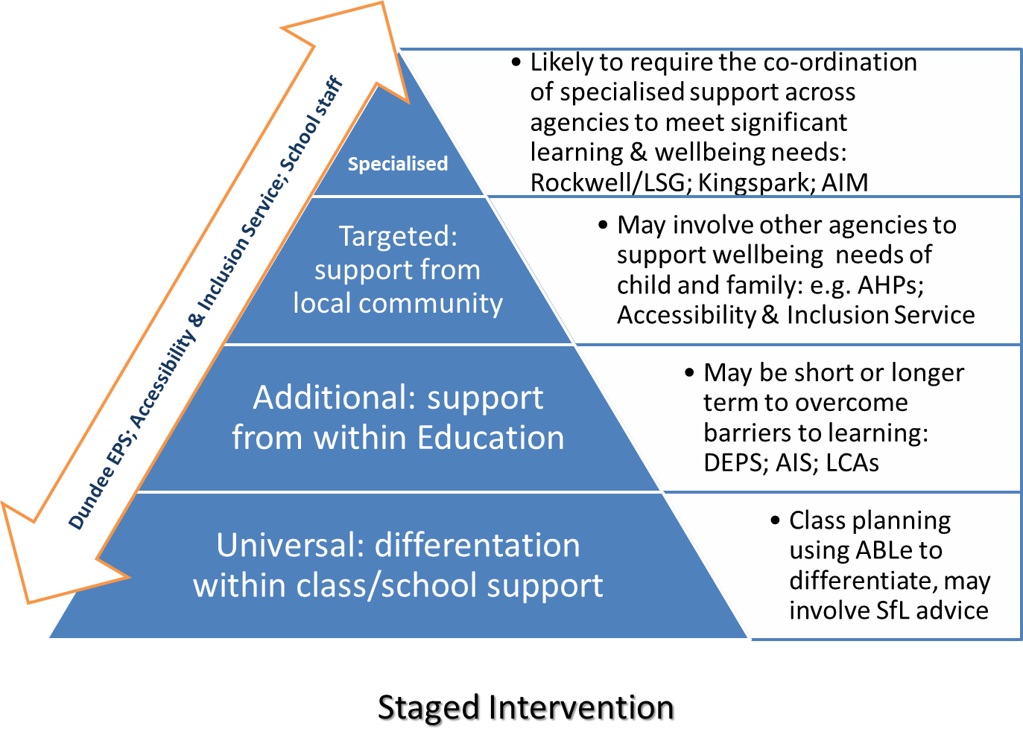

Very good curriculum design and excellent learning and teaching are essential in order to ensure that the needs of children and young people are met. Meeting the needs of children and young people who require additional support is the responsibility of every member of staff In Dundee establishments. (Learning and Teaching Policy : External Link 'Learning and Teaching Policy Sept 2019.docx')

Key factors underpinning inclusive practice include:
- High teacher expectation
- Robust assessment and planning within a staged approach
- Appropriate adaptations to the learning environment
- Ongoing professional development
- Nurturing approaches and positive relationships

In Dundee, the ABLe toolkit ( www.ableschools.org.uk ), and the Good Practice Checklist audit tool guide practice in this area (Internal Link External Link 'Dundee Good Practice Checklist.docx')

- Self-Evaluation for improvement planning– the key to improving practice using the tools below.

Self-evaluation for improvement planning is a continuous process which is overseen by the Education Management Team and the Complex ASN Delivery Group. HGIOS 4 (QI 3.1) is used as the QI framework with nurseries and schools, and analysis of inspections and local authority engagement/visits indicates that while there are some improvements in outcomes for children and young people with additional support and wellbeing needs, there is a gap in classroom practice at universal/additional level related to differentiation; and making better use of ASN data at whole school level.

2.4 Personalised Support: This indicator focuses on the provision of high-quality support that enables all children and young people to achieve success. It highlights the importance of wellbeing and involving children and young people in decisions about how their needs should be met. Monitoring the impact of interventions and making timely adjustments to practice are key to providing highly effective universal and targeted support.
Themes:
- Universal support
- Targeted support
- Removal of barriers to learning

3.1 Ensuring Wellbeing, Equality and Inclusion : This indicator focuses on the impact of the school’s approach to wellbeing which underpins children and young people’s ability to achieve success. It highlights the need for policies and practices to be well grounded in current legislation and a shared understanding of the value of every individual.

Themes:
- Wellbeing
- Fulfilment of statutory duties
- Inclusion and equality

See Appendix 3 for observation framework

- Career Long Professional Learning

There are many opportunities for staff for professional learning and development, including eLearning modules; a selection of Supporting Learners Introduction sessions every year: regular information shared with staff about other CLPL opportunities eg Open University Modules, webinars etc. Through collaborative working with partners there are also offers of wide range of learning opportunities including occupational and speech and language therapy input, visiting speakers and CALL Scotland.
The Principal Teacher for Supporting Learners networks have regular meetings where there are opportunities for CLPL to take place.

- Transitions

All transitions into and across establishments and services in all sectors should be regarded as processes not events. The process is not complete until the child or young person with support needs is settled and progressing in the new situation.

For children due to move from an early years establishment to primary school, arrangements should be set in motion at least six months prior to the transition; For children and young people moving from primary to secondary school, transition arrangements should start not less than one year ahead of the move; and

For children or young people leaving school transition arrangements should start at least one year ahead of the move.

For children and young people of school age, therefore, transition planning meetings should be held at least one year before a child or young person leaves, or is admitted to an establishment, and progress should be reviewed at least six months before the transition.

Parents/carer and the child or young person should be fully involved in the transition process and the outcome of the process should be clearly recorded. In each establishment, the head teacher will establish who is the main point of contact and co-ordinator of the transition of an individual child or young person with additional support needs.

A key person of the sending establishment should work with the key person in the receiving establishment and will generally need to collaborate with key professionals. Together they are responsible for checking that the resources and arrangements are in place for the child or young person being received or transferred.
Internal Link External Link 'Post 16 Transition for Pupils with ASN 2018.docx'

- Care Experienced Children and Young People (CECYP)

Care Experienced children and young people are one of the top priorities for Dundee Children’s and Families Service. An emphasis is placed on ensuring their wellbeing and progress in accordance with the guidelines for CECYP and the Corporate Parenting
It is presumed within the Revised Additional Support for Learning Act 2009, that CECYP have additional support needs unless it is determined that they do not need additional support to benefit from school education.
The designated education officer with responsibility for CECYP should carefully monitor the attendance, progress and attainment and wellbeing of every looked after child or young person.
Through that monitoring, and in consultation with children, young people, parents/carers and partners, a decision will be taken as to whether or not each CECYP needs additional support to ensure appropriate educational progress, including consideration for a CSP.
That decision, and the reasons for it, should be clearly recorded by the education officer in an appropriate minute on an annual basis as a minimum.

Where an additional support need has been identified: this will be recorded; noted at the appropriate stage of the staged model that reflects the additional support need; and kept under review by the establishment. In addition, at every review for a CECYP there should be a discussion of educational needs.
The outcome of this shared discussion should be recorded in the minutes of the meeting and, where appropriate, reflected in the ABLe plan or SCP.

Policy national advice contained in ‘We Can And Must Do Better’.

Review
- This policy framework will be revised, monitored and reviewed by the Supporting Learners Reference Group and within the delivery plan for children’s services (REF NAME OF GROUP). It will be formally revised and updated no later than June 2020

Publication date: December 2019
Review date: August 2021
Officer responsible: Education Manager (ASN, Educational Psychology & Inclusion)

Appendix 1. Local Policy and Guidance

Name of Document | Review date | Need to know/ new information
Accessibility Strategy | August 2021 | Consideration of School trip information and need for Reasonable Adjustments  Internal Link External Link 'Accessiblity Strategy Aug 2018.docx'
Autism Strategy | August 2021 | Strategy and action plan for Autism across partners in Dundee.  Includes reference to E-learning module / OU modules  Internal Link External Link 'Autism_Strategy Aug 2018.doc'
Administration of Medicine | August 2021 | - Inhalers and Epipens to be added  - Ensuring privacy when administrating medication  - Ensuring good recording procedures around this  - Contact details for HV , and NHS staff  Internal Link External Link 'Administration of Medication in Schools August 2018.doc'
AIM (Anxiety in Motion) – Overview |  | Information ‘leaflet’ on AIM provision for secondary age pupils with significant anxiety which prevents them from attending school  Internal Link External Link 'AIM 2018.docx'
Anti Bullying Guidance |  | Internal Link External Link 'Anti-Bullying Guidelines.docx'
Assessment Arrangements Guidelines | August 2021 | Information for schools on gathering evidence and making arrangements for assessment arrangements, including SQA  Internal Link External Link 'Assessment Arrangements Policy May 2019.docx'
ASN and Inclusion Services - Guidance | Sept 2021 | Guidance for process for accessing city-wide services for Additional Support Needs, Educational Psychology & Inclusion  Internal Link External Link 'ASN and Inclusion Services.docx'
Children’s Rights Guidance (w.r.t. ASL Act) | May 2021 | New rights for 12-15 year olds , including the right to ask for assessment and information about their additional support needs.  Internal Link External Link 'Childrens Rights Guidance 2018.docx'
Child Protection Guidance |  | Information of processes and support when there is a child protection concern.
Children Unable to attend school due to Ill Health | September 2021 | Up to date information about the provision of education for children and young people unable to attend school due to ill health.  Internal Link External Link 'Education for children who are unable to attend school due to ill health.docx'

Tayside Mediation Service Leaflet | N/A | Information on how to access and use independent mediation for matters relating to Additional Support Needs.  Seek advice from Jennifer King or Janette Kerr if this is being considered. Internal Link External Link 'Dispute Resolution Leaflet.docx'
Critical Incident Guidance |  | Information about what to do after a critical incident and how to find appropriate support.  Internal Link External Link 'Managing critical incidents and sudden bereavement.pdf'
CSP Guidance | August 2021 | Information on the process around CSP and guidance around the legislation. Also flowchart to support implementation  Internal Link External Link 'CSP Guidance Revised 2019.docx'
Dispute Resolution Leaflet for Parents/Carers | Sept 2021 | General information about dispute resolution processes. Seek advice from Jennifer King or Janette Kerr if this is being considered.  Internal Link External Link 'Dispute Resolution Information for Parents carers and young people.docx'
Dyslexia Pathway | January 2021 | Information about dyslexia assessment and how to support children and young people.  Internal Link External Link 'Dyslexia Pathway Jan 2018.pdf'
Enrolment/ Placing request Procedures: Pupils Transferring within and into Dundee with ASN | Feb 2020 | Process to follow for pupils with ASN, including those who are Looked After. This guidance is an appendix to the general guidance on Placing Requests. It is important for transition planning.  Internal Link External Link 'Placing Request Guidance (ASN) Oct 18.php.doc'
Equality Outcomes | April 2021 | Equality outcomes for education within the Mainstreaming Equalities report.  Internal Link External Link 'Draft EQUALITY OUTCOMES mainstreaming report 2017.docx'
Good Practice Checklist | June 2021 | An audit tool for schools to use in relation to the learning environment for children and young people with more complex additional support needs, including Autism.  Internal Link External Link 'Dundee Good Practice Checklist.docx'
Information Sharing Guidance | October 2021 | Council –wide guidance on Information Sharing (w.r.t. Children & Young People’s Act and Data Protection). This includes a guide on sharing information within the TATC framework.  Internal Link External Link 'Information Sharing Guidance.pdf'
Intimate Care Guidance | Oct 2020 | To be used for intimate and personal care of children and young people.  Internal Link External Link 'Intimate Care Policy new 2017.doc'
Care Experienced CYP Charter | Oct 2021 | The Charter for Care Experienced Children and Young People for practitioners across the Dundee Partnership.
Nurturing Approaches in Dundee | Aug 2017 | Guidance in implementing Nurture and to highlight CLPL framework and information about Named Person  Internal Link External Link 'Nurturing Approaches in Dundee (2).docx'
De-escalation Guidance | June 2021 | To be used alongside ‘Nurture Approaches in Dundee’.  The process for Debriefing in included.  Internal Link External Link 'DCC De-escalation Guidelines 2017.docx'
Physical Intervention Guidance | June 2021 | As above, including an important section on ‘seclusion’.  Internal Link External Link 'Physical Intervention Guidelines Feb 2019.docx'
Placing Request Guidance (ASN) |  | Details of what to do in regards to placing request of pupils with ASN  Internal Link External Link 'Placing Request Guidance (ASN) Oct 18.php.doc'
Promoting Inclusion, Reducing Exclusion: Policy, Practice & Paperwork | Oct 2021 | Policy and guidance on promoting inclusion in order to reduce exclusion. Sections on Looked After Children & those with Additional Support Needs are particularly important.  Internal Link External Link 'DCC_CFS_Promotoing_Inclusion  Reducing_Exclusion_Policy,_Practice_and_Paperwork_170818
SLMG Guidance  (Supporting Learners Management Groups) | June 2021 | Overview of SLMG framework and revised process for sending pupils’ information at the time of SLMG meetings.  Internal Link External Link 'SLMG Guidance Aug 2019.docx'
Self-evaluation: Wellbeing, Equality & Inclusion (3.1, 2.4) | Annual | Internal Link External Link 'Template QI3.1(Wellbeing,equality&inclusion) blank.docx'
SEEMIS recording for ASN (inc Census) | July 2019 | Annual guidance for completing the ASN Census. In addition, school ASN databases to be circulated which are aligned to Seemis.
Supporting Learners Policy Framework | Aug 2020 | Overview of the aims, actions and outcomes for supporting learners across Dundee.  Internal Link External Link 'DCC Supporting Learners Policy Framework Aug 2017.pdf'
The Role of the Senior Learning and Care Practitioner |  | Information re role and how to access support from SLCP  Internal Link External Link 'The Role of SLCP.docx'
The Tayside Plan for Children & Young People | April 2021 | Refer to Priority Group 4 for actions and outcomes related to Complex Additional Support Needs; Looked After Children & Young People; Young Carers; and young people at risk of offending.  Internal Link External Link 'Tayside Plan April 21.pdf'
Transition : Post 16 transition | Sept 2020 | Important information for pupils with ASN regarding transition and Health and Social Care referral process  Internal Link External Link 'Post 16 Transition for Pupils with ASN 2018.docx'
Home-School Travel Assistance Policy |  | Internal Link External Link 'Home - school transport policy and Code of Practice.doc'
Using Visuals to Facilitate Inclusion | August 2021 | To help support good practice checklist  Internal Link External Link 'Using Visuals to Facilitate Inclusion.doc'

Appendix 2

HOW WE WILL SUPPORT LEARNERS

AIM | Implementation of Policy Framework | ACTION
Children and young people with complex and additional support needs will have the same opportunities and have quality of life in Dundee. | Nurturing Approaches In Dundee | - Consistent & evidence-based approach to responding to behavior across the city  - Implementation & evaluation of impact of Nurture Framework  - Staff training framework developed based on Nurturing Principles which will be delivered in a tiered system using a whole school approach
 | TATC Framework including transitions | - Child’s Plans are SMART and linked to assessments of risks and needs  - Child’s Plans are embedded in single planning system and include FACDs & CSPs  - Pupils and Parent/Carers are regularly given opportunities to voice their views and opinions in relation to the support they are receiving.  - All leaflets/website info and policy/ strategy informed by parent/carer co-production and participation.  - Increase use of adapted Wellbeing wheels to ensure children & young people have accessible communication  - Increase number of children/young people with complex & ASN on pupil councils  - Transition planning for all pupils with ASN  - Transition Strategy forum to consider transition planning
 | Supporting Learners Policy  Including SLMGs | - Improved data-sharing and analysis which is compliant with CYPA/ASL Act  - Increase in children/young people attending local community schools  - Continue SLMGs to ensure local communities are central to  - decision-making and resource management  - Reliable data for ASN across all SLMGs  - Build capacity within the community/mainstream and specialised provision to meet diversity of learning needs through outreach support, shared resources and other co-operative practice  - Increase Outreach advice and support from Kingspark School  - Improve capacity of local nurseries and schools to understand and meet the needs of children/young people with complex & ASN  - School/Nursery Self -Evaluation through HGIOS 4 2.4 and 3.1  - Accessibility and Inclusion to provide ongoing support to nurseries & schools  - Increased commitment to working alongside parent/carers groups
 | Autism Strategy | - Consistent and integrated approach to social & communication needs (inc Autism) which meets national strategy standards  - E-Learning module developed for all DCC staff  - Schools to be supported to put in place an inclusive environment and be trained in how this should be used to allow pupils with autism to access the curriculum to increase accessibility and reduce the need for individual planning  - Transition planning which is in line with Principles of Good Transitions 3  - ICT (inc SQA) Accessibility framework developed which will allow a more consistent use of ICT for reasonable adjustments leading to improved attainment for pupils with ASN.  - Advanced learning and development opportunities for complex autism
 | Equality and Accessibility Strategy | - Developing learning environment adaptations increase accessibility and reduce the need for individual planning  - Good Practice Checklists  - ICT (inc SQA) Accessibility framework developed which will allow a more consistent use of ICT for reasonable adjustments leading to improved attainment for pupils with ASN

Appendix 3

QUALITY INDICATOR 3.1 – Ensuring Wellbeing, Equality and Inclusion
(with reference to QIs 2.3 Learning, Teaching & Assessment; and 2.4 Personalised Support)
This template can be used by schools and officers/managers within Dundee’s School Improvement Framework to gather, analyse and report on evidence in relation to the 3 inter-related QIs which inform how well a school is implementing its statutory duties (specifically Additional Support for Learning Act; Children & Young People’s Act/GIRFEC; and Equalities Act).
Evidence is gathered from:
1. Professional dialogue, including partner agencies
2. Feedback from children and young people
3. Feedback from parents
4. Observations of interactions and classroom environment
5. Audit of assessment and planning for individuals and school processes
6. Outcome data (Wellbeing; Exclusion & Attendance; Attainment & Achievement)

Features/Questions | Commentary/Evidence (How Do You Know That ?) | Next steps/action for improvement
Wellbeing
What whole school strategies are in place to promote positive relationships and behaviour?

How do we know that the learning environment is built on positive,
nurturing and appropriately challenging relationships which lead to high-quality learning outcomes ?

To what extent are young people, parents and partners more fully involved in planning learning and support and are active participants in decisions which affect them ?

How well do all staff understand their role and responsibility in supporting learners’ health & wellbeing ?

To what extent do staff make effective use of GIRFEC staged intervention processes and the named person service to ensure children and young people’s needs are met ?

How well is the GIRFEC national practice model (Wellbeing; My World Triangle) used to gather robust assessment information which informs intervention? (process and quality of plans) ?

How do we know that all young people feel they are safe, healthy, achieving, nurtured, active, responsible, respected and included ?

Learning, teaching & assessment (2.3)
Are approaches to pedagogy ensuring that young people with barriers to learning and challenges in their lives are engaged in their learning and making progress (link to 2.3)?

Are tasks, activities and resources effectively differentiated and provide appropriate pace and challenge for all learners ?

How well do staff record, analyse and use assessment information to identify development needs for individual learners and specific groups ?

Do staff consider whether their learning and teaching and assessment approaches meet the needs of diverse learners?

How good is our understanding of differentiation? Do staff and partners use a range of approaches that meet the needs of all learners?

Are we providing more diverse courses/ awards/ accreditation for young people whose barriers to learning may prevent them from attaining national benchmarks ?

What approaches are we using to support learning and wellbeing - universal and targeted?

How do we know they are making a difference to attainment, engagement and inclusion for individuals and groups of children/young people ?

What are the aims of tutor time (or similar) and how well are they being achieved?

Personalised Support (2.4)
Are there consistent approaches to monitoring, recording and tracking achievement across key aspects of learning to identify those in need of additional support ?

Are all class teachers aware of the young people in their class with additional support needs ?

How consistently are ABLe plans and strategy sheets used to inform support across the school?

Are Individualised learning plans/programmes in place (if appropriate) to improve the outcomes for young people?
Are there appropriately high expectations and challenge for children and young people with ASN ?

The school reviews the progress of all children
effectively, including those with additional support needs. They can provide reliable and valid evidence to support this process.

How do we know if personalised support is having the desired impact of improving outcomes for learners?

Does the school have effective assessment systems in place to identify the ever-increasing diverse needs of children?

Is there an ASN database to monitor the pattern of need across the school and inform strategic approaches to meeting need?

Are appropriate supports in place at all stages to allow all young people to access learning, be fully included in all curriculum areas and have the same opportunities as others to remain at school until S6, if this is their choice?

How do guidance staff, SLT , ASN and support staff work together to ensure learning and wellbeing needs are addressed most effectively?

How are support staff used across the school to support learning ? Relate to EEF report.

Do support staff have access to appropriate training and professional learning opportunities to ensure all young people’s needs are being met?

How effectively are interventions helping to improve overall attendance and improve the attendance of some young people who are not attending for significant periods of time?

How well are LAC children tracked and supported?

Fulfilment of statutory duties
What professional learning related to ASL & Equalities legislation and Children and Young People Act has been made available to all members of the school community?

How are transitions between and within school supported?

What evidence do we have that young people are actively engaged in their transition planning for adult life ?

Are CSPs regularly considered in line with legislation?

How do we know that children and young people at risk of exclusion are receiving their full educational entitlements, e.g. those with flexible and part-time timetables (FACD) ?

